HUMAN ANATOMY AND PHYSIOLOGY-II (Theory)
Subject code: BP201T
Class – 09
LARGE INTESTINE
- The large intestine is about 1.5 metres long, beginning at the caecum in the right iliac fossa and terminating at the rectum and anal canal deep in the pelvis. Its lumen is about 6.5 cm in diameter, larger than that of the small intestine. It forms an arch round the coiled-up small intestine.
- The large intestine is divided into the caecum, colon, sigmoid colon, rectum and anal canal.
Caecum
- This is the first part of the large intestine. It is a dilated region which has a blind end inferiorly and is continuous with the ascending colon superiorly. Just below the junction of the two the ileocecal valve opens from the ileum. The vermiform appendix is a fine tube, closed at one end, which leads from the caecum. It is usually about 8 to 9 cm long and has the same structure as the walls of the large intestine but contains more lymphoid tissue.
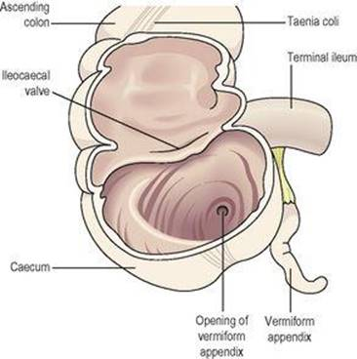

Colon
- The colon has four parts which have the same structure and functions.
Ascending colon
This passes upwards from the caecum to the level of the liver where it curves acutely to the left at the hepatic flexure to become the transverse colon.
Transverse colon
- This is a loop of colon that extends across the abdominal cavity in front of the duodenum and the stomach to the area of the spleen where it forms the splenic flexure and curves acutely downwards to become the descending colon.
Descending colon
- This passes down the left side of the abdominal cavity then curves towards the midline. After it enters the true pelvis it is known as the sigmoid colon.

Sigmoid colon
- This part describes an S-shaped curve in the pelvis that continues downwards to become the rectum.
Rectum
- This is a slightly dilated section of the large intestine about 13 cm long. It leads from the sigmoid colon and terminates in the anal canal.
Anal canal
- This is a short passage about 3.8 cm long in the adult and leads from the rectum to the exterior. Two sphincter muscles control the anus; the internal sphincter, consisting of smooth muscle, is under the control of the autonomic nervous system and the external sphincter, formed by skeletal muscle, is under voluntary control.
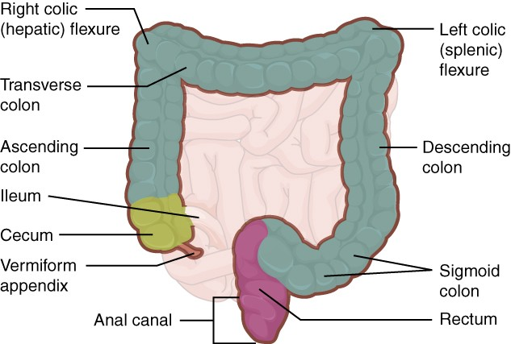
Structure
- The four layers of tissue described in the basic structure of the gastrointestinal tract are present in the caecum, colon, the rectum and the anal canal. The arrangement of the longitudinal muscle fibres is modified in the caecum and colon. They do not form a smooth continuous layer of tissue but are instead collected into three bands, called taeniae coli, situated at regular intervals round the caecum and colon. They stop at the junction of the sigmoid colon and the rectum. As these bands of muscle tissue are slightly shorter than the total length of the caecum and colon they give it a sacculated or puckered appearance.
- The longitudinal muscle fibres spread out as in the basic structure and completely surround the rectum and the anal canal. The anal sphincters are formed by thickening of the circular muscle layer.
- In the submucosal layer there is more lymphoid tissue than in any other part of the alimentary tract, providing non-specific defence against invasion by resident and other potentially harmful microbes.
- In the mucosal lining of the colon and the upper region of the rectum are large numbers of mucus-secreting goblet cells within simple tubular glands. They are not present beyond the junction between the rectum and the anal canal.
- The lining membrane of the anal canal consists of stratified squamous epithelium continuous with the mucous membrane lining of the rectum above and which merges with the skin beyond the external anal sphincter. In the upper section of the anal canal the mucous membrane is arranged in 6 to 10 vertical folds, the anal columns. Each column contains a terminal branch of the superior rectal artery and vein.

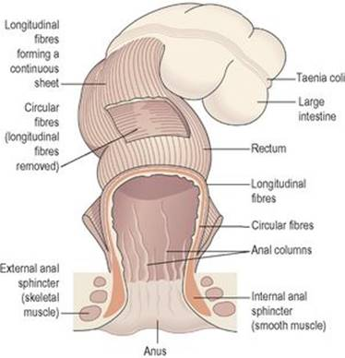
Arrangement of muscle fibres in the large intestine, rectum and anus
Blood supply
Arterial supply is mainly by the superior and inferior mesenteric arteries. The superior mesenteric artery supplies the caecum, ascending and most of the transverse colon. The inferior mesenteric artery supplies the remainder of the colon and the proximal part of the rectum. The middle and inferior rectal arteries, branches of the internal iliac arteries, supply the distal section of the rectum and the anus.
Venous drainage is mainly by the superior and inferior mesenteric veins which drain blood from the parts supplied by arteries of the same names. These veins join the splenic and gastric veins to form the portal vein. Veins draining the distal part of the rectum and the anus join the internal iliac veins, meaning that blood from this region returns directly to the inferior cava, bypassing the portal circulation.
Functions of the large intestine, rectum and anal canal
Absorption
The contents of the ileum which pass through the ileocaecal valve into the caecum are fluid, even though a large amount of water has been absorbed in the small intestine. In the large intestine absorption of water, by osmosis, continues until the familiar semisolid consistency of faeces is achieved. Mineral salts, vitamins and some drugs are also absorbed into the blood capillaries from the large intestine.
Microbial activity
The large intestine is heavily colonised by certain types of bacteria, which synthesise vitamin K and folic acid. They include Escherichia coli, Enterobacter aerogenes, Streptococcus faecalis and Clostridium perfringens. These microbes are commensals, i.e. normally harmless, in humans. However, they may become pathogenic if transferred to another part of the body, e.g. E. coli may cause cystitis if it gains access to the urinary bladder. Gases in the bowel consist of some of the constituents of air, mainly nitrogen, swallowed with food and drink and as a feature of some anxiety states. Hydrogen, carbon dioxide and methane are produced by bacterial fermentation of unabsorbed nutrients, especially carbohydrate. Gases pass out of the bowel as flatus (wind). Large numbers of microbes are present in the faeces. Mass movement
The large intestine does not exhibit peristaltic movement as in other parts of the digestive tract. Only at fairly long intervals (about twice an hour) does a wave of strong peristalsis sweep along the transverse colon forcing its contents into the descending and sigmoid colons. This is known as mass movement and it is often precipitated by the entry of food into the stomach. This combination of stimulus and response is called the gastrocolic reflex. Defaecation
Usually the rectum is empty, but when a mass movement forces the contents of the sigmoid colon into the rectum the nerve endings in its walls are stimulated by stretch. In the infant, defaecation occurs by reflex (involuntary) action. However, during the second or third year of life the ability to override the defaecation reflex is learned. In practical terms this acquired voluntary control means that the brain can inhibit the reflex until such time as it is convenient to defaecate. The external anal sphincter is under conscious control through the pudendal nerve. Thus defaecation involves involuntary contraction of the muscle of the rectum and relaxation of the internal anal sphincter. Contraction of the abdominal muscles and lowering of the diaphragm increase the intra-abdominal pressure (Valsalva’s manoeuvre) and so assist the process of defaecation. When defaecation is voluntarily postponed the need to defaecate tends to fade until the next mass movement occurs and the reflex is initiated again. Repeated suppression of the reflex may lead to constipation (hard faeces) as more water is absorbed. Constituents of faeces
The faeces consist of a semisolid brown mass. The brown colour is due to the presence of stercobilin.
Even though absorption of water takes place in the small and large intestines, water still makes up about 60 to 70% of the weight of the faeces. The remainder consists of: fibre (indigestible cellular plant and animal material), dead and live microbes, epithelial cells shed from the walls of the tract, fatty acids, mucus secreted by the epithelial lining of the large intestine.
Mucus helps to lubricate the faeces and an adequate amount of dietary non-starch polysaccharide (NSP, fibre and previously known as roughage) ensures that the contents of the large intestine are sufficiently bulky to stimulate defaecation.

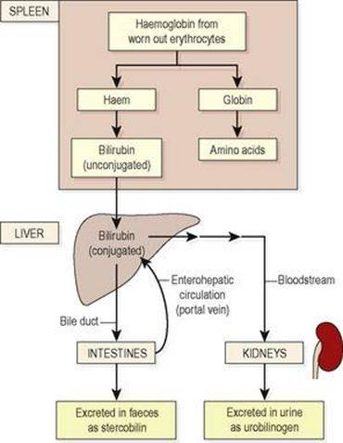
Fate of bilirubin from breakdown of worn-out erythrocytes.

