HUMAN ANATOMY AND PHYSIOLOGY-II (Theory)
Subject code: BP201T
Class – 04
SALIVARY GLANDS
- The salivary glands release their secretions into ducts that lead into the mouth. There are three main pairs the parotid glands, the submandibular glands and the sublingual glands. There are also numerous smaller salivary glands scattered around the mouth.
Parotid glands:
- These are situated one on each side of the face, just below the external acoustic meatus. Each gland has a parotid duct opening into the mouth at the level of its second upper molar tooth.
Submandibular glands:
- These lie one on each side of the face under the angle of the jaw. The two submandibular ducts open on the floor of the mouth, one on each side of the frenulum of the tongue.
Sublingual glands:
- These glands lie under the mucous membrane of the floor of the mouth in front of the submandibular glands. They have numerous small ducts that open into the floor of the mouth.
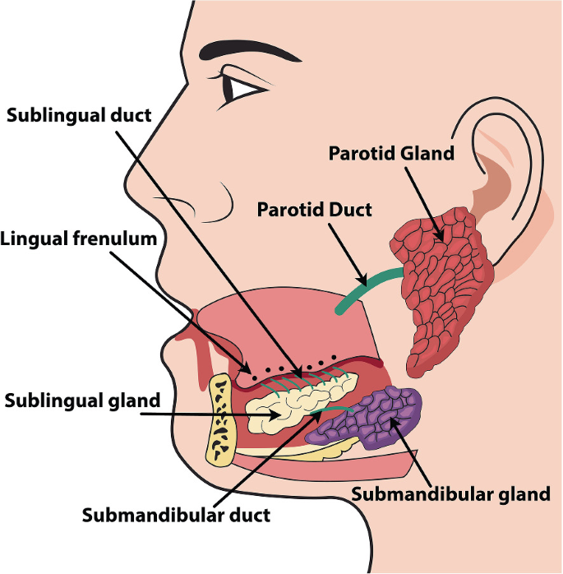

STRUCTURE:
- The glands are all surrounded by a fibrous capsule. They consist of a number of lobules made up of small acini lined with secretory cells. Saliva is released into ductules that join up to form larger ducts leading into the mouth.
Blood Supply
Arterial supply is by various branches from the external carotid arteries, and venous drainage is into the external jugular veins.
Composition of Saliva
Saliva is the combined secretions from the salivary glands and the small mucus-secreting glands of the oral mucosa. About 1.5 litres of Saliva is produced daily and it consists of
- Water
- Mineral salts
- Salivary amylase- a digestive enzyme
- Mucus
- Antimicrobial substances- immunoglobulins (antibodies) and the enzyme lysozyme.
Secretion of Saliva:
Saliva secretion is controlled by the autonomic nervous system. Parasympathetic stimulation Causes profuse secretion of watery saliva with a relatively low content of enzymes and other organic substances. Sympathetic stimulation results in secretion of small amounts of saliva rich in organic material, especially from the submandibular glands.
Functions of Saliva:
- Chemical digestion of polysaccharides: Saliva contains the enzyme amylase, which begins the breakdown of complex sugars, including starches, reducing them to the disaccharide maltose. The Optimum pH for the action of salivary amylase is 6.8 (slightly acid). Salivary pH ranges from 5.8 to 7.4, depending on the rate of flow; the higher the flow rate, the higher the pH. Enzyme action continues during swallowing until terminated by the strongly acidic gastric juices, which degrade the amylase.
- Lubrication of Food:
The high water content means that dry food entering the mouth is moistened and lubricated by saliva before it can be made into a bolus ready for swallowing.
- Cleaning and lubrication of the mouth:
An adequate flow of saliva is necessary to keep the mouth clean, moist and pliable. This also helps to prevent damage to the mucous membrane by rough or abrasive food.
- Non-specific defence:
Lysozyme and immunoglobulins (antibodies) present in saliva combat invading microbes.
- Taste:
The taste buds are stimulated only by chemical substances in solution and therefore dry foods stimulate the sense of taste only after thorough mixing with saliva. The senses of taste and smell are closely linked and involved in the enjoyment of food.

