HUMAN ANATOMY AND PHYSIOLOGY-II (Theory)
Subject code: BP201T
Class – 6
RESPIRATION
The term respiration means the exchange of gases between body cells and the environment. This involves two main processes:
Breathing (pulmonary ventilation)
This is movement of air into and out of the lungs.
Exchange of gases
This takes place:
In the lungs: external respiration
In the tissues: internal respiration.
Breathing
Breathing supplies oxygen to the alveoli, and eliminates carbon dioxide.
Muscles of breathing
Expansion of the chest during inspiration occurs as a result of muscular activity, partly voluntary and partly involuntary. The main muscles used in normal quiet breathing are the external intercostal muscles and the diaphragm.
Intercostal muscles
There are 11 pairs of intercostal muscles that occupy the spaces between the 12 pairs of ribs. They are arranged in two layers, the external and internal intercostal muscles.
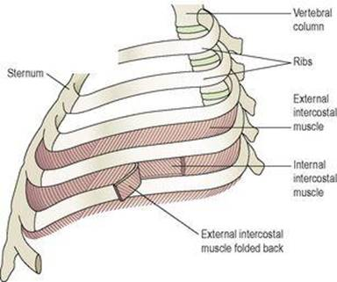
External intercostal muscles
These extend downwards and forwards from the lower border of the rib above to the upper border of the rib below. They are involved in inspiration.
Internal intercostal muscles
These extend downwards and backwards from the lower border of the rib above to the upper border of the rib below, crossing the external intercostal muscle fibres at right angles. The internal intercostal are used when exhalation becomes active, as in exercise.
The first rib is fixed. Therefore, when the external intercostal muscles contract they pull all the other ribs towards the first rib. Because of the shape and sizes of the ribs they move outwards when pulled upwards, enlarging the thoracic cavity. The intercostal muscles are stimulated to contract by the intercostal nerves.
Diaphragm
The diaphragm is a dome-shaped muscular structure separating the thoracic and abdominal cavities. It forms the floor of the thoracic cavity and the roof of the abdominal cavity and consists of a central tendon from which muscle fibres radiate to be attached to the lower ribs and sternum and to the vertebral column by two crura. When the muscle of the diaphragm is relaxed, the central tendon is at the level of the 8th thoracic vertebra. When it contracts, its muscle fibres shorten and the central tendon is pulled downwards to the level of the 9th thoracic vertebra, lengthening the thoracic cavity. This decreases pressure in the thoracic cavity and increases it in the abdominal and pelvic cavities. The diaphragm is supplied by the phrenic nerves.
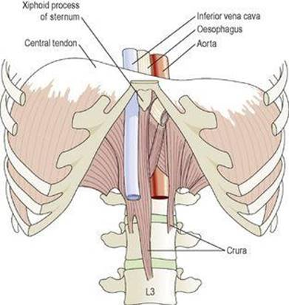
The diaphragm

Quiet, restful breathing is sometimes called diaphragmatic breathing because 75% of the work is done by the diaphragm.
The external intercostal muscles and the diaphragm contract simultaneously, enlarging the thoracic cavity in all directions,that is from back to front, side to side and top to bottom.
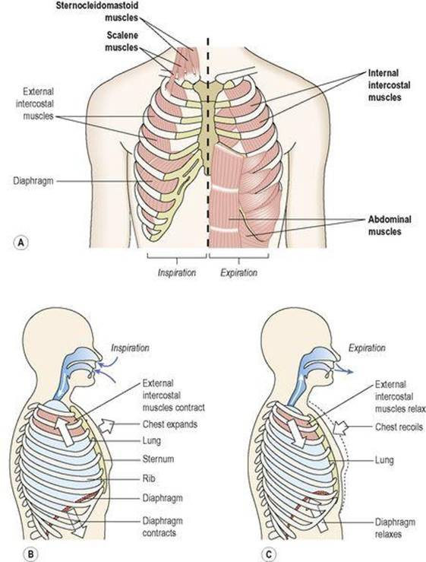
Changes in chest size during inspiration. A. Muscles involved in respiration (accessory muscles labelled in bold). B, C. Changes in chest volume.

Accessory muscles of respiration
When extra respiratory effort is required, additional muscles are used. Forced inspiration is assisted by the sternocleidomastoid muscles and the scalene muscles, which link the cervical vertebrae to the first two ribs, and increase ribcage expansion. Forced expiration is helped by the activity of the internal intercostal muscles and sometimes the abdominal muscles, which increase the pressure in the thorax by squeezing the abdominal contents.
Cycle of breathing
The average respiratory rate is 12 to 15 breaths per minute. Each breath consists of three phases:
Inspiration
Expiration
Pause.
As described previously, the visceral pleura is adherent to the lungs and the parietal pleura to the inner wall of the thorax and to the diaphragm. Between them is a thin film of serous fluid.
Breathing is dependent upon changes in pressure and volume in the thoracic cavity. It follows the underlying physical principle that increasing the volume of a container decreases the pressure inside it, and that decreasing the volume of a container increases the pressure inside it. Since air flows from an area of high pressure to an area of low pressure, changing the pressure inside the lungs determines the direction of airflow.
Inspiration
Simultaneous contraction of the external intercostal muscles and the diaphragm expands the thorax. As the parietal pleura is firmly adherent to the diaphragm and the inside of the ribcage, it is pulled outward along with them. This pulls the visceral pleura outwards too, since the two pleura are held together by the thin film of pleural fluid. Because the visceral pleura is firmly adherent to the lung, the lung tissue is, therefore, pulled up and out with the ribs, and downwards with the diaphragm. This expands the lungs, and the pressure within the alveoli and in the air passages falls, drawing air into the lungs in an attempt to equalise the atmospheric and alveolar air pressures.
The process of inspiration is active, as it needs energy for muscle contraction. The negative pressure created in the thoracic cavity aids venous return to the heart and is known as the respiratory pump. At rest, inspiration lasts about 2 seconds.
Expiration
Relaxation of the external intercostal muscles and the diaphragm results in downward and inward movement of the ribcage and elastic recoil of the lungs. As this occurs, pressure inside the lungs rises and expels air from the respiratory tract. The lungs still contain some air, and are prevented from complete collapse by the intact pleura. This process is passive as it does not require the expenditure of energy.
At rest, expiration lasts about 3 seconds, and after expiration there is a pause before the next cycle begins.
Physiological variables affecting breathing
Elasticity
Elasticity is the term used to describe the ability of the lung to return to its normal shape after each breath. Loss of elasticity of the connective tissue in the lungs necessitates forced expiration and increased effort on inspiration.
Compliance
This is a measure of the stretchability of the lungs, i.e. the effort required to inflate the alveoli. The healthy lung is very compliant, and inflates with very little effort. When compliance is low the effort needed to inflate the lungs is greater than normal, e.g. in some diseases where elasticity is reduced or when insufficient surfactant is present. Note that compliance and elasticity are opposing forces.
Airway resistance
When this is increased, e.g. in bronchoconstriction, more respiratory effort is required to inflate the lungs.

