HUMAN ANATOMY AND PHYSIOLOGY-II (Theory)
Subject code: BP201T
Class – 1
RESPIRATORY SYSTEM:
Nose and Nasal cavity
Position and structure
The nasal cavity is the main route of air entry, and consists of a large irregular cavity divided into two equal passages by a septum. The posterior bony part of the septum is formed by the perpendicular plate of the ethmoid bone and the vomer. Anteriorly, it consists of hyaline cartilage.
The roof is formed by the cribriform plate of the ethmoid bone and the sphenoid bone, frontal bone and nasal bones.
The floor is formed by the roof of the mouth and consists of the hard palate in front and the soft palate behind. The hard palate is composed of the maxilla and palatine bones and the soft palate consists of involuntary muscle.
The medial wall is formed by the septum.
The lateral walls are formed by the maxilla, the ethmoid bone and the inferior conchae.
The posterior wall is formed by the posterior wall of the pharynx.
Lining of the nose
The nose is lined with very vascular ciliated columnar epithelium (ciliated mucous membrane) which contains mucus-secreting goblet cells. At the anterior nares this blends with the skin and posteriorly it extends into the nasal part of the pharynx.
Openings into the nasal cavity
The anterior nares, or nostrils, are the openings from the exterior into the nasal cavity. Nasal hairs are found here, coated in sticky mucus.
The posterior nares are the openings from the nasal cavity into the pharynx.
The paranasal sinuses are cavities in the bones of the face and the cranium, containing air. There are tiny openings between the paranasal sinuses and the nasal cavity. They are lined with mucous membrane, continuous with that of the nasal cavity.
The main sinuses are: maxillary sinuses in the lateral walls
Frontal and sphenoidal sinuses in the roof
Ethmoidal sinuses in the upper part of the lateral walls.
The sinuses function in speech and also lighten the skull. The nasolacrimal ducts extend from the lateral walls of the nose to the conjunctival sacs of the eye. They drain tears from the eyes.

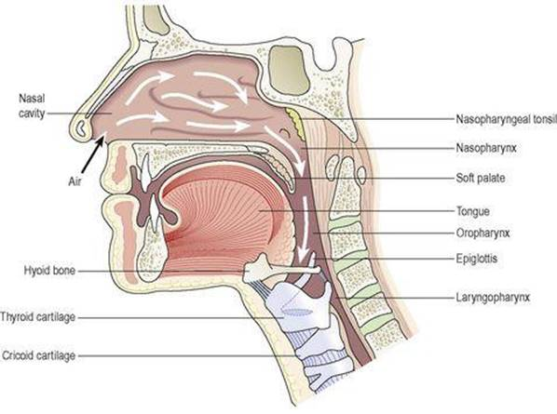
Respiratory function of the nose
The nose is the first of the respiratory passages through which the inspired air passes. The function of the nose is to begin the process by which the air is warmed, moistened and filtered. The projecting conchae increase the surface area and cause turbulence, spreading inspired air over the whole nasal surface. The large surface area maximises warming, humidification and filtering.
Warming
This is due to the immense vascularity of the mucosa. This explains the large blood loss when a nosebleed (epistaxis) occurs.
Filtering and cleaning
Hairs at the anterior nares trap larger particles. Smaller particles such as dust and bacteria settle and adhere to the mucus. Mucus protects the underlying epithelium from irritation and prevents drying. Synchronous beating of the cilia wafts the mucus towards the throat where it is swallowed or coughed up (expectorated).
Humidification
As air travels over the moist mucosa, it becomes saturated with water vapour. Irritation of the nasal mucosa results in sneezing, a reflex action that forcibly expels an irritant.
The sense of smell
The nose is the organ of the sense of smell (olfaction). Nerve endings that detect smell are located in the roof of the nose in the area of the cribriform plate of the ethmoid bones and the superior conchae. These nerve endings are stimulated by airborne odours. The resultant nerve signals are carried by the olfactory nerves to the brain where the sensation of smell is perceived

