NOMENCLATURE AND CLASSIFICATION 0F ENZYMES
In the early days, the enzymes were given names by their discoverers in an arbitrary manner.
Enzymes are sometimes considered under two broad categories :
(a) Intracellular enzymes – They are functional within cells where they are synthesized.
(b) Extracellular enzymes – These enzymes are active outside the cell; all the digestive enzymes belong to this group.
The International Union of Biochemistry (IUB) appointed an Enzyme Commission in 1961.
This committee made a thorough study of the existing enzymes and devised some basic principles for the classification and nomenclature of enzymes. Since 1964, the IUB system of enzyme classification has been in force. Enzymes are divided into six major classes (in that order). Each class on its own represents the general type of reaction brought about by the enzymes of that class.
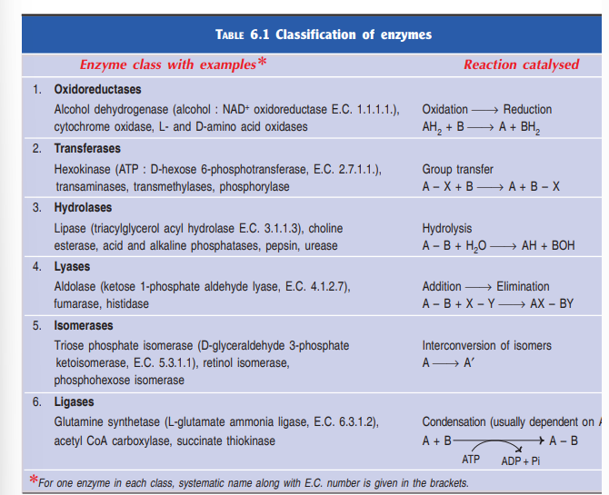
1. Oxidoreductases : Enzymes involved in oxidation-reduction reactions.
2. Transferases : Enzymes that catalyse the transfer of functional groups.
3. Hydrolases : Enzymes that bring about hydrolysis of various compounds.
4. Lyases : Enzymes specialised in the addition or removal of water, ammonia, CO2 etc.
5. Isomerases : Enzymes involved in all the isomerization reactions.
6. Ligases : Enzymes catalysing the synthetic reactions (Greek : ligate—to bind) where two molecules are joined together and ATP is used.
[The word OTHLIL (first letter in each class) may be memorised to remember the six classes of enzymes in the correct order].
Each class in turn is subdivided into many sub-classes which are further divided. A four digit Enzyme Commission (E.C.) number is assigned to each enzyme representing the class (first digit), sub-class (second digit), sub-sub class (third digit) and the individual enzyme (fourth digit). Each enzyme is given a specific name indicating the substrate, coenzyme (if any) and the type of the reaction catalysed by the enzyme. Although the IUB names for the enzymes are specific and unambiguous, they have not been accepted for general use as they are complex and cumbersome to remember. Therefore, the trivial names, along with the E.C. numbers as and when needed, are commonly used and widely accepted.

