HUMAN ANATOMY AND PHYSIOLOGY-II (Theory)
Subject code: BP201T
Class – 3
LARYNX
Position
The larynx or ‘voice box’ links the laryngopharynx and the trachea. It lies at the level of the 3rd, 4th, 5th and 6th cervical vertebrae. Until puberty there is little difference in the size of the larynx between the sexes. Thereafter, it grows larger in the male, which explains the prominence of the ‘Adam’s apple’ and the generally deeper voice.
Structures associated with the larynx
Superiorly – the hyoid bone and the root of the tongue
Inferiorly – it is continuous with the trachea
Anteriorly – the muscles attached to the hyoid bone and the muscles of the neck
Posteriorly – the laryngopharynx and 3rd to 6th cervical vertebrae
Laterally – the lobes of the thyroid gland.
Structure
Cartilages
The larynx is composed of several irregularly shaped cartilages attached to each other by ligaments and membranes.
The main cartilages are:
1 Thyroid Cartilage
1 Cricoid Cartilage } Hyaline Cartilage
2 Arytenoid Cartilage
1 epiglottis - elastic fibrocartilage
Thyroid cartilage
This is the most prominent of the laryngeal cartilages. Made of hyaline cartilage, it lies to the front of the neck. Its anterior wall projects into the soft tissues of the front of the throat, forming the laryngeal prominence or Adam’s apple, which is easily felt and often visible in adult males. The anterior wall is partially divided by the thyroid notch. The cartilage is incomplete posteriorly, and is bound with ligaments to the hyoid bone above and the cricoid cartilage below. anterior wall is partially divided by the thyroid notch. The cartilage is incomplete posteriorly, and is bound with ligaments to the hyoid bone above and the cricoid cartilage below.
The upper part of the thyroid cartilage is lined with stratified squamous epithelium like the larynx, and the lower part with ciliated columnar epithelium like the trachea. There are many muscles attached to its outer surface. The thyroid cartilage forms most of the anterior and lateral walls of the larynx.
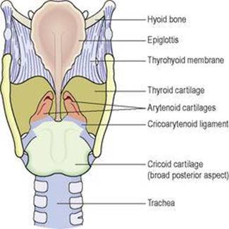
Larynx – viewed from behind.
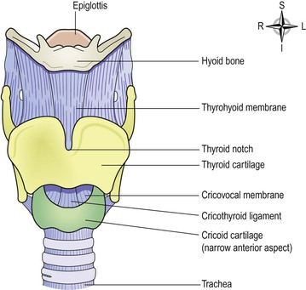
Larynx – viewed from the front

Cricoid cartilage
This lies below the thyroid cartilage and is also composed of hyaline cartilage. It is shaped like a signet ring, completely encircling the larynx with the narrow part anteriorly and the broad part posteriorly. The broad posterior part articulates with the arytenoid cartilages and with the thyroid cartilage. It is lined with ciliated columnar epithelium and there are muscles and ligaments attached to its outer surface. The lower border of the cricoid cartilage marks the end of the upper respiratory tract.
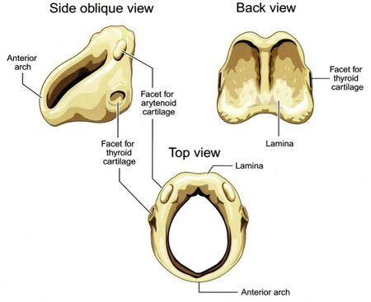
Arytenoid cartilages
These are two roughly pyramid-shaped hyaline cartilages situated on top of the broad part of the cricoid cartilage forming part of the posterior wall of the larynx. They give attachment to the vocal cords and to muscles and are lined with ciliated columnar epithelium.
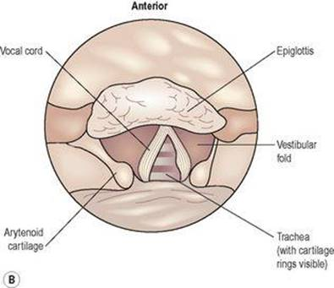
Diagram of the vocal cords showing the principal structures.
Epiglottis
This is a leaf-shaped fibroelastic cartilage attached on a flexible stalk of cartilage to the inner surface of the anterior wall of the thyroid cartilage immediately below the thyroid notch. It rises obliquely upwards behind the tongue and the body of the hyoid bone. It is covered with stratified squamous epithelium. If the larynx is likened to a box then the epiglottis acts as the lid; it closes off the larynx during swallowing, protecting the lungs from accidental inhalation of foreign objects.
Ligaments and membranes
There are several ligaments that attach the cartilages to each other and to the hyoid bone.
Blood and nerve supply
Blood is supplied to the larynx by the superior and inferior laryngeal arteries and drained by the thyroid veins, which join the internal jugular vein. The parasympathetic nerve supply is from the superior laryngeal and recurrent laryngeal nerves, which are branches of the vagus nerves. The sympathetic nerves are from the superior cervical ganglia, one on each side. These provide the motor nerve supply to the muscles of the larynx and sensory fibres to the lining membrane.
Interior of the larynx The vocal cords are two pale folds of mucous membrane with cord-like free edges, which extend from the inner wall of the thyroid prominence anteriorly to the arytenoid cartilages posteriorly.
When the muscles controlling the vocal cords are relaxed, the vocal cords open and the passageway for air coming up through the larynx is clear; the vocal cords are said to be abducted (open).The pitch of the sound produced by vibrating the vocal cords in this position is low. When the muscles controlling the vocal cords contract, the vocal cords are stretched out tightly across the larynx, and are said to be adducted (closed). When the vocal cords are stretched to this extent, and are vibrated by air passing through from the lungs, the sound produced is high pitched. The pitch of the voice is therefore determined by the tension applied to the vocal cords by the appropriate sets of muscles. When not in use, the vocal cords are adducted. The space between the vocal cords is called the glottis.
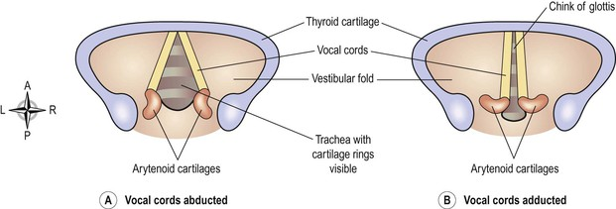
Functions
Production of sound
Sound has the properties of pitch, volume and resonance. Pitch of the voice depends upon the length and tightness of the cords. Shorter cords produce higher pitched sounds. At puberty, the male vocal cords begin to grow longer, hence the lower pitch of the adult male voice. Volume of the voice depends upon the force with which the cords vibrate. The greater the force of expired air, the more strongly the cords vibrate and the louder the sound emitted. Resonance, or tone, is dependent upon the shape of the mouth, the position of the tongue and the lips, the facial muscles and the air in the paranasal sinuses.
Speech
This is produced when the sounds produced by the vocal cords are manipulated by the tongue, cheeks and lips.
Protection of the lower respiratory tract
During swallowing the larynx moves upwards, blocking the opening into it from the pharynx. In addition, the hinged epiglottis closes over the larynx. This ensures that food passes into the oesophagus and not into the trachea.
Passageway for air
The larynx links the pharynx above with the trachea below.
Humidifying, filtering and warming
These processes continue as inspired air travels through the larynx.

