HUMAN ANATOMY AND PHYSIOLOGY-II (Theory)
Subject code: BP201T
Class – 5
LUNGS
Position and gross structure
There are two lungs, one lying on each side of the midline in the thoracic cavity. They are cone-shaped and have an apex, a base, a tip, costal surface and medial surface.
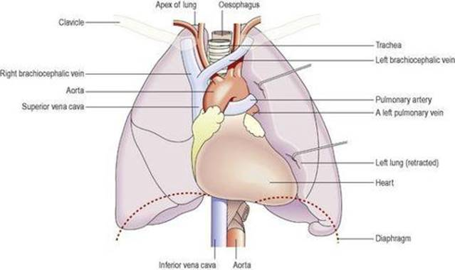
ORGANS ASSOCIATED WITH THE LUNGS.
Apex
This is rounded and rises into the root of the neck, about 25 mm above the level of the middle third of the clavicle. It lies close to the first rib and the blood vessels and nerves in the root of the neck.
Base
This is concave and semilunar in shape, and lies on the upper (thoracic) surface of the diaphragm.
Costal surface
This surface is convex and lies directly against the costal cartilages, the ribs and the intercostal muscles.
Medial surface
This surface is concave and has a roughly triangular-shaped area, called the hilum, at the level of the 5th, 6th and 7th thoracic vertebrae. Structures forming the root of the lung enter and leave at the hilum. These include the primary bronchus, the pulmonary artery supplying the lung and the two pulmonary veins draining it, the bronchial artery and veins, and the lymphatic and nerve supply,
The area between the lungs is the mediastinum. It is occupied by the heart, great vessels, trachea, right and left bronchi, oesophagus, lymph nodes, lymph vessels and nerves. The right lung is divided into three distinct lobes: superior, middle and inferior. The left lung is smaller because the heart occupies space left of the midline. It is divided into only two lobes: superior and inferior. The divisions between the lobes are called fissures.
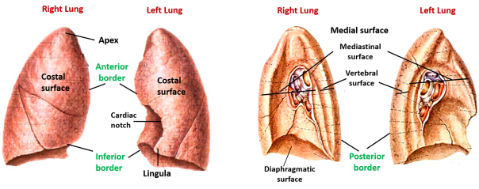
The lobes of the lungs and vessels/airways of each hilum – medial views.
Pleura and pleural cavity
The pleura consists of a closed sac of serous membrane (one for each lung) which contains a small amount of serous fluid. The lung is invaginated (pushed into) into this sac so that it forms two layers: one adheres to the lung and the other to the wall of the thoracic cavity.
Visceral pleura
This is adherent to the lung, covering each lobe and passing into the fissures that separate them.
Parietal pleura
This is adherent to the inside of the chest wall and the thoracic surface of the diaphragm. It is not attached to other structures in the mediastinum and is continuous with the visceral pleura round the edges of the hilum.
Pleural cavity
This is only a potential space and contains no air. In health, the two layers of pleura are separated by a thin film of serous fluid (pleural fluid), which allows them to glide over each other, preventing friction between them during breathing. The serous fluid is secreted by the epithelial cells of the membrane. The double membrane arrangement of the pleura is similar to the serous pericardium of the heart.
The two layers of pleura, with serous fluid between them, behave in the same way as two pieces of glass separated by a thin film of water. They glide over each other easily but can be pulled apart only with difficulty, because of the surface tension between the membranes and the fluid. If either layer of pleura is punctured, the underlying lung collapses owing to its inherent property of elastic recoil.
Interior of the lungs
The lungs are composed of the bronchi and smaller air passages, alveoli, connective tissue, blood vessels, lymph vessels and nerves, all embedded in an elastic connective tissue matrix. Each lobe is made up of a large number of lobules.
Pulmonary blood supply
The pulmonary trunk divides into the right and left pulmonary arteries, which transport deoxygenated blood to each lung. Within the lungs each pulmonary artery divides into many branches, which eventually end in a dense capillary network around the walls of the alveoli. The walls of the alveoli and the capillaries each consist of only one layer of flattened epithelial cells. The exchange of gases between air in the alveoli and blood in the capillaries takes place across these two very fine membranes (together called the respiratory membrane). The pulmonary capillaries join up, forming two pulmonary veins in each lung. They leave the lungs at the hilum and carry oxygenated blood to the left atrium of the heart. The innumerable blood capillaries and blood vessels in the lungs are supported by connective tissue.
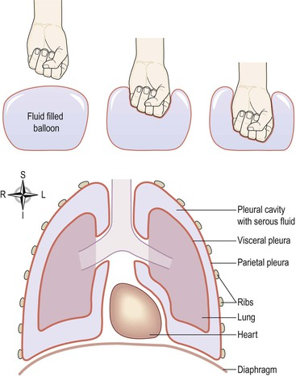
The relationship of the pleura to the lungs

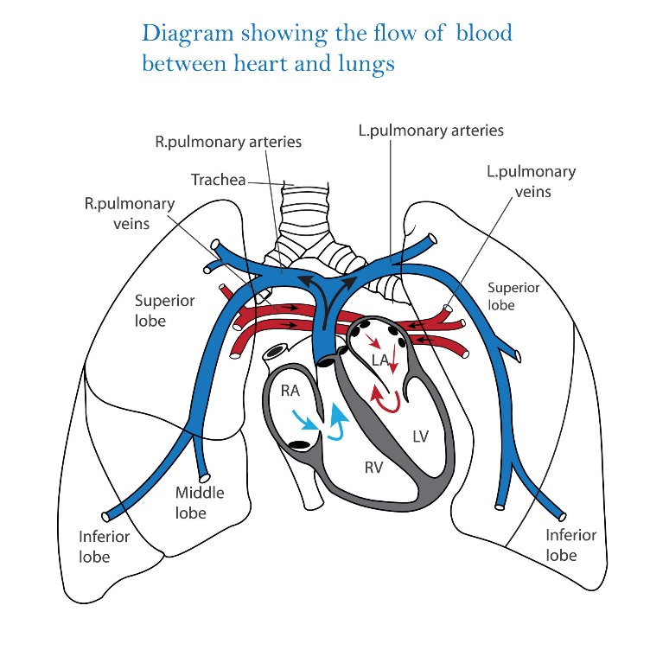

The alveoli and their capillary network. A. A group of intact alveoli. B. Section through an alveolus.
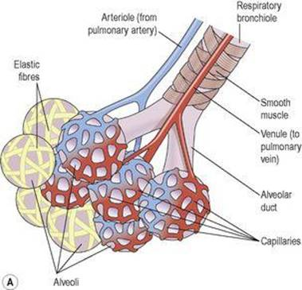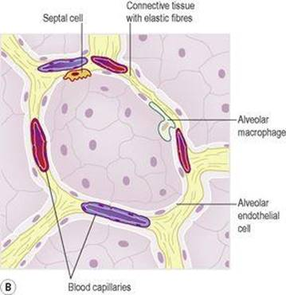
Bronchi and bronchioles
The two primary bronchi are formed when the trachea divides, at about the level of the 5th thoracic vertebra.
Right bronchus
This is wider, shorter and more vertical than the left bronchus and is therefore more likely to become obstructed by an inhaled foreign body. It is approximately 2.5 cm long. After entering the right lung at the hilum it divides into three branches, one to each lobe. Each branch then subdivides into numerous smaller branches.
Left bronchus
This is about 5 cm long and is narrower than the right. After entering the lung at the hilum it divides into two branches, one to each lobe. Each branch then subdivides into progressively smaller airways within the lung substance.
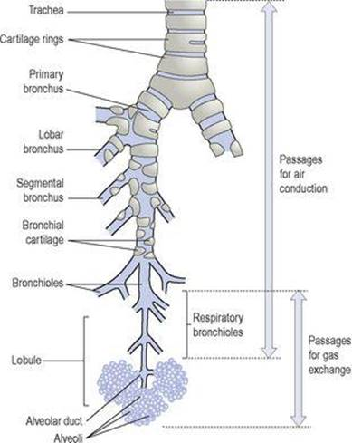
The lower respiratory tract.
Structure
The bronchial walls are composed of the same tissues as the trachea, and are lined with ciliated columnar epithelium. The bronchi progressively subdivide into bronchioles, terminal bronchioles, respiratory bronchioles, alveolar ducts and finally, alveoli. The wider passages are called conducting airways because their function is to bring air into the lungs, and their walls are too thick to permit gas exchange.
Structural changes in the bronchial passages
As the bronchi divide and become progressively smaller, their structure changes to match their function.
Cartilage
Since rigid cartilage would interfere with expansion of lung tissue and the exchange of gases, it is present for support in the larger airways only. The bronchi contain cartilage rings like the trachea, but as the airways divide, these rings become much smaller plates, and at the bronchiolar level there is no cartilage present in the airway walls at all.
Smooth muscle
As the cartilage disappears from airway walls, it is replaced by smooth muscle. This allows the diameter of the airways to be increased or decreased through the action of the autonomic nervous system, regulating airflow within each lung.
Epithelial lining
The ciliated epithelium is gradually replaced with non-ciliated epithelium, and goblet cells disappear.
Blood and nerve supply, lymph drainage
The arterial supply to the walls of the bronchi and smaller air passages is through branches of the right and left bronchial arteries and the venous return is mainly through the bronchial veins. On the right side they empty into the azygos vein and on the left into the superior intercostal vein. The vagus nerves (parasympathetic) stimulate contraction of smooth muscle in the bronchial tree, causing bronchoconstriction, and sympathetic stimulation causes bronchodilation.
Lymph is drained from the walls of the air passages in a network of lymph vessels. It passes through lymph nodes situated around the trachea and bronchial tree then into the thoracic duct on the left side and right lymphatic duct on the other.
Functions
Control of air entry
The diameter of the respiratory passages is altered by contraction or relaxation of the smooth muscle in their walls, thus regulating the speed and volume of airflow into and within the lungs. These changes are controlled by the autonomic nerve supply: parasympathetic stimulation causes constriction and sympathetic stimulation causes dilation.
The following functions continue as in the upper airways:
Warming and humidifying
Support and patency
Removal of particulate matter cough reflex.
Respiratory bronchioles and alveoli
Structure
Within each lobe, the lung tissue is further divided by fine sheets of connective tissue into lobules. Each lobule is supplied with air by a terminal bronchiole, which further subdivides into respiratory bronchioles, alveolar ducts and large numbers of alveoli (air sacs). There are about 150 million alveoli in the adult lung. It is in these structures that the process of gas exchange occurs. As airways progressively divide and become smaller and smaller, their walls gradually become thinner until muscle and connective tissue disappear, leaving a single layer of simple squamous epithelial cells in the alveolar ducts and alveoli. These distal respiratory passages are supported by a loose network of elastic connective tissue in which macrophages, fibroblasts, nerves and blood and lymph vessels are embedded. The alveoli are surrounded by a dense network of capillaries. Exchange of gases in the lung (external respiration) takes place across a membrane made up of the alveolar wall and the capillary wall fused firmly together. This is called the respiratory membrane.
On microscopic examination, the extensive air spaces are clearly seen and healthy lung tissue has a honeycomb appearance.
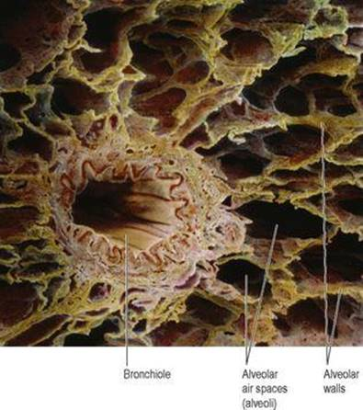
Coloured scanning electron micrograph of lung alveoli and a bronchiole.

Lying between the squamous cells are septal cells that secrete surfactant, a phospholipid fluid which prevents the alveoli from drying out. In addition, surfactant reduces surface tension and prevents alveolar walls collapsing during expiration. Secretion of surfactant into the distal air passages and alveoli begins about the 35th week of fetal life. Its presence in newborn babies facilitates expansion of the lungs and the establishment of respiration. It may not be present in sufficient amounts in the immature lungs of premature babies, causing serious breathing problems.
Nerve supply to bronchioles
Parasympathetic fibres from the vagus nerve cause bronchoconstriction. The absence of supporting cartilage means that small airways may be completely closed off by constriction of their smooth muscle. Sympathetic stimulation relaxes bronchiolar smooth muscle.
Functions
External respiration
Defence against infection
At this level, ciliated epithelium, goblet cells and mucus are no longer present, because their presence would impede gas exchange and encourage infection. By the time inspired air reaches the alveoli, it is usually clean. Defence relies on protective cells present within the lung tissue. These include lymphocytes and plasma cells, which produce antibodies and phagocytes, including alveolar macrophages. These cells are most active in the distal air passages where ciliated epithelium has been replaced by flattened cells.
Warming and humidifying
These continue as in the upper airways. Inhalation of dry or inadequately humidified air over a period of time causes irritation of the mucosa and encourages infection.

