HUMAN ANATOMY AND PHYSIOLOGY-II (Theory)
Subject code: BP201T
Class – 7
LUNG VOLUMES AND CAPACITIES
In normal quiet breathing there are about 15 complete respiratory cycles per minute. The lungs and the air passages are never empty and, as the exchange of gases takes place only across the walls of the alveolar ducts and alveoli, the remaining capacity of the respiratory passages is called the anatomical dead space (about 150 ml).
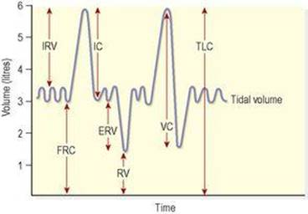
Lung volumes and capacities. IRV: inspiratory reserve volume; IC: inspiratory capacity; FRC: functional residual capacity; ERV: expiratory reserve volume; RV: residual volume; VC: vital capacity; TLC: total lung capacity.
Tidal volume (TV)
This is the amount of air passing into and out of the lungs during each cycle of breathing (about 500 ml at rest).
Inspiratory reserve volume (IRV)
This is the extra volume of air that can be inhaled into the lungs during maximal inspiration, i.e. over and above normal TV.
Inspiratory capacity (IC)
This is the amount of air that can be inspired with maximum effort. It consists of the tidal volume (500 ml) plus the inspiratory reserve volume.
Functional residual capacity (FRC)
This is the amount of air remaining in the air passages and alveoli at the end of quiet expiration. Tidal air mixes with this air, causing relatively small changes in the composition of alveolar air. As blood flows continuously through the pulmonary capillaries, this means that exchange of gases is not interrupted between breaths, preventing moment-to-moment changes in the concentration of blood gases. The functional residual volume also prevents collapse of the alveoli on expiration.
Expiratory reserve volume (ERV)
This is the largest volume of air which can be expelled from the lungs during maximal expiration.
Residual volume (RV)
This cannot be directly measured but is the volume of air remaining in the lungs after forced expiration.
Vital capacity (VC)
This is the maximum volume of air which can be moved into and out of the lungs:
VC= Tidal Volume+ IRV+ ERV
Total lung capacity (TLC)
This is the maximum amount of air the lungs can hold. In an adult of average build, it is normally around 6 litres. Total lung capacity represents the sum of the vital capacity and the residual volume. It cannot be directly measured in clinical tests because even after forced expiration, the residual volume of air still remains in the lungs.
Alveolar ventilation
This is the volume of air that moves into and out of the alveoli per minute. It is equal to the tidal volume minus the anatomical dead space, multiplied by the respiratory rate:
Alveolar ventilation = (TV- Anatomical dead space) × respiratory rate
= (500-150) ml × 15 per minute
= 5.25 litres per minute
Lung function tests are carried out to determine respiratory function and are based on the parameters outlined above. Results of these tests can help in diagnosis and monitoring of respiratory disorders.
Exchange of gases
Although breathing involves the alternating processes of inspiration and expiration, gas exchange at the respiratory membrane and in the tissues is a continuous and ongoing process. Diffusion of oxygen and carbon dioxide depends on pressure differences, e.g. between atmospheric air and the blood, or blood and the tissues.
Composition of air
Atmospheric pressure at sea level is 101.3 kilopascals (kPa) or 760 mmHg. With increasing height above sea level, atmospheric pressure is progressively reduced and at 5500 m, about two-thirds the height of Mount Everest (8850 m), it is about half that at sea level. Under water, pressure increases by approximately 1 atmosphere per 10 m below sea level.
Air is a mixture of gases: nitrogen, oxygen, carbon dioxide, water vapour and small quantities of inert gases. The percentage of each in inspired and expired air is listed in Table 10.1. Each gas in the mixture exerts a part of the total pressure proportional to its concentration, i.e. the partial pressure. This is denoted as, e.g. PO2, PCO2.
The composition of inspired and expired air
 | Inspired air % | Expired air %
Oxygen | 21 | 16
Carbon Dioxide | 0.04 | 4
Nitrogen and rare gases | 78 | 78
Water vapour | Variable | Saturated

Partial pressures of gases

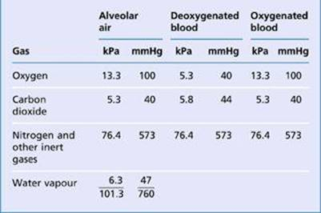

Alveolar air
The composition of alveolar air remains fairly constant and is different from atmospheric air. It is saturated with water vapour, and contains more carbon dioxide and less oxygen. Saturation with water vapour provides 6.3 kPa (47 mmHg) thus reducing the partial pressure of all the other gases present. Gaseous exchange between the alveoli and the bloodstream (external respiration) is a continuous process, as the alveoli are never empty, so it is independent of the respiratory cycle. During each inspiration only some of the alveolar gases are exchanged.
Diffusion of gases
Exchange of gases occurs when a difference in partial pressure exists across a semipermeable membrane. Gases move by diffusion from the higher concentration to the lower until equilibrium is established. Atmospheric nitrogen is not used by the body so its partial pressure remains unchanged and is the same in inspired and expired air, alveolar air and in the blood.
External respiration
This is exchange of gases by diffusion between the alveoli and the blood in the alveolar capillaries, across the respiratory membrane. Each alveolar wall is one cell thick and is surrounded by a network of tiny capillaries (the walls of which are also only one cell thick). The total area of respiratory membrane for gas exchange in the lungs is about equivalent to the area of a tennis court. Venous blood arriving at the lungs has travelled from all the tissues of the body, and contains high levels of CO2 and low levels of O2. Carbon dioxide diffuses from venous blood down its concentration gradient into the alveoli until equilibrium with alveolar air is reached. By the same process, oxygen diffuses from the alveoli into the blood. The relatively slow flow of blood through the capillaries increases the time available for gas exchange to occur. When blood leaves the alveolar capillaries, the oxygen and carbon dioxide concentrations are in equilibrium with those of alveolar air.
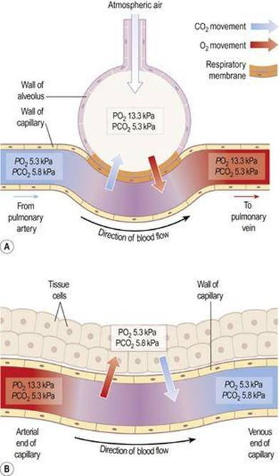

- External respiration. B. internal respiration.

Internal respiration
This is exchange of gases by diffusion between blood in the capillaries and the body cells. Gas exchange does not occur across the walls of the arteries carrying blood from the heart to the tissues, because their walls are too thick. PO2 of blood arriving at the capillary bed is therefore the same as blood leaving the lungs. Blood arriving at the tissues has been cleansed of its CO2 and saturated with O2 during its passage through the lungs, and therefore has a higher PO2 and a lower PCO2 than the tissues. This creates concentration gradients between capillary blood and the tissues, and gas exchange therefore occurs. O2 diffuses from the bloodstream through the capillary wall into the tissues. CO2 diffuses from the cells into the extracellular fluid, then into the bloodstream towards the venous end of the capillary.

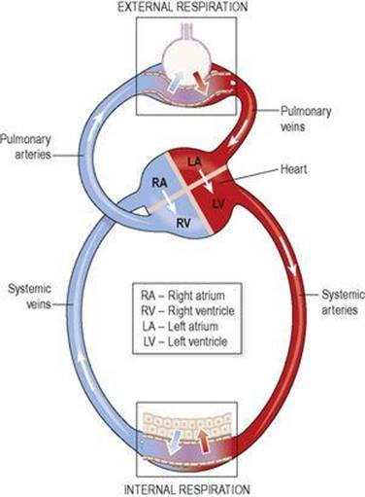

Summary of external and internal respiration.

Transport of gases in the bloodstream
Oxygen and carbon dioxide are carried in the blood in different ways.

Oxygen
Oxygen is carried in the blood in: chemical combination with haemoglobin as oxyhaemoglobin (98.5%) solution in plasma water (1.5%).
Oxyhaemoglobin is unstable, and under certain conditions readily dissociates releasing oxygen. Factors that increase dissociation include low O2 levels, low pH and raised temperature. In active tissues there is increased production of carbon dioxide and heat, which leads to increased release of oxygen. In this way oxygen is available to tissues in greatest need. Whereas oxyhaemoglobin is bright red, deoxygenated blood is bluish-purple in colour.

Carbon dioxide
Carbon dioxide is one of the waste products of metabolism. It is excreted by the lungs and is transported by three mechanisms:
As bicarbonate ions (HCO3 −) in the plasma (70%)
some is carried in erythrocytes, loosely combined with haemoglobin as carbaminohaemoglobin (23%)
some is dissolved in the plasma (7%).

Regulation of air and blood flow in the lung

During quiet breathing, only a small portion of the lung’s total capacity is ventilated with each breath. This means that only a fraction of the total alveoli are being ventilated, usually in the upper lobes, and much of the remaining lung is temporarily collapsed. Airways supplying alveoli that are not being used are constricted, directing airflow into functioning alveoli. In addition, the pulmonary arterioles bringing blood into the ventilated alveoli are dilated, to maximise gas exchange, and blood flow (perfusion) past the non-functioning alveoli is reduced.
When respiratory requirements are increased, e.g. in exercise, the increased tidal volume expands additional alveoli, and the blood flow is redistributed to perfuse these too. In this way, air flow (ventilation) and blood flow (perfusion) are matched to maximise the opportunity for gas exchange.

