HUMAN ANATOMY AND PHYSIOLOGY-II (Theory)
Subject code: BP201T
Class – 05
PROPAGATION OF ACTION POTENTIAL
To communicate information from one part of body to another, action potentials in neuron must travel from where they arise trigger zone to axon terminal. It is not decremental (does not die out) keep its strength as it spreads along the membrane. This mode of conduction is called propagation.
There are two types of propagation: 1) Continuous Conduction
2) Saltatory Conduction

Continuous Conduction:
- It involves step by step depolarization and repolarization of each adjacent segment of plasma membrane.
- This conduction occurs in unmyelinated axon and in muscle fiber.
- In this action potential propagate only a relatively short distance in few milliseconds.

Saltatory Conduction:
- It is special mode of action potential propagation that occur in myelinated axons.
- Few Voltage-gated channels are present in regions where a myelin sheath covers the axolemma.
- At Nodes of Ranvier (where no myelin sheath), axolemma has many Voltage-gated channels.
- When an action potential propagates along a myelinated axon an electrical current flow through extracellular fluid surrounding myelin sheath and through cytosol from one node to the next.
- As compare to Continuous conduction, the action potential propagate much faster along myelinated axon.
- The action potential at first node generate ionic current in the cytosol and ECF that depolarize membrane to threshold, this open Voltage-gated Na+ Channel at second node resulting ionic flow through opened channel form an action potential at second node.
- Then action potential at second node generates an ionic current that opens Voltage gated Na+ channel at third node and so on.

Difference between Saltatory and continuous Conduction

- 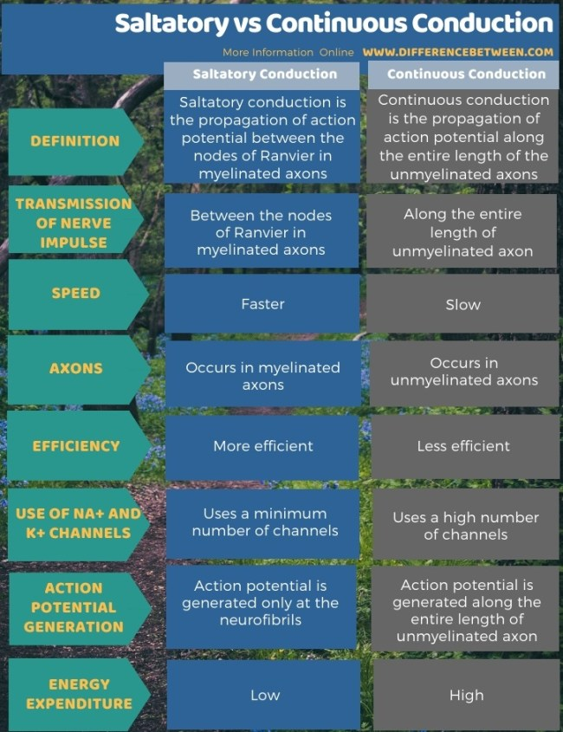

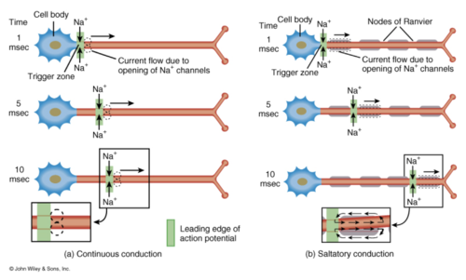

Factors that affect the speed of propagation:

- Amount of Myelination: Action potential propagate more rapidly along myelinated axons.
- Axon diameter: Larger diameter axons propagate action potential faster than small diameter.
- Temperature: Axon propagate action potentials at lower speed when cooled.

