HUMAN ANATOMY AND PHYSIOLOGY-II (Theory)
Subject code: BP201T
Class – 04
Electrophysiology of Nervous tissues
Nerve Conduction studies are electrophysiological Procedures that assess the Peripheral Nervous system.
The nervous tissues (Nerve cell and Nerve fibre) has two special properties
- Electrical Excitability: Ability to generate electrical impulse in response to a stimulus.
- Conductivity: Ability to rapidly transmit electrical impulse in a particular direction.
Like muscle fibers, neurons are electrically excitable they communicate with one another using two types of electrical signals
(1) Graded Potential (2) Action Potential
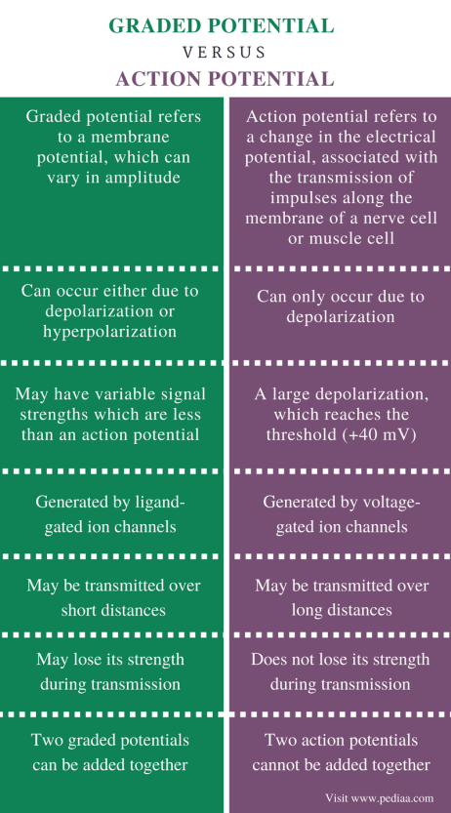

The production of action and graded potential depends on two basic features of plasma membrane of excitable cells,
- Existence of a resting Membrane potential
- Presence of Specific Type of ion Channels.

The Plasma Membrane of most body cells (including Excitable cells) exhibit a membrane potential (An electrical potential difference or voltage across the Membrane).
In Excitable cells this voltage is termed as resting membrane potential. Graded and action potential occur because membranes of neurons contain many different kinds of ion channels that open or close in response to special stimuli.

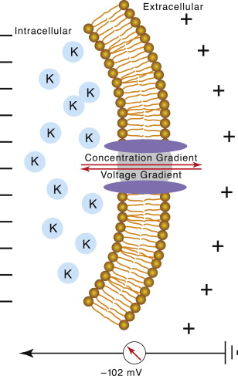
Membrane Potential

Generation of Action Potential
An action potential or impulse is a sequence of rapidly occurring events that decreases and reverse the membrane potential then eventually restore it to resting state.

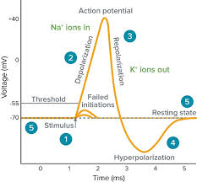

During depolarisation phase the negative membrane potential becomes less negative and reach 0 and then become positive.
During repolarisation Phase the membrane potential be restored to resting state -70mv.
Following repolarizing phase there may be ab after hyperpolarizing phase during which membrane potential temporarily becomes more negative than resting level.
Two types of Voltage-gated channels open and then close during an action potential (present mainly in axon plasma membrane and axon terminal).
Changes in ion flow through Voltage-gated channels during the depolarizing and repolarizing phases of an action potential.
- Resting State: All voltage gated Na+ and K+ channels are closed. The axon Plasma membrane is at resting membrane potential, small build-up of negative charges along inside surface of membrane and an equal build-up of positive charges along outside surface of membrane.
- Depolarizing Phase: When Membrane Potential of axon reaches threshold, the Na+ Channel activation gates open. As Na+ ions move through these channels into the neuron, a build-up of positive charges forms along inside surface of membrane and the membrane becomes depolarized.
- Repolarizing phase begins: Na+ Channel inactivation gates close and K+ Channels open. The membrane starts to become repolarized as some K+ ions leave the neuron and a few negative charges begin to build up along the inside surface of the membrane.
- Repolarization Phase Continues: K+ Outflow Continues. As more K+ ions leave the neuron, more negative charges build up along inside surface of membrane. K+ outflow eventually restores resting membrane potential. Na+ Channel activation gates close and inactivation gates open. Return to resting state when K+ gates close.
An action potential occur when depolarization reaches a certain level termed as threshold (about-55mv). Different neurons have different threshold.
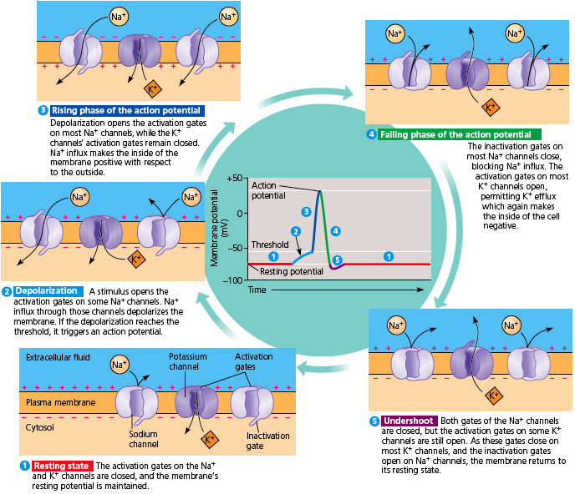

REFRACTORY PERIOD: After an action potential there is a short period of time when another action potential cannot be generated.
(OR)
Time taken for a neuron to recover after an action potential, during which another action potential cannot be regenerated (0.5-1msec).
Two types of refractory period
- Absolute refractory period
- Refractory Period

