HUMAN ANATOMY AND PHYSIOLOGY-II (Theory)
Subject code: BP201T
Class – 09

Cerebral Tracts
- The surface of the Cerebral Cortex is composed of grey matter (nerve cell bodies).
- Within the cerebrum the lobes are connected by masses of nerve fibres, or tracts, which make up the white matter of the brain.
- The afferent and efferent fibres linking the different parts of the brain and spinal cord are:
- Association (arcuate) tracts: which are most numerous and connect different parts of a cerebral hemisphere by extending from one gyrus to another, some of which are adjacent and distant.
- Commissural tracts: Which connect corresponding areas of the two cerebral hemispheres; the largest and most important commissure is the Corpus Callosum.
- Projection tracts: Which connect the cerebral cortex with grey matter of lower parts of the brain and with the spinal cord. E.g. Internal Capsule.
- The internal Capsule is an important projection tract that lies deep within the brain between the basal ganglia and the thalamus.
- Many nerve impulses passing to and from the cerebral cortex are carried by fibres that form the internal capsule.
- Motor fibres within the internal Capsule form the pyramidal tracts (Corticospinal tracts) that cross over (decussate) at the medulla oblongata and are the main pathway to skeletal muscles.
- Those motor fibres do not pass through the internal capsule form the extra pyramidal tracts and have connections with many parts of the brain, including the basal ganglia, thalamus and cerebellum.

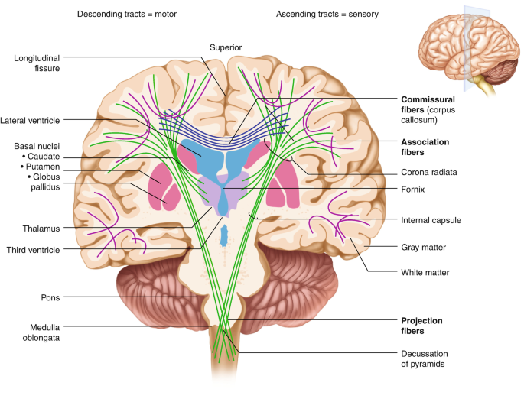
Basal Ganglia:
- Group of Cell bodies that lie deep within the brain and form part of the Extrapyramidal tracts.
- They act as relay stations with connections to many parts of the brain, including motor areas of the Cerebral Cortex and thalamus.
- Their functions include initiation and fine control of complex movement and learned coordinated activities, such as posture and walking.
- In addition, basal ganglia influence many aspects of cortical functions including memory, thinking, learning, problem solving, emotions, Consciousness etc.
- Basal ganglia disorders are Parkinson disease and schizophrenia.
- Two ganglia lateral to thalamus are Globus pallidus (closer to thalamus) and putamen (closer to cerebral cortex) – lentiform nucleus. Third basal ganglion is Caudate Nucleus, all together known as Corpus Striatum.
- If control is inadequate or absent, movements are jerky, clumsy and uncoordinated.

