HUMAN ANATOMY AND PHYSIOLOGY-II (Theory)
Subject code: BP201T
Class – 08
CENTRAL NERVOUS SYSTEM (Meninges)
- Central Nervous System Consists of the Brain and Spinal Cord.
- Those structures are both well protected from damage and injury.
- The brain is enclosed with in the skull and Spinal cord by the vertebrae that form the Spinal Column.

MENINGES:
- Brain and Spinal cord are completely surrounded by three layers of tissues called Meninges lying between Skull and the brain and between the Vertebral Foramina and the Spinal Cord.
- Named from outside to inwards:
Dura mater, Arachnoid mater, Pia mater.
- In brain, two Spaces are associated with the meninges:
- Subdural Space: this a potential Space that lies between the dura and arachnoid maters, and contains a Small amount of Serous fluid.
- Subarachnoid Space: this separates the arachnoid and pia maters and contain Cerebrospinal fluid (CSF).
- These continue into the Spinal Canal, which contains an additional space, Epidural space.

- Dura mater:
- Cerebral dura mater consists of two layers of dense fibrous tissue.
- Outer layer takes place of the periosteum on the inner surface of the Skull bones and the inner layer provides a protective covering for the brain.
- Two Dural layers around the brain are fused together except where they separate to enclose the Dural venous sinuses.
- Extensions of the dura mater separates parts of the brain
- Falx Cerebri, which separates the two cerebral hemispheres.
- Falx Cerebelli, which separates the two cerebellar hemispheres.
- Tentorium Cerebelli, which separates the cerebrum and the cerebellum.
- Venous Blood from the brain drains into Venous Sinuses between the two layers of dura mater.
- Superior sagittal sinus is formed by the falx cerebri, tentorium cerebelli forms the straight and transverse sinuses.
- Spinal dura mater forms a loose sheath round the Spinal cord, extending from the foramen magnum to the 2nd sacral vertebra.
- Therefore it encloses the filum terminale and fuses with the periosteum of the coccyx.
- It is an extension of the cerebral dura mater and is separated from the periosteum of the vertebrae and ligaments within the neural canal by the epidural space, containing blood vessels and areolar Connective tissue.
- Nerves entering and leaving the spinal cord pass through the epidural space.
- Dyes, used for diagnostic purposes, and local anaesthetics or analgesics to relieve pain may be injected into the epidural space.

- Arachnoid mater:
- This is a layer of fibrous tissue that lies between the dura and pia maters.
- The arachnoid mater passes over the Convolutions of the brain and accompanies the inner layer of dura mater in the formation of the falx cerebri, tentorium cerebelli and falx cerebelli.
- It continues downwards to envelop the spinal cord and ends by merging with the dura mater at the level of the 2nd sacral vertebra.

- Pia mater:
- This is a delicate layer of connective tissue containing many minute blood vessels.
- It adheres to the brain, completely covering the Convolutions and dipping into each fissure.
- It continues downwards, surrounding the spinal cord.
- Beyond, the end of the Cord it continues as the filum terminale, pierces the arachnoid tube and goes on with the dura mater, to fuse with the periosteum of the coccyx.

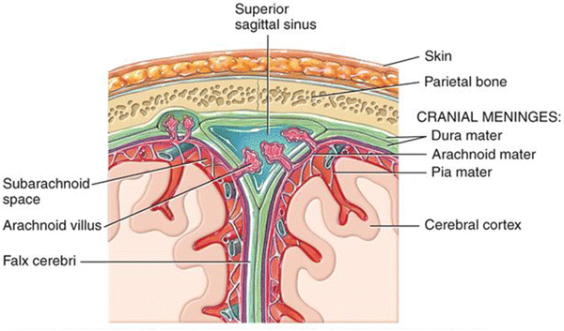
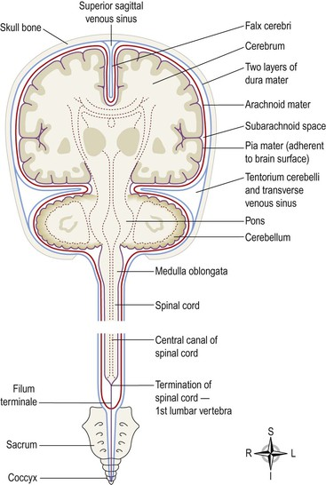

The Meninges: Frontal section of the brain

Ventricles of the brain:

The brain contains four irregular-shaped cavities or ventricles, containing CSF
They are the:
- Right and left lateral ventricles
- Third ventricle
- Fourth Ventricle

Lateral ventricles:
- These cavities lie within the cerebral hemispheres, one on each side of the median plane just below the corpus callosum.
- They are separated from each other by a thin membrane, the septum pellucidum, and are lined with ciliated epithelium.
- They communicate with the third ventricle by interventricular foramina.

Third ventricle:
- It is a cavity situated below the lateral ventricles between the two parts of the thalamus.
- It communicates with the fourth ventricle by a canal, the cerebral aqueduct.

Fourth ventricle:
- It is a diamond shaped cavity situated below and behind the third ventricle, between the cerebellum and pons.
- It continuous below with central canal of the spinal cord and communicates with the subarachnoid space by foramina in its roof.
- CSF enters the subarachnoid space through these openings.

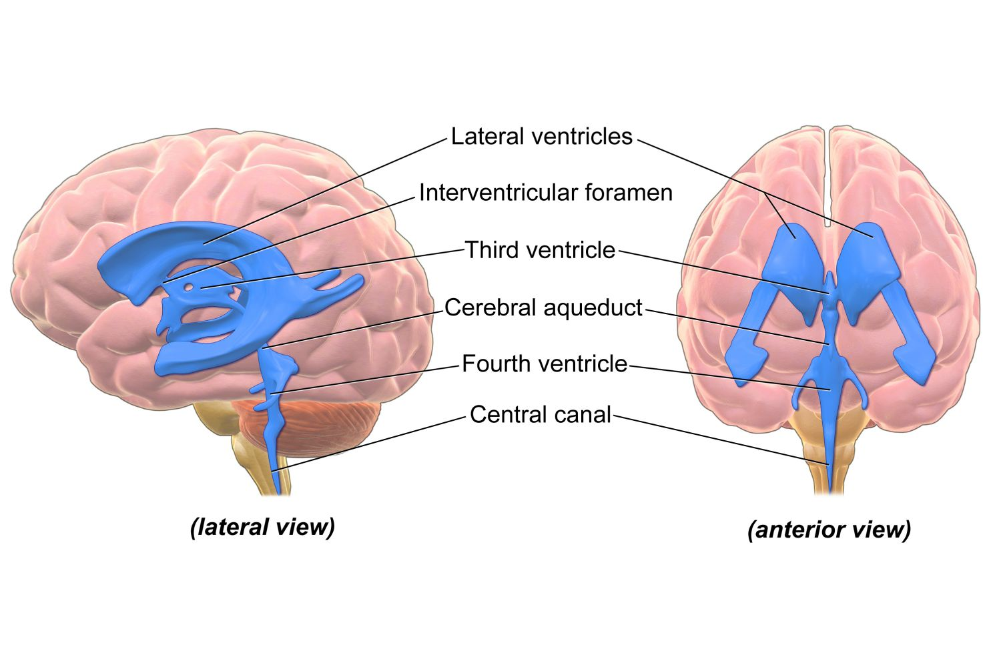

Cerebrospinal fluid
- CSF Circulates constantly from the ventricles through the subarachnoid space around the brain and spinal cord.
- It is a clear, slightly alkaline fluid with a specific gravity of 1.005, consisting of
- Water
- Mineral salts
- Glucose
- Plasma proteins
- A few leukocytes
- Small amounts of creatinine
- Small amounts of urea
- CSF is secreted into each ventricle of the brain by Choroid plexuses. These are vascular areas that are rich in blood vessels and surrounded by ependymal cells in the lining of ventricle walls.
- CSF passes back into the blood through tiny finger-like projections of arachnoid mater, called arachnoid villi (arachnoid granulations) which project into the venous sinuses.
- The movement of CSF from the sub arachnoid space to venous sinuses depends on the difference in pressure on each side of the walls of the arachnoid villi, which act as one-way valves.
- When CSF pressure is higher than venous pressure, CSF is pushed into the blood and when the venous pressure is higher, the arachnoid villi collapse, preventing the passage of blood constituents into the CSF.
- There may also be reabsorption of CSF by cells in the walls of the ventricles.
- From the roof of the fourth ventricle, CSF flows through foramina into the subarachnoid space and completely surrounds the brain and spinal cord.
- There is no discrete CSF pump, but its movement is aided by pulsating blood vessels, respiration and changes of posture.
- CSF is secreted continuously at a rate of about 0.5 mL per minute, i.e. 720 mL per day. The volume remains fairly constant at about 150 mL, as absorption keeps pace with secretion.
- CSF may be sampled by inserting a needle into the subarachnoid space above or below the 4th lumbar vertebra, which is about 2cm below the end of the spinal cord. This procedure is known as lumbar puncture,
- CSF pressure can be measured by attaching a vertical tube to the needle.
- If the brain is enlarged by, for example, haemorrhage or tumour, some compensation is made by a reduction in the amount of CSF.
- When the volume of brain tissue is reduced, such as in degeneration or atrophy, the volume of CSF is increased.

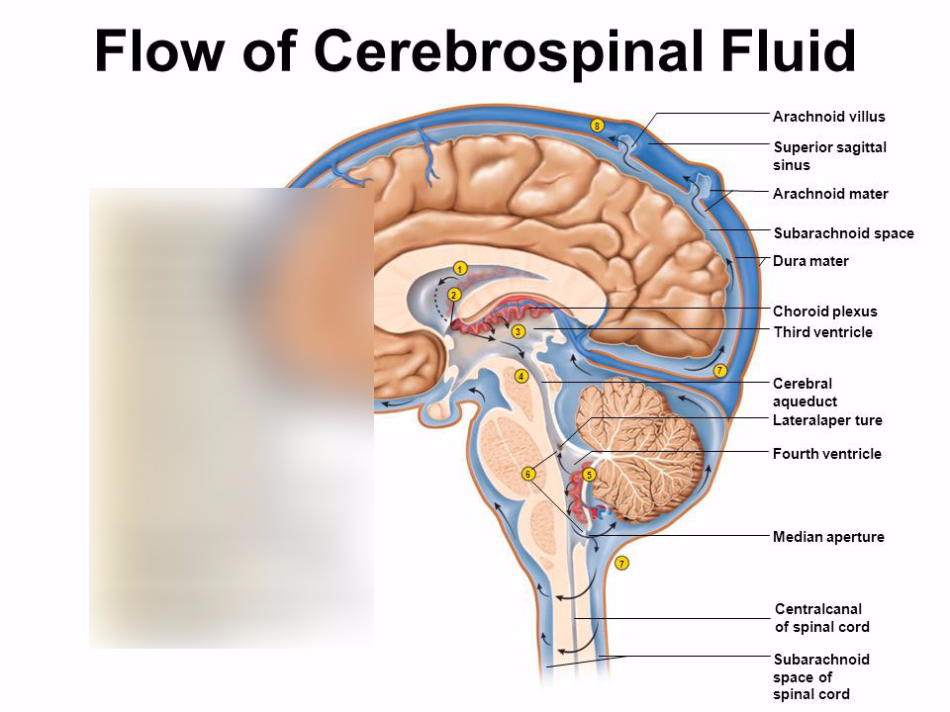
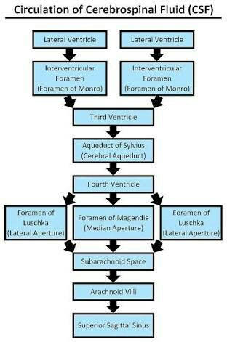

Functions of CSF:
- CSF protects the brain and spinal cord by maintaining a uniform pressure around these vital structures and by acting as a cushion or shock absorber between the brain and the skull.
- It keeps the brain and spinal cord moist and there may be a exchange of nutrients and waste products between CSF and the interstitial fluid of the brain.
- It is involved in regulation of breathing as it bathes the surface of the medulla where the chemoreceptors or central respiratory receptors are located.

