HUMAN ANATOMY AND PHYSIOLOGY-II (Theory)
Subject code: BP201T
Class – 06
SYNAPSES
- Synapse is a neuronal junction that facilitates the transmission of an electrical signal from one neuron to another or from a neuron to an effector cell such as muscle cell.
- Synapse are essential for Homeostasis because they allow information to filtered and integrated.
- At a Synapse between neurons, Neuron sending the signal is called presynaptic neuron. Neuron receiving the message is called postsynaptic neuron.
- The Synapses are of two types: (1) Electrical Synapses
(2) Chemical Synapses

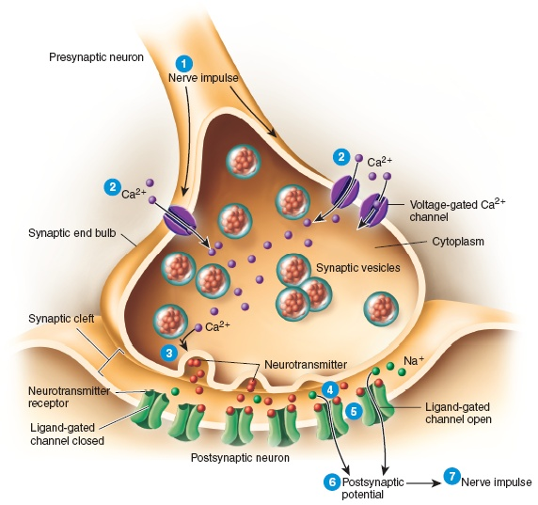

- Electrical Synapses:
- Action Potential (Impulse) Conduct directly between adjacent cells through structure called Gap Junctions.
- Each Gap Junction contain hundred or more tubular Connexions act like tunnels to connect Cytosol of two cells directly, as ions flow from one to next, the action potential spread from cell to cell.
- Gap junctions are Common in Smooth muscle, Cardiac muscle and Developing embryo, also occurs in neurons.
- Advantage: Faster Communication and synchronization

- Chemical Synapses:
- Plasma membrane of presynaptic and post synaptic are very close but do not touch separated by synaptic cleft filled with interstitial fluid.
- Nerve impulse cannot cross the synaptic cleft so an alternate or indirect form of communication occurs.
- In response to nerve impulse, Presynaptic Neuron release neurotransmitter diffuses through the fluid in the synaptic cleft and binds to receptors in plasma membrane of the post synaptic neurons.
- Post synaptic neuron receives a chemical signal and produce post synaptic potential.
- So, pre synaptic neuron converts an electrical signal (nerve impulse) into a chemical signal (released neurotransmitter).
- Post synaptic neuron receives chemical signal and generate electrical signal.
- The time required for these processes at a chemical synapse is synaptic delay of about 0.5msec, this is the reason due to which chemical synapses relay signals more slowly than electrical synapses.

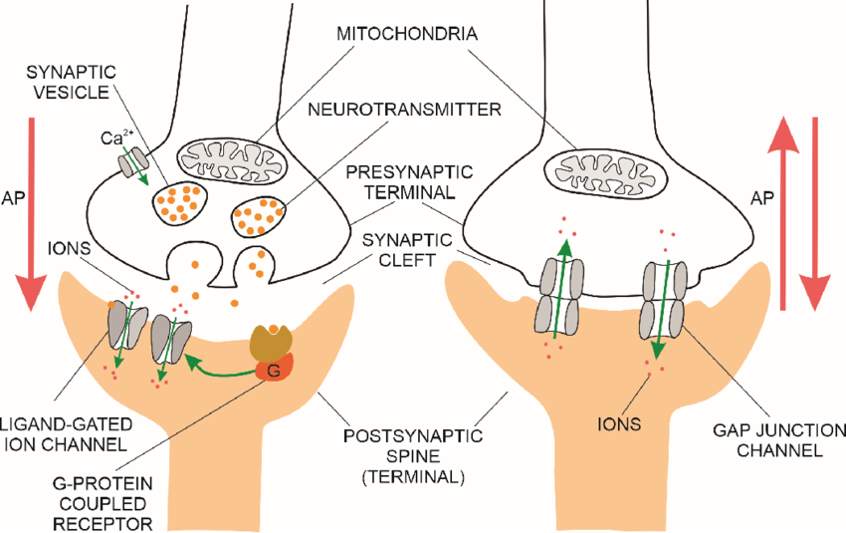

Chemical Synapses Electrical Synapses
NEUROTRANSMITERS

- Neurotransmitters are chemical messengers that transmit signals from neuron to target cell across synapse.
- Target cell may be a neuron or any kind of cell like muscle or gland cell.
- Neurotransmitters are packaged into synaptic vesicles of presynaptic neuron terminal.
- Neurotransmitters can be divided into two classes based on size
- Small molecule neurotransmitters
- Neuropeptides

- Small molecule neurotransmitters:

It includes Acetylcholine, Amino acids, Biogenic amines, ATP and other purines, Nitric oxide.

Acetylcholine:
- It is released by PNS Neurons and CNS Neurons.
- Ach has excitatory function at one synapse bind to ionotropic receptors and open cation channel (Na+).
- It shows inhibitory function at other synapse, bind to metabotropic receptors and open K+ Channel.
- An enzyme acetylcholinesterase inactivates Ach.

Amino acids:

- Several Amino acids are neurotransmitters present in CNS.
- Glutamate and aspartate are excitatory neurotransmitters
- Glycine and GABA are inhibitory neurotransmitters.

Biogenic amines:
- Certain Amino acids are modified and decarboxylated to produce biogenic amines.
- Biogenic amines that are prevalent in nervous system include norepinephrine, epinephrine, dopamine and serotonin.
- Norepinephrine plays role in arousal (awakening from deep sleep, dreaming and regulating mood).
- Small no.of neurons in brain use epinephrine.
- Brain neurons contain Neurotransmitter Dopamine active during emotional response, addictive behaviours and pleasurable experiences.
- Serotonin also known as 5-hydroxytryptamine (5-HT) involved in sensory perception, temperature regulation, Control of mood, Appetite and induction of sleep.

ATP and other Purines:
- The adenosine portion (Ring structure) of ATP is called purine ring.
- ATP, ADP and AMP are excitatory neurotransmitter in both CNS and PNS.
- Most of synaptic vesicles contain ATP and also neurotransmitter.
- In PNS, ATP and norepinephrine released together from some sympathetic neurons.
- Some Parasympathetic neurons release ATP and Acetylcholine.

Nitric Oxide:
- The enzyme Nitric oxide synthase (NOS) Catalyses formation of NO from amino acid arginine.
- 2% of neurons in brain produces NO.
- Unlike other neurotransmitter NO is not Synthesized in advance (not packaged into Synaptic Vesicles), it formed on demand and act immediately.
- Some research suggest that NO plays a role in memory and learning (In large quantity NO is highly toxic).

- Neuropeptides:
- Neurotransmitter consisting of 3 to 40 amino acids linked by Peptide bonds called Neuropeptides.
- Neuropeptides are numerous and widespread in both CNS and PNS.
- Neuropeptides bind to Metabotropic receptors and have excitatory and inhibitory action.
- Neuropeptides are formed in the Neuron cell body and are packed into vesicles, transported to axon terminal.

Substance-P:
- Found in Sensory Neurons, Spinal Cord and part of brain associated with pain. Enhances perception of pain.
- Substance P Caused pain through a process known as nociception.
- A nociceptor is a sensory neuron or nerve cell that reacts to potentially damaging stimuli by signalling the spinal cord and brain.

Enkephalins:
- An enkephalin is a pentapeptide involved in regulating nociception (pain sensation) in the body.
- Inhibit Pain impulses by supressing release of substance-p, may have role in memory and learning, control of body temperature, Sexual activity and mental illness (Depression, Schizophrenia).

Endorphins:
- Inhibit pain by blocking release of Substance-P.

Dynorphins:
Controlling pain and emotions.
NEUROTRANSMITTER RECEPTORS
- The neurotransmitter released from a presynaptic neuron bind to neurotransmitter receptors on plasma membrane of a post synaptic cell.
- Each neurotransmitter receptor has one or more neurotransmitter binding sites, where its specific neurotransmitter binds.
- When neurotransmitter binds to specific neurotransmitter binding site on receptor, an ion channel open and a post synaptic potential (Either an Excitatory post synaptic potential or inhibitory post synaptic potential) form on membrane of post synaptic cell.
- Neurotransmitter receptors classified as of two types: 1) Ionotropic Receptors
2) Metabotropic Receptors

- IONOTROPIC RECEPTORS: (Ligand Gated Channel)

- An ionotropic receptor contains a neurotransmitter binding site and an ion channel present on same protein.
- When Specific neurotransmitter binds to receptor then the ion channel open and EPSP or IPSP occurs in postsynaptic cell.
- EPSP results from opening of Cation Channels like Na+, K+ and Ca2+. So inside of post synaptic cells becomes less negative (depolarized).
- So Excitatory neurotransmitters binds to ionotropic receptors that contain cation channels.
- Many inhibitory neurotransmitters binds to ionotropic receptors that contains chloride (Cl-) channel.
- Inhibitory post synaptic potential (IPSPs) result from opening of Cl- Channel, then large number of Chloride ions (Cl-) diffuse inward and becomes more negative (hyperpolarization).

- METABOTROPIC RECEPTORS : (G-Protein Coupled Receptors)

- These receptors contain neurotransmitter binding site but lack an ion channel as part of its structure.
- So metabotropic receptors coupled with separate ion channel by a type of membrane protein called G-Protein.
- When a neurotransmitter binds to metabotropic receptor, then G-Protein either directly open channel or act indirectly by activating other molecule “Second Messenger” in cytosol which open ion Channel.
- Inhibitory Neurotransmitter bind to metabotropic receptors that link to K+ Channels

