HUMAN ANATOMY AND PHYSIOLOGY-II (Theory)
Subject code: BP201T
Class – 02
NEUROGLIAL CELLS
The neurons of the CNS are supported by non-excitable glial cells. It is non-neural cells (It is not a part of neuron or doesn’t make a neuron structure). It is present near neurones in CNS or PNS. Unlike nerve cells, which cannot divide, glial cells continue to replicate throughout life.
- It maintain homeostasis
- It helps to form Myelin sheath
- It provides support to Neurones
- It provide protection to neuron

Functions of Neuroglial cells
- To surrounds neurones & hold them in place.
- To supply Nutrients & oxygen to neurones.
- To destroy pathogen & remove dead neurones.

Types of Neuroglial cells
There are six types of Neuroglial cells
Astrocytes
Oligodendrocytes } these four cells present in CNS
Ependymal Cells
Microglia
Satellite Cells } PNS
Schwann Cells
In CNS :
Astrocytes: These cells are the most abundant neuroglia. They are star shaped with fine branching processes and they lie in a mucopolysaccharide ground substance. At the free ends of the some of the processes there are small swellings called foot processes. These are found in large numbers adjacent to blood vessels, with their foot processes forming a sleeve round them. This means that the blood is separated from the neurones by the capillary wall and a layer of Astrocyte foot processes, which together constitute the Blood-brain barrier.
The blood-brain barrier is a selective barrier that protects the brain from potentially toxic substances and chemical variations in the blood, e.g. after a meal. Oxygen, carbon dioxide, glucose and other lipid-soluble substances, such as alcohol, quickly cross the barrier into the brain. Some large molecules, many drugs, inorganic ions and amino acids pass more slowly or do not pass at all from the blood to the brain.
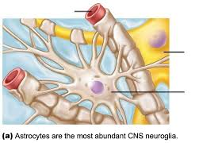
There are two types of Astrocytes
Protoplasmic Astrocytes: Many short branching processes found in gray matter.
Fibrous Astrocytes: Many long branching processes found in white matter.
Oligodendrocytes: These cells are smaller than astrocytes. They are found in clusters round nerve cell bodies in grey matter and are located adjacent to and along the length of myelinated nerve fibres. These cells are responsible for the forming and maintaining the myelin sheath around CNS Myelinated axons.
Myelin sheath is a multilayerd lipid and protein covering around some axons that insulate them and increases the speed of nerve impulse conduction.

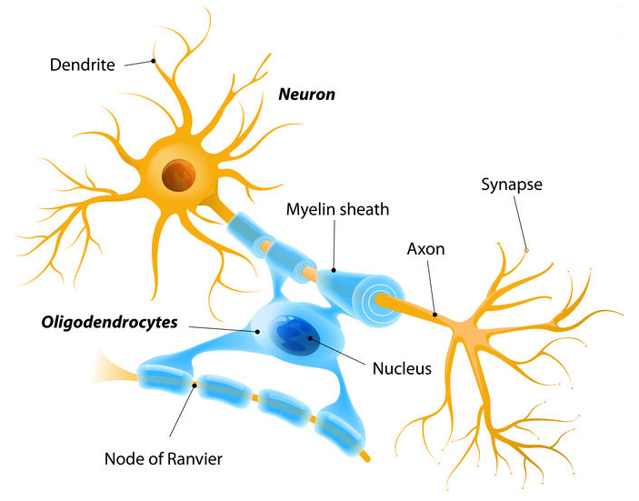

Microglia: The smallest and numerous glial cells, these cells are derived from monocytes that migrate from blood into the nervous system before birth. They are dispersed throughout the brain. They migrate and become phagocytic, removing microbes and damaged tissue, in areas of inflammation and cell destruction.

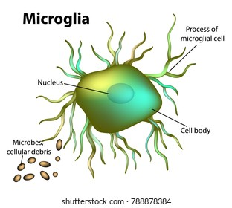

Ependymal Cells: These cells are cuboidal or columnar cells arranged in single layer has microvilli and cilia.
These cells form the epithelial lining of the ventricles of the brain and the central canal of the spinal cord. Those cells that form the Choroid plexuses of the ventricles Secrete Cerebrospinal Fluid (CSF). Functionally ependymal cells Monitor and assist in circulation of CSF and also form blood-cerebrospinal fluid barrier.

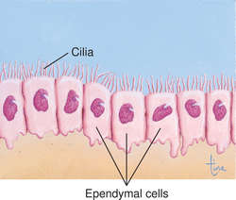

In PNS:
- Satellite cells:
- Surround neuron cell bodies in ganglia.
- Regulate neurotransmitter levels.
- Provides structural support to cell bodies of neurons.
- Schwann cells :
- Myelinate neurons in PNS.
- Maintenance and regeneration of neurons after injury,

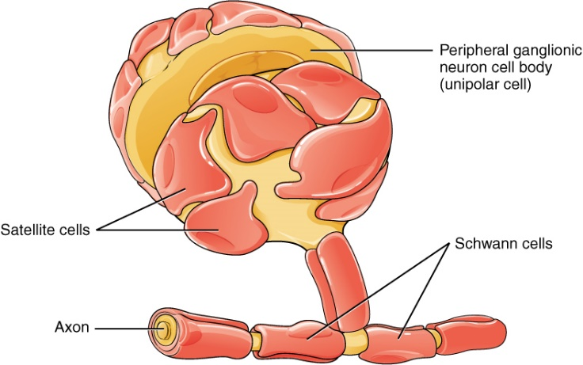

Neuroglial Damage:
- Astrocytes: When these cells are damaged, their processes multiply, forming a mesh or scar, which inhibits the regrowth of damaged CNS Neurones.
- Oligodendrocytes: These cells increase in number around degenerating neurones and are destroyed in demyelinating diseases such as multiple Sclerosis.
- Microglia: Where there is inflammation and cell destruction the microglia are activated and migrate to the site of damage, where they become phagocytic. For example, multiple Sclerosis, Alzheimer’s disease and stroke.

