HUMAN ANATOMY AND PHYSIOLOGY-II (Theory)
Subject code: BP201T
Class – 12
Brain stem
- Brain stem is the part of the brain between the spinal cord and the diencephalon.
Midbrain:
- It is situated around the cerebral aqueduct between the cerebrum above and the pons below.
- It consists of nuclei and nerve fibres (tracts), which connect the cerebrum with lower parts of the brain and with the spinal cord.
- The nuclei act as relay stations for the ascending and descending nerve fibres and have important roles in auditory and visual reflexes.
- Anterior part of mid brain contains paired bundles of axons known as cerebral peduncles consists of axons of Cortico spinal, Cortico pontine and Cortico bulbar tracts.
- That conduct nerve impulses from motor areas in cerebral cortex to spinal cord, pons and medulla respectively and also sensory neurons from medulla to thalamus.
- Posterior part of midbrain is called tectum contain four rounded elevations (nuclei)
- Superior Colliculi-2: Coordinate movement of eyeballs in response to visual or other stimuli.
- Inferior Colliculi-2: Coordinate movement of hand and trunk in response to auditory stimuli.

- Other nuclei include left and right substantia nigra containing dopamine releasing neurons which help in control subconscious muscle activity.
- Left and right red nuclei function with cerebellum and coordinate muscle movements.
- Still other nuclei in midbrain are associated with 2 pairs of cranial nerves i.e.; Oculomotor (III), Trochlear (IV) nerve.

Pons:
- It is situated in front of the cerebellum, below the mid brain and above the medulla oblongata.
- It consists mainly of nerve fibres (white matter) that forms a bridge between the two hemispheres of the cerebellum.
- It processes information from several of the cranial nerves, including the 5th cranial nerve (Sensory information from the face, scalp. mouth and nose, and motor control of chewing) and 8th cranial nerve (hearing and balance).
- The pons contain the Pneumotaxic area that operates in conjunction with the respiratory centre in the medulla oblongata to control respiration.
- The anatomical structure of the pons is opposite to that of the cerebrum, in that the cell bodies (grey matter) lie deeply and the nerve fibres are on the surface.
Medulla Oblongata:
- The medulla oblongata or simply the medulla is the most inferior region of the brain stem.
- Extending from the pons above, it is continuous with the spinal cord below. It is about 2.5 cm long and lies just within the cranium, above the foramen magnum.
- Its anterior and posterior surfaces are marked by central fissures. The outer aspect is composed of white matter, which passes between the brain and spinal cord, and grey matter which lies centrally.
- Some medullary nerves relay information from the special senses of hearing and balance to higher centres in the brain.
- The vital centres, consisting of groups of cell bodies (nuclei) associated with autonomic reflex activity, lies in its deeper structure.
- Cardiovascular centre, respiratory centre, reflex centres of vomiting, coughing, sneezing and swallowing.
- The medulla oblongata has several special features.

Decussation (crossing )of the pyramids
- In the medulla, motor nerves descending from the motor area in the cerebrum to the spinal cord in the pyramidal (corticospinal tracts) cross from one side to the other. This means that the left hemisphere of the cerebrum controls the right half of the body and vice versa. These tracts are the main pathways to skeletal (Voluntary) Muscles.

Sensory Decussation
- Some of the sensory nerves ascending to the cerebrum from the spinal cord cross from one side to the other in the medulla. Others decussate lower down in the spinal cord.

Cardiovascular Centre
- CVC Controls blood pressure and the rate and force of cardiac contraction. Within the CVC, other groups of nerve cells forming the vasomotor centre control the diameter of the blood vessels, especially the small arteries and arterioles.
- The vasomotor centre is stimulated by the arterial baroreceptors, body temperature cause vasoconstriction, although severe pain may cause vasodilation, a fall in blood pressure and fainting.

Respiratory centre

- This area controls the rate and depth of respiration. From here, nerve impulses pass to the phrenic and intercostal nerves, which stimulate contraction of the diaphragm and intercostal muscles, thus initiating inspiration. It functions in close association with the pneumotaxic area in the pons.

Reflex centres
- Irritants in the stomach or respiratory tract stimulate the medulla oblongata, activating the reflex centres. Vomiting, coughing and sneezing are protective reflexes that attempt to expel irritants.

Reticular formation:
- It is a collection of neurones in the core of the brain stem, surrounded by numerous and diffuse neural pathways that conduct ascending and descending nerve impulses between the brain and spinal cord.
- It has a vast number of synaptic links with other parts of the brain and is therefore constantly receiving information being transmitted in ascending and descending tracts.

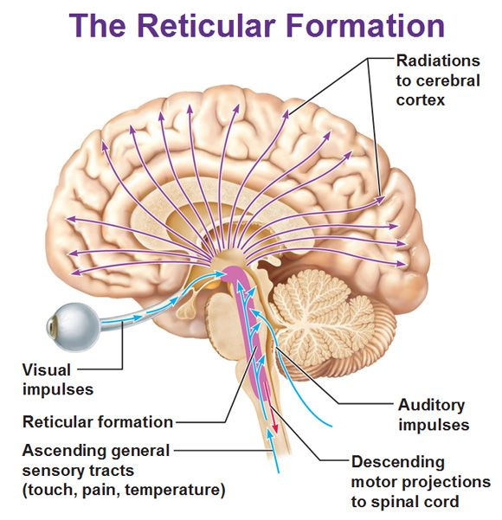
- Reticular activating system
- RAS consists of areas within the reticular formation that, when activated, bring about increased stimulation of the cerebral cortex, accompanied by arousal and increased alertness, although the mechanisms involved are poorly understood.
- The RAS also mediates selective awareness, meaning that it selectively blocks or permits transmission of sensory information to the cerebral cortex.
- E.g the slightest noise made by a sick child moving in bed may arouse a sleeping mother but the noise of regularly passing trains does not disturb her.

Cerebellum:
- It is situated behind the pons and immediately below the posterior portion of the cerebrum occupying the posterior cranial fossa.
- It is ovoid in shape and has two hemispheres, separated by a narrow median strip called the vermis.
- Grey matter forms the surface of the cerebellum, and the white matter lies deeply.

Functions:
- It controls and coordinates the movements of various groups of skeletal muscles, ensuring smooth, even and precise actions.
- Cerebellar activity is not under voluntary control.
- It coordinates activities associated with the maintenance of posture, balance and equilibrium.
- The sensory input for these functions is derived from the muscles, joints, eyes and ears.
- Proprioceptor impulses from the stretch receptors in the muscles and joints indicate their position in relation to the body as a whole, the eyes and the semicircular canals in the ears provide information about the position of the head in space,
- The cerebellum integrates this information and regulates skeletal muscle activity so that balance and posture are maintained.
- The cerebellum may also have a role in learning and language processing.
- Damage to the cerebellum results in clumsy, uncoordinated muscular movement, staggering gait and inability to carry out smooth, steady and precise movements.

