HUMAN ANATOMY AND PHYSIOLOGY-II (Theory)
Subject code: BP201T
Class – 10
FUNCTIONS OF THE CEREBRAL CORTEX
There are three main types of activity associated with the cerebral cortex:
- Higher-order functions, e.g. Language, memory, sense of responsibility, thinking, reasoning, moral decision making and learning.
- Sensory perception, including the perception of pain, temperature, touch, sight, hearing, taste and smell.
- Initiation and control of Skeletal muscle contraction and therefore voluntary movement.

FUNCTIONAL AREAS OF THE CEREBRAL CORTEX

There are different types of functional area:
- Motor, which direct skeletal (Voluntary) muscle movements.
- Sensory, which receive and decode sensory impulses, enabling sensory perception.
- Association, which are concerned with integration and processing of complex mental functions such as intelligence, memory, reasoning, judgement and emotions.
- In general, areas of the cortex lying anterior to the Central sulcus are associated with motor functions, and those lying posterior to it are associated with sensory functions.

MOTOR AREAS OF THE CEREBRAL CORTEX
Primary motor area
- This lies in the Frontal lobe, immediately anterior to the central sulcus. The cell bodies are pyramid shaped and they control skeletal muscle activity.
- Two neurones are involved in the pathway to skeletal muscle.
- The first, upper motor neurone, descends from the motor cortex through the internal capsule to the medulla oblongata. Here it crosses to the opposite side and descends in the spinal cord.
- At the appropriate level in the spinal cord it synapses with a second neurone (lower motor neurone), which leaves the spinal cord and travels to the target muscle.
- It terminates at the motor-end-plate of muscle fibre. This means that the motor area of the right hemisphere of the cerebrum controls voluntary muscle movement on the left side of the body and vice versa.
- Damage to either of these neurones may result in paralysis.

Motor Speech (Broca’s) area
This is situated in the frontal lobe just above the lateral sulcus and controls the muscle movement needed for speech. It is dominant in the left hemisphere in right-handed people and vice-versa.

Sensory areas of the cerebral Cortex
Somatosensory area:
- This is the area immediately behind the central sulcus, where sensations of pain, temperature, pressure and touch, awareness of muscular movement and the position of joints (proprioception) are perceived.
- The Somatosensory areas of the right hemisphere receives impulses from the left side of the body and vice versa.
- The size of the cortical areas representing different parts of the body is proportional to the extent of sensory innervation.
- E.g. the larger area for the face is Consistent with the Extensive area for the face is consistent with the extensive sensory nerve supply by the three branches of the trigeminal nerves (5th Cranial Nerves)

Auditory (hearing) area:
- This lies immediately below the Lateral sulcus with in the temporal lobe. The nerve Cell receive and interpret impulses transmitted from the inner ear by the cochlear (Auditory) part of the Vestibulocochlear Nerves (8th Cranial Nerves).

Olfactory (Smell) area:
- This lies deep within the temporal lobe, where impulses from the olfactory epithelium of the nose, transmitted via the olfactory nerves (1st Cranial nerves), are received and interpreted.
Taste area:
- This lies just above the lateral sulcus in the deep layers of the somatosensory area. Here, impulses from sensory receptors in taste buds are received and perceived as taste.

Visual area:
- This lies behind the parieto-occipital Sulcus and includes the greater part of the occipital lobe. The optic nerve (2nd Cranial Nerves) pass from the eye to this area, which receives and interprets the impulses as visual impressions.

Association areas:
These are connected to each other and other areas of the cerebral cortex by association tracts. They receive, coordinate and interpret impulses from the sensory and motor cortices, permitting higher cognitive abilities.

Premotor area:
This lies in frontal lobe, immediately anterior to the motor area. The neurones here coordinate movement initiated by the primary motor cortex, ensuring that learned patterns of movement can be repeated. For e.g in tying a shoelace or writing, many muscles contract but the movements must be coordinated and carried out in a particular sequence.

Prefrontal area:
This extends anteriorly from the premotor area to include the remainder of the frontal lobe. It is a large area and is more highly developed in humans than in other animals. Intellectual functions controlled here include perception and comprehension of the passage of time, the ability to anticipate consequences of events and the normal management of emotions.

Sensory speech (Wernicke’s area):
This is situated in the temporal lobe, adjacent to the parieto-occipital area. It is here that language, both written and spoken, is perceived, and comprehension and intelligence are based. Understanding language is central to higher mental functions, as they are language-based. This area is dominant in the left hemisphere in right handed people and vice-versa.

Parieto-occipital area:
This lies behind the somatosensory area and includes most of the parietal-lobe (including Wernicke’s area). Its functions are thought to include spatial awareness, interpretation of language and the ability to name objects.

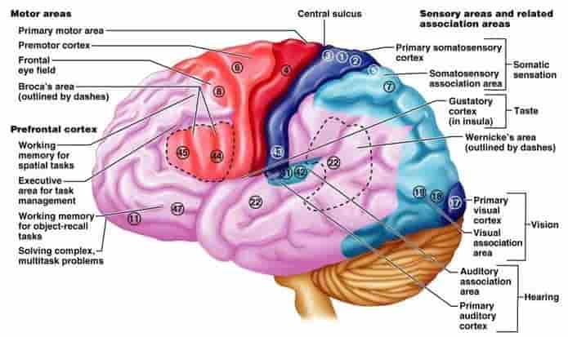

Functional areas of the cerebral cortex

