KETONE BODIES
The compounds namely acetone, aceto-acetate and Beta-hydroxybutyrate (or 3-hydroxy-butyrate) are known as ketone bodies (Fig.14.10). Only the first two are true ketones while Beta-hydroxybutyrate does not possess a keto (C O) group. Ketone bodies are water-soluble and energy yielding. Acetone, however, is an exception, since it cannot be metabolized
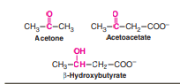

Ketogenesis :
The synthesis of ketone bodies occurs in the liver.
The enzymes for ketone body synthesis are located in the mitochondrial matrix. Acetyl CoA, formed by oxidation of fatty acids, pyruvate or some amino acids, is the precursor for ketone bodies. Ketogenesis occurs through the following reactions (Fig.14.11).
1. Two moles of acetyl CoA condense to form acetoacetyl CoA. This reaction is catalysed by thiolase, an enzyme involved in the final step of Beta-oxidation. Hence, acetoacetate synthesis is appropriately regarded as the reversal of thiolase reaction of fatty acid oxidation.
2. Acetoacetyl CoA combines with another molecule of acetyl CoA to produce beta-hydroxy beta-methyl glutaryl CoA (HMG CoA). HMG CoA synthase, catalysing this reaction, regulates the synthesis of ketone bodies.
3. HMG CoA lyase cleaves HMG CoA to produce acetoacetate and acetyl CoA.
4. Acetoacetate can undergo spontaneous decarboxylation to form acetone.
5. Acetoacetate can be reduced by a dehydrogenease to E-hydroxybutyrate. The carbon skeleton of some amino acids (ketogenic) is degraded to acetoacetate or acetyl CoA and, therefore, to ketone bodies, e.g. leucine, lysine, phenylalanine etc.

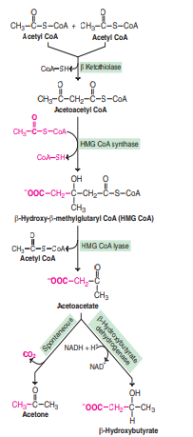

Utilization of ketone bodies:
The ketone bodies, being water-soluble, are easily transported from the liver to various tissues.
The two ketone bodies ,acetoacetate and Beta-hydroxybutyrate serve as important Structures of ketone bodies. Synthesis of ketone bodies (ketogenesis).
sources of energy for the peripheral tissues such as skeletal muscle, cardiac muscle, renal cortex etc. The tissues which lack mitochondria (e.g. erythrocytes) however, cannot utilize ketobodies. The production of ketone bodies and their utilization become more significant when glucose is in short supply to the tissues, as observed in starvation, and diabetes mellitus.
During prolonged starvation, ketone bodies are the major fuel source for the brain and other parts of central nervous system. It should be noted that the ability of the brain to utilize fatty acids for energy is very limited. The ketone bodies can meet 50-70% of the brain’s energy needs.

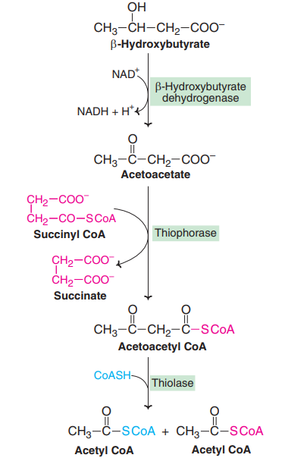
(Metabolism (utilization) of ketone bodies to acetyl CoA.)

Ketoacidosis:
Both acetoacetate and E-hydroxybutyrate are strong acids. Increase in their concentration in blood would cause acidosis. The carboxyl group has a pKa around 4.
Therefore, the ketone bodies in the blood dissociate and release H+ ions which lower the pH. Diabetic ketoacidosis is dangerous—may result in coma, and even death, if not treated.
Ketosis due to starvation is not usually accompanied by ketoacidosis. Treatment of ketoacidosis : Rapid treatment of diabetic ketoacidosis is required to correct the metabolic abnormalities and the associated water and electrolyte imbalance. Administration of insulin is necessary to stimulate uptake of glucose by tissues and inhibition of ketogenesis

