HUMAN ANATOMY AND PHYSIOLOGY-II (Theory)
Subject code: BP201T
Class – 01
NERVOUS SYSTEM
The nervous system is very important in helping to maintain the homeostasis (balance) of the human body. It control and coordinate the human body and it gives the immediate response or quick response to our body. It is also responsible for our Perceptions, behaviours and memories and initiates all Voluntary movements.
The branch of medical science that deals with the normal functioning and disorders of nervous system is called Neurology.

Organization of the Nervous System:

- With a mass of only 2 kg, about 3% of total body weight.
- Nervous System is one of the smallest system in the 11 body system but they control the other 10 body systems.
- The nervous system is complex, highly organized network of billions of neurons and even more neuroglia,
- The skull encloses brain which contains about 100 billion neurons.
- 12 pairs of Cranial nerves (I- XII) emerge from the base of the brain.
- A nerve is a bundle of 100-1000 of axons associated connective tissue and blood vessels that lies outside the brain and spinal cord. Each nerve follows a defined path and serves special region of the body.
E,g Cranial nerve I carries signals from about sense of smell to the brain.

- The spinal cord connects to the brain through Foramen magnum of skull and is encircled by bones of Vertebral Column. ( contain about 100 millions of neurons)
- 31 pairs of spinal nerves emerge from Spinal cord. Each serve a special region on right or left side of the body.
- Ganglia are small masses of nervous tissue consisting mainly of neuron cell bodies that are located outside the brain and spinal cord. ( Ganglia are closely associated with cranial and spinal nerves)
- Enteric plexus is extensive network of neurons located in the walls of organs of gastrointestinal tract help to regulate the digestive system.
- Sensory receptor is the dendrites of sensory organs as well as separate specialized cells that monitor changes in internal or external environment (photoreceptor in retina).

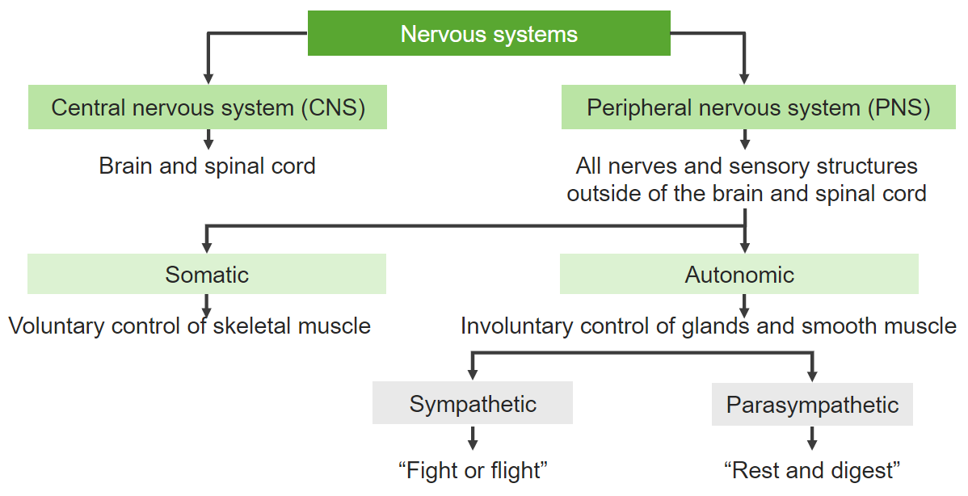Nervous System is divided into two parts:
- Central nervous system which is main system of our body which consists of Brain and Spinal Cord.
- Brain which occupies Cranial Cavity
- Spinal cord which occupies Vertebral canal

- Peripheral Nervous system which consists of all nerves lies outside of the brain

- Sensory Nervous System in which impulse or information goes to brain from peripheral nervous system in our body.

- Motor Nervous System It is the response of our CNS to our peripheral Nervous System

- Somatic Nervous System
i) For Voluntary action
ii) It consists of Sensory neurons that conducts impulses from somatic and special receptors to the CNS and motor neurons from the CNS to skeletal muscles.

e.g.; Hand movements, walking etc. which we can do by him or herself.

- Autonomic Nervous System
i) For Involuntary action
ii) It consists of Sensory neurons. From motor neurons that convey impulses from CNS to Smooth muscle tissue, Cardiac muscle tissue and glands
E.g. Breathing, digestion, heart rate etc.

- Sympathetic Nervous System It activates the fight or flight response during a threat or perceived danger. It decrease digestion rate and increase heart rate etc.

- Parasympathetic Nervous system restores the body to a state of calm. It increase digestion rate and normal heart rate etc.

FUNCTIONS OF THE NERVOUS SYSTEM
- The nervous system perform Complex tasks it allows us to sense various smell, produce speech and remember past events.
- It also provides signals that control body movements and regulate operations of internal organs.
- These diverse activities can be grouped into three basic functions.
- Sensory Functions: Sensory receptors detect internal stimuli such as increase in blood acidity, external stimuli such as rain drop landing on arm. This sensory information then carried into brain and spinal cord through cranial and spinal nerves.
- Integrative Functions: Nervous system integrate (processes) sensory information by analysing and storing some of its and by making decisions for appropriate responses. An important integrative function is Perception (Conscious awareness of sensory stimuli it occurs in brain).
- Motor Functions: Once sensory information is integrated the nervous system elicit an appropriate motor response by activating effectors (muscles and glands) through cranial and spinal nerves. Stimulation of effectors causes muscle to contact and glands to secrete.

Nervous system consists of two Specific type of cells i.e; neurons and neuroglial Cells

Neurons are the conducting cells and neuroglial cells are the Supporting cells

Neurons (Nerve Cells): Each Neurone consists of Cell body, one Axon and many dendrites. Neurones are commonly referred to as nerve cells, because they are highly specialized cells of nervous system which can detect, receive and transmit different kinds of stimulus.

Neurons Possess electrical excitability (the ability to respond to a stimulus and convert it into a stimulus).

Stimulus: A stimulus is any change in the environment that is internally or externally in our body.

Action Potential (Nerve Impulse): It is an electrical signal that propagates along the surface of the membrane of neuron.
It begins and travels due to the movement of ions (such as Na+ & K+) between intestinal fluid and inside neurons through special ion channels in its plasma membrane.

Nerve impulses travel at speed ranging from 0.5 to 130 meters per second.

Some neurons are tiny and propagates impulses over a short distance (less than 1mm) within the CNS

Parts of neuron

- Cell Body: It is also called Perikaryon or Soma. It is Main processing centre of the cell. It consists of Nucleus and Organelles but absent of centrioles. It produce grey matter of nervous tissue and it has high metabolic rate. It also have extension of dendrites.

- Dendrites: These are thin branching extensions of the cell body that conduct nerve impulse towards the body. The plasma membrane of dendrites contains numerous receptors site for binding Chemical messenger from other cell.
Their cytoplasm contains Nissle bodies, mitochondria and other organelles.

- Axon: It is the extension of the cell body, single branch which conduct nerve impulses away from the Cell body. It is also called Nerve fibres.
Axon is a long, Cylindrical Projection that joins to the cell body at a cone shape structure called Axon Hillock and action potential is also generated in Axon hillock. Plasma membrane of an axon is called axolemma which is covered by Schwann cells. Schwann cell is just outside of axolemma and it gives protection to the axon. And next layer which is protective layer that is Myelin sheath it is made of fatty material of Schwann cell. Myelin sheath insulate the message which is inside the axon, provides safety.

Axon Terminal or Telodendrite: At the end of an axon, there is a so-called axon terminal that is button-like and is responsible for providing synapses between neurons. The axon terminal contains specialized chemicals called neurotransmitters that are initially contained inside the synaptic vesicles.

Nodes of Ranvier are gaps in the myelin sheath coating on the neural axon. The myelin allows the electrical impulse to move quickly down the axon. The nodes of Ranvier allow for ions to diffuse in and out of the neuron, propagating the electrical signal down the axon.

Distal branched ends of axon, which are swollen called synaptic Knob. Function: It has synaptic secretory vesicles which produces neurotransmitters.

A tract is a collection of nerve fibers (axons) in the central nervous system. A nerve is a collection of nerve fibers (axons) in the peripheral nervous system.

Ganglia are clustered nerve cells located in the PNS while nuclei are those clustered nerve cells that are located in the CNS.

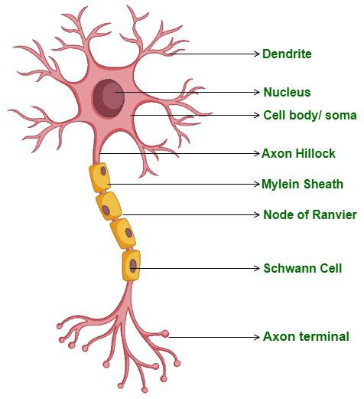

Classification of neurons:
- Structural Classification:
- Unipolar Neuron: They have dendrites and one axon they are fused together to form continuous process that emerges from the cell body.
Dendrites of most unipolar neurons functions as sensory receptors that detect a sensory stimulus such as touch, pressure, pain or temperature.

- Bipolar Neuron: They have one main dendrite and one axon.
They are found in retina of eye, Inner ear, olfactory area of brain (to smell).

- Multipolar Neurons: They usually have several dendrites and one axon.
Most neurons in the brain and spinal cord are of this type.

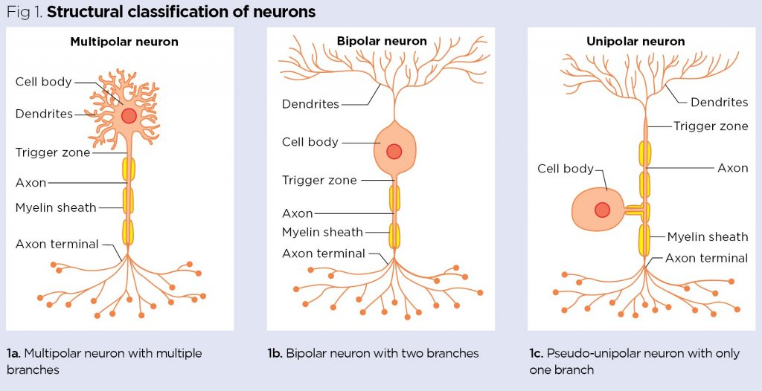

- Functional Classification:

- Sensory or afferent neurons: These neurons either contain sensory receptor at their dendrites or are located just after sensory receptors that are separate cells.
Once an appropriate stimulus activates a sensory receptor, sensory neuron forms an action potential in its axon and action potential is conveyed into CNS through cranial and spinal Nerves.

- Motor or efferent Neurons: They convey action potential away from CNS to effector organs.
- Interneurons or Association Neurons: Mainly located within the CNS between sensory and motor neurons
Interneurons integrate (process) incoming sensory information then elicit a motor response by activating appropriate motor neuron.

