Environmental science

NATURAL RESOURCES

- Life in planet earth depends upon on a variety of goods and services provided by the nature , which are known as natural resources
- The word resource means a source of supply. The natural resources include water, air, soil, minerals, coal, forests, crops and wildlife are examples.
- Natural resources are naturally occurring substances that are considered valuable in their relatively unmodified (natural) form.
- A natural resource’s value rests in the amount of the material available and the demand for it. The term was introduced to a broad audience by E.F. Schumacher in his 1970s book Small is Beautiful.

PREREQUISITE DISCUSSIONS

The main problem associated with natural resources is unequal consumption. A major part of natural resources are consumed in the developed‘ world. The developing nations‘ also over use many resources because of their greater human population. However, the consumption of resources per capita (per individual) of the developed countries is up to 50 times greater than in most developing countries. Advanced countries produce over 75% of global industrial waste and greenhouse gases. Energy from fossil fuels consumed in relatively much greater quantities in developed countries. Their per capita consumption of food too is much greater as well as their waste.
The USA for example with just 4% of the world‘s population consumes about 25% of the world‘s resources. Producing animal food for human consumption requires more land than growing crops. Thus countries that are highly dependent on non-vegetarian diets need much larger areas for pastureland than those where the people are mainly vegetarian. Our natural resources can be compared with money in bank. If we use it rapidly the capital will be reduced to zero. On the other hand if we use only the interest, it can sustain us over the longer term. This is called sustainable utilization or development. The quality of human life and the quality of ecosystems on earth are indicators of the sustainable use of resources. There are clear indicators of sustainable lifestyles in human life. The natural reserves are stock supply, which man utilizes for sustenance and welfare.

The natural resources are of two kinds

- Renewable resources: which are inexhaustive and can be regenerated within a given span of time. e.g. forest, wildlife, wind energy, biomass energy tidal energy hydropower etc.
- Non-renewable resources: which cannot be regenerated e.g. fossil fuels like coal , petroleum, minerals etc. Once we exhaust these reserves the same cannot be replenished
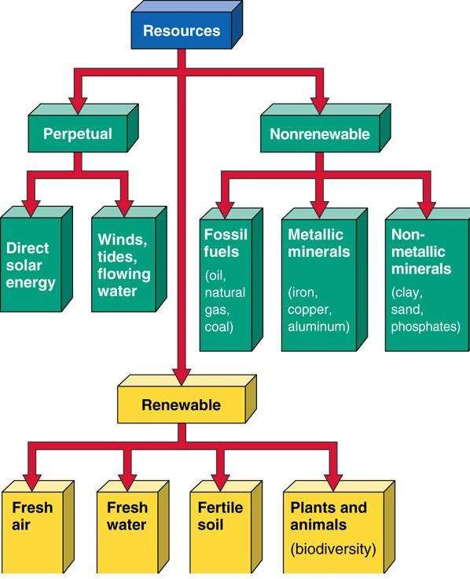

Non-renewable resources

- These are minerals that have been formed in the lithosphere over millions of years and constitute a closed system
- These non-renewable resources, once used, remain on earth in a different form and unless recycled become waste material
- Non-renewable resources include fossil fuels such as oil and coal, which if extracted at the present rate, will soon be totally used up. End products of fossil fuels are in the form of heat and mechanical energy and chemical compounds, which cannot be reconstituted as a resource
- Resource that exists in a fixed amount (stock) in various places in the earth's crust and has the potential for renewal by geological, physical, and chemical processes taking place over hundreds of millions to billions of years.
- Energy, metals, and other minerals. Examples are copper, aluminum, iron, salt, clay, coal, and oil.
- Any potentially renewable resource can become non-renewable if used improperly
- Theoretically, never exhaust due to economic feasibility for extracting.

Renewable resources

- Though water and biological living resources are considered renewable, they are in fact renewable only within certain limits
- They are linked to natural cycles such as the water cycle
- Fresh water (even after being used) is evaporated by the sun’s energy, forms water vapour and is reformed in clouds and falls to earth as rain
- Water sources are heavily polluted by sewage and toxic substances that it becomes impossible to use the water
- Forests, once destroyed take thousands of years to re-grow into fully developed natural ecosystems with their full complement of species
- Fish are today being over-harvested until the catch has become a fraction of the original resource and the fish are incapable of breeding successfully to replenish the population
- Output of agricultural land if mismanaged drops drastically
- When the population of a species of plant or animal is reduced by human activities, until it cannot reproduce fast enough to maintain a viable number, the species becomes extinct
- Many species are probably becoming extinct without us even knowing, and other linked species are affected by their loss

Natural Resources and Associated Problems
Human population is growing day-by-day. Continuous increase in population caused an increasing demand for natural resources. Due to urban expansion, electricity need and industrialization, man started utilizing natural resources at a much larger scale. Non-renewable resources are limited. They cannot be replaced easily. After some time, these resources may come to an end. It is a matter of much concern and ensures a balance between population growth and utilization of resources. This overutilization creates many problems. In some regions there 7 are problems of water logging due to over irrigation. In some areas, there is no sufficient water for industry and agriculture. Thus, there is need for conservation of natural resources.

There are many problems associated with natural resources:

Forest resources and associated problems
- Use and over-exploitation.
- Deforestation.
- Timber extraction.
- Mining and its effects on forest.
- Dams and their effects on forests and tribal people

