dHUMAN ANATOMY AND PHYSIOLOGY-II (Theory)
Subject code: BP201T
Class – 8
CONTROL OF RESPIRATION
Effective control of respiration enables the body to regulate blood gas levels over a wide range of physiological, environmental and pathological conditions, and is normally involuntary. Voluntary control is exerted during activities such as speaking and singing but is overridden if blood CO2 rises (hypercapnia).
The respiratory centre
This is formed by groups of nerves in the medulla, the respiratory rhythmicity centre, which control the respiratory pattern, i.e. the rate and depth of breathing. Regular discharge of inspiratory neurones within this centre set the rate and depth of breathing. Activity of the respiratory rhythmicity centre is adjusted by nerves in the pons (the pneumotaxic centre and the apneustic centre), in response to input from other parts of the brain.
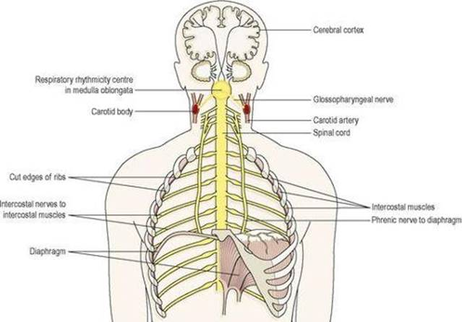

Some of the structures involved in control of respiration.

Motor impulses leaving the respiratory centre pass in the phrenic and intercostal nerves to the diaphragm and intercostal muscles respectively.
Chemoreceptors
These are receptors that respond to changes in the partial pressures of oxygen and carbon dioxide in the blood and cerebrospinal fluid. They are located centrally and peripherally.
Central chemoreceptors
These are located on the surface of the medulla oblongata and are bathed in cerebrospinal fluid. When arterial PCO2 rises (hypercapnia), even slightly, the central chemoreceptors respond by stimulating the respiratory centre, increasing ventilation of the lungs and reducing arterial PCO2. The sensitivity of the central chemoreceptors to raised arterial PCO2 is the most important factor in controlling normal blood gas levels. A small reduction in PO2 (hypoxaemia) has the same, but less pronounced effect, but a substantial reduction depresses breathing.
Peripheral chemoreceptors
These are situated in the arch of the aorta and in the carotid bodies. They are more sensitive to small rises in arterial PCO2 than to small decreases in arterial PO2 levels. Nerve impulses, generated in the peripheral chemoreceptors, are conveyed by the glossopharyngeal and vagus nerves to the medulla and stimulate the respiratory centre. The rate and depth of breathing are then increased. An increase in blood acidity (decreased pH or raised [H+]) stimulates the peripheral chemoreceptors, resulting in increased ventilation, increased CO2 excretion and increased blood pH.
Exercise and respiration
Physical exercise increases both the rate and depth of respiration to supply the increased oxygen requirements of the exercising muscles. Exercising muscles produces higher quantities of CO2, which stimulates central and peripheral chemoreceptors. The increased respiratory effort persists even after exercise stops, in order to supply enough oxygen to repay the ‘oxygen debt’. This represents mainly the oxygen needed to get rid of wastes, including lactic acid.
Other factors that influence respiration
Breathing may be modified by the higher centres in the brain by:
Speech, singing
Emotional displays, e.g. crying, laughing, fear
Drugs, e.g. sedatives, alcohol sleep.
Temperature influences breathing. In fever, respiration is increased due to increased metabolic rate, while in hypothermia it is depressed, as is metabolism. Temporary changes in respiration occur in swallowing, sneezing and coughing.
The Hering–Breuer reflex prevents overinflation of the lungs. Stretch receptors in the lung, linked to the respiratory centre by the vagus nerve, inhibit respiration when lung volume approaches maximum.

