CHOLESTEROL BIOSYNTHESIS
About 1 g of cholesterol is synthesized per day in adults. Almost all the tissues of the body participate in cholesterol biosynthesis. The largest contribution is made by liver (50%), intestine (15%), skin, adrenal cortex, reproductive tissue etc.
The enzymes involved in cholesterol synthesis are found in the cytosol and microsomal fractions of the cell. Acetate of acetyl CoA provides all the carbon atoms in cholesterol.
The reducing equivalents are supplied by NADPH while ATP provides energy. For the production of one mole of cholesterol, 18 moles of acetyl CoA, 36 moles of ATP and 16 moles of NADPH are required.
The synthesis of cholesterol may be learnt in 5 stages
1. Synthesis of HMG CoA
2. Formation of mevalonate (6C)
3. Production of isoprenoid units (5C)
4. Synthesis of squalene (30C)
5. Conversion of squalene to cholesterol.

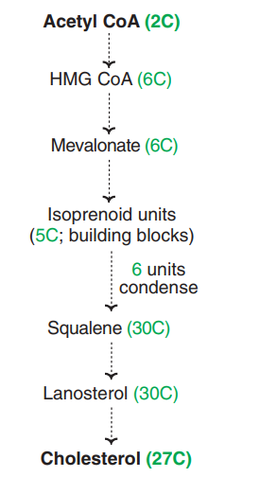
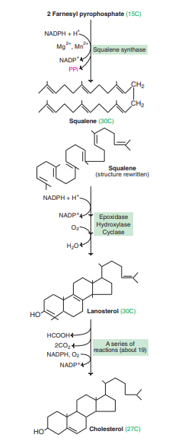
Functions of cholesterol:
Cholesterol is essential to life, as it performs a number of important functions
1. It is a structural component of cell membrane.
2. Cholesterol is the precursor for the synthesis of all other steroids in the body. These include steroid hormones, vitamin D and bile acids.
3. It is an essential ingredient in the structure of lipoproteins in which form the lipids in the body are transported.
4. Fatty acids are transported to liver as cholesteryl esters for oxidation.
DEGRADATION OF CHOLESTEROL :
The steroid nucleus (ring structure) of the cholesterol cannot be metabolized in humans. Cholesterol (50%) is converted to bile acids, excreted in feces, serves as a precursor for the synthesis of steroid hormones, vitamin D, coprostanol and cholestanol. The latter two are the fecal sterols, besides cholesterol.
- Synthesis of bile acids

The bile acids possess 24 carbon atoms, 2 or 3 hydroxyl groups in the steroid nucleus and a side chain ending in carboxyl group. The bile acids are amphipathic in nature since they possess both polar and non-polar groups. They serve as emulsifying agents in the intestine and actively participate in the digestion and absorption of lipids.
The synthesis of primary bile acids takes place in the liver and involves a series of reactions. The step catalysed by 7 alpha-hydroxylase is inhibited by bile acids and this is the rate limiting reaction. Cholic acid and chenodeoxycholic acid are the primary bile acids and the former is found in the largest amount in bile. On conjugation with glycine or taurine, conjugated bile acids (glycocholic acid, taurocholic acid etc.) are formed which are more efficient in their function as surfactants. In the bile, the conjugated bile acids exist as sodium and potassium salts which are known as bile salts.
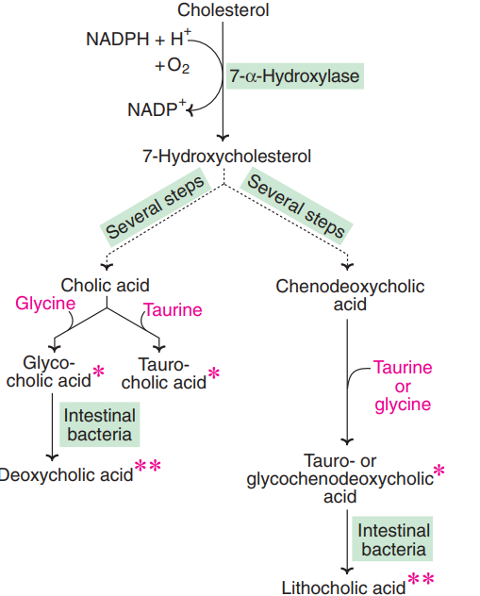

Synthesis of steroid hormones from cholesterol
Cholesterol is the precursor for the synthesis of all the five classes of steroid hormones (a) Glucocorticoids (e.g. cortisol) (b) Mineralocorticoids (e.g. aldosterone) (c) Progestins (e.g. progesterone) (d) Androgens (e.g. testosterone) (e) Estrogens (e.g. estradiol). A brief outline of steroid hormonal synthesis and more details are discussed under ‘Hormones
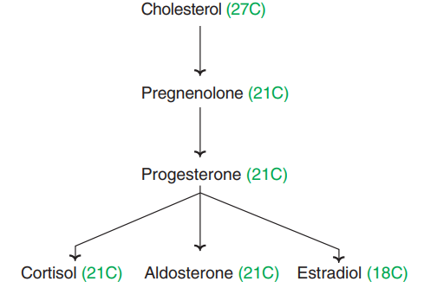

Synthesis of vitamin D

7-Dehydrocholesterol, an intermediate in the synthesis of cholesterol, is converted to chole-calciferol (vitamin D3) by ultraviolet rays in the skin. A brief summary of prominent sources and the major pathways for utilization of cholesterol with the liver as the central metabolic organ .

