CATABOLISM OF PHENYLALANINE AND TYROSINE

Phenylalanine (Phe, F) and tyrosine (Tyr, Y) are structurally related aromatic amino acids. Phenylalanine is an essential amino acid while tyrosine is non-essential. Besides its incorporation into proteins, the only function of phenylalanine is its conversion to tyrosine. For this reason, ingestion of tyrosine can reduce the dietary requirement of phenylalanine. This phenomenon is referred to as ‘sparing action’ of tyrosine on phenylalanine.
The predominant metabolism of phenylalanine occurs through tyrosine. Tyrosine is incorporated into proteins and is involved in the synthesis of a variety of biologically important compounds epinephrine, norepinephrine, dopamine (catecholamines), thyroid hormones and the pigment melanin.
Conversion of phenylalanine to tyrosine
Under normal circumstances, the degradation of phenylalanine mostly occurs through tyrosine. Phenylalanine is hydroxylated at para-position by phenylalanine hydroxylase to produce tyrosine (p-hydroxy phenylalanine). This is an irreversible reaction and requires the participation of a specific coenzyme biopterin containing pteridine ring) which is structurally related to folate.
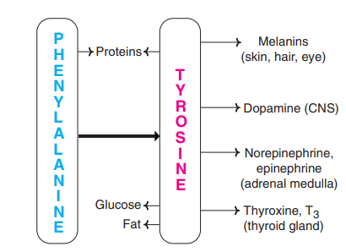
The active form of biopterin is tetrahydrobiopterin (H4-biopterin). In the phenylalanine hydroxylase reaction, tetrahydrobiopterin is oxidized to dihydrobiopterin (H2-biopterin). Tetrahydrobiopterin is then regenerated by an NADPH-dependent dihydrobiopterin
The enzyme phenylalanine hydroxylase is present in the liver. In the conversion of phenylalanine to tyrosine, the reaction involves the incorporation of one atom of molecular oxygen (O2) into the para position of phenylalanine while the other atom of O2 is reduced to form water. It is the tetrahydrobiopterin that supplies the reducing equivalents which, in turn, are provided by NADPH. Due to a defect in phenylalanine hydroxylase, the conversion of phenylalanine to tyrosine is blocked resulting in the disorder phenylketonuria (PKU).

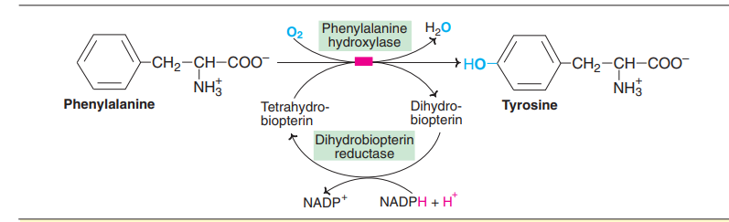Synthesis of tyrosine from phenylalanine

DEGRADATION OF TYROSINE (PHENYLALANINE):
The metabolism of phenylalanine and tyrosine is considered together. The sequence of the reactions in the degradation of these amino acids is described hereunder
1. As phenylalanine is converted to tyrosine, a single pathway is responsible for the degradation of both these amino acids, which occurs mostly in liver.
2. Tyrosine first undergoes transamination to give p-hydroxyphenylpyruvate. This reaction is catalysed by tyrosine transaminase (PLP dependent).
3. p-Hydroxyphenylpyruvate hydroxylase (or dioxygenase) is a copper-containing enzyme. It catalyses oxidative decarboxylation as well as hydroxylation of the phenyl ring of p-hydroxyphenylpyruvate to produce homogentisate. This reaction involves a shift in hydroxyl group from para position to meta position, and incorporates a new hydroxyl group at para position. This step in tyrosine metabolism requires ascorbic acid.
4. Homogentisate oxidase (iron metalloprotein) cleaves the benzene ring of homogentisate to form 4-maleylacetoacetate. Molecular oxygen is required for this reaction to break the aromatic ring.
5. Maleylacetoacetate undergoes isomerization to form 4-fumaryl acetoacetate and this reaction is catalysed by maleylacetoacetate isomerase.
6. Fumaryl acetoacetase (fumaryl acetoacetate hydrolase) brings about the hydrolysis of fumaryl acetoacetate to liberate fumarate and acetoacetate. Fumarate is an intermediate of citric acid cycle and can also serve as precursor for gluconeogenesis. Acetoacetate is a ketone body from which fat can be synthesized. Phenylalanine and tyrosine are, therefore, both glucogenic and ketogenic.
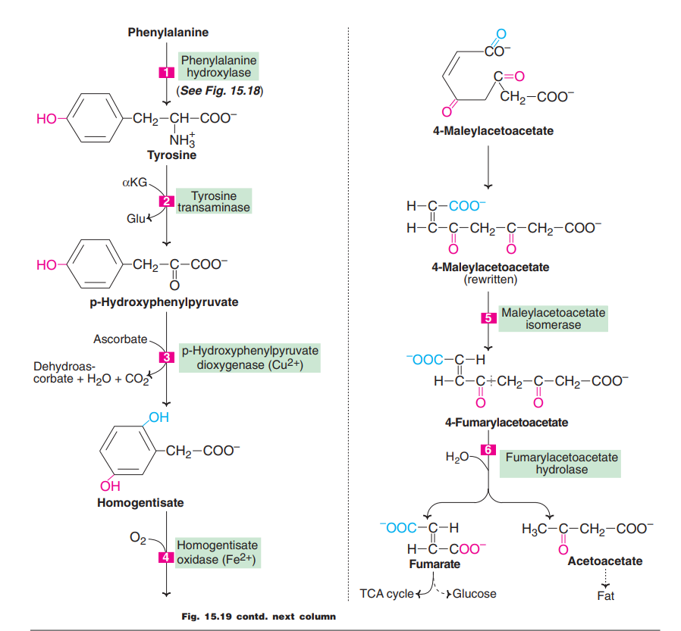Tyrosine metabolism—degradative pathway

