BIOSYNTHESIS OF FATTY ACIDS

- The dietary carbohydrates and amino acids, when consumed in excess, can be converted to fatty acids and stored as triacylglycerols.
- De novo (new) synthesis of fatty acids occurs predominantly in liver, kidney, adipose tissue and lactating mammary glands.
- The enzyme machinery for fatty acid production is located in the cytosomal fraction of the cell
The fatty acid synthesis may be learnt in 3 stages
- Production of acetyl CoA and NADPH
- Conversion of acetyl CoA to malonyl CoA
- Reactions of fatty acid synthase complex.

- Production of acetyl CoA and NADPH Acetyl :

CoA and NADPH are the prerequisites for fatty acid synthesis. Acetyl CoA is produced in the mitochondria by the oxidation of pyruvate and fatty acids, degradation of carbon skeleton of certain amino acids, and from ketone bodies. Mitochondria, however, are not permeable to acetyl CoA. An alternate or a bypass arrangement is made for the transfer of acetyl CoA to cytosol. Acetyl CoA condenses with oxaloacetate in mitochondria to form citrate. Citrate is freely transported to cytosol where it is cleaved by citrate lyase to liberate acetyl CoA and oxaloacetate. Oxaloacetate in the cytosol is converted to malate .
Malic enzyme converts malate to pyruvate. NADPH and CO2 are generated in this reaction. Both of them are utilized for fatty acid synthesis.
Advantages of coupled transport of acetyl CoA and NADPH : The transport of acetyl CoA from mitochondria to cytosol is coupled with the cytosomal production of NADPH and CO2 which is highly advantageous to the cell for optimum synthesis of fatty acids.
II.Formation of malonyl CoA:
Acetyl CoA is carboxylated to malonyl CoA by the enzyme acetyl CoA carboxylase . This is an ATP-dependent reaction and requires biotin for CO2 fixation. The mechanism of action of acetyl CoA carboxylase is similar to that of pyruvate carboxylase . Acetyl CoA carboxylase is a regulatory enzyme in fatty acid synthesis .
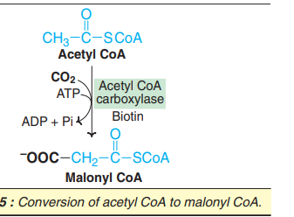

- Reactions of fatty acid synthase complex:

The remaining reactions of fatty acid synthesis are catalysed by a multifunctional enzyme known as fatty acid synthase (FAS) complex. In eukaryotic cells, including man, the fatty acid synthase exists as a dimer with two identical units. Each monomer possesses the activities of seven different enzymes and an acyl carrier protein (ACP) bound to 4c-phosphopantetheine. Fatty acid synthase functions as a single unit catalysing all the seven reactions. Dissociation of the synthase complex results in loss of the enzyme activities. In the lower organisms (prokaryotes), the fatty acid synthesis is carried out by a multienzyme complex in association with a separate acyl carrier protein. This is in contrast to eukaryotes where ACP is a part of fatty acid synthase. The sequence of reactions of the extra— mitochondrial synthesis of fatty acids (palmitate).

- The two carbon fragment of acetyl CoA is transferred to ACP of fatty acid synthase, catalysed by the enzyme, acetyl CoA-ACP transacylase. The acetyl unit is then transferred from ACP to cysteine residue of the enzyme. Thus ACP site falls vacant.
- The enzyme malonyl CoA-ACP transacylase transfers malonate from malonyl CoA to bind to ACP.
- The acetyl unit attached to cysteine is transferred to malonyl group (bound to ACP). The malonyl moiety loses CO2 which was added by acetyl CoA carboxylase. Thus, CO2 is never incorporated into fatty acid carbon chain. The decarboxylation is accompanied by loss of free energy which allows the reaction to proceed forward. This reaction is catalyzed by E-ketoacyl ACP synthase.
- Beta-Ketoacyl ACP reductase reduces ketoacyl group to hydroxyacyl group. The reducing equivalents are supplied by NADPH.
- Beta-Hydroxyacyl ACP undergoes dehydration. A molecule of water is eliminated and a double bond is introduced between D and E carbons.
- A second NADPH-dependent reduction, catalysed by enoyl-ACP reductase occurs to produce acyl-ACP. The four-carbon unit attached to ACP is butyryl group. The carbon chain attached to ACP is transferred to cysteine residue and the reactions 2-6 are repeated 6 more times. Each time, the fatty acid chain is lengthened by a two-carbon unit (obtained from malonyl CoA). At the end of 7 cycles, the fatty acid synthesis is complete and a 16-carbon fully saturated fatty acid—namely palmitate—bound to ACP is produced.
- The enzyme palmitoyl thioesterase separates palmitate from fatty acid synthase. This completes the synthesis of palmitate.

Summary of palmitate synthesis:

16 carbons present in palmitate, only two come from acetyl CoA directly. The remaining 14 are from malonyl CoA which, in turn, is produced by acetyl CoA. The overall reaction of palmitate synthesis is summarized 8 Acetyl CoA + 7 ATP + 14 NADPH + 14 H+ o Palmitate + 8 CoA + 7 ADP + 7 Pi + 6H2O

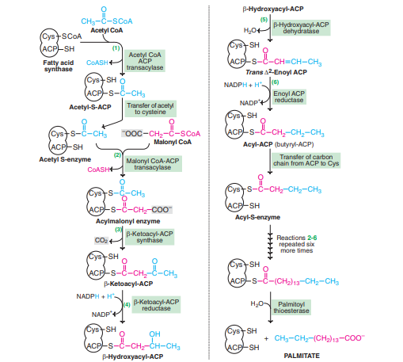
Biosynthesis of long chain fatty acid-palmitate

