BIOSYNTHESIS OF PURINE RIBONUCLEOTIDES
Many compounds contribute to the purine ring of the nucleotides.
1. N1 of purine is derived from amino group of aspartate.
2. C2 and C8 arise from formate of N10- formyl THF.
3. N3 and N9 are obtained from amide group of glutamine.
4. C4, C5 and N7 are contributed by glycine. 5. C6 directly comes from CO2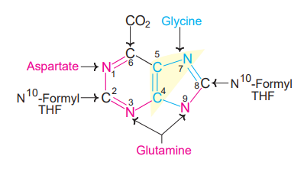
The purines are built upon a pre-existing ribose 5-phosphate. Liver is the major site for purine nucleotide synthesis. Erythrocytes, polymorphonuclear leukocytes and brain cannot produce purines.
The pathway for the synthesis of inosine monophosphate (IMP or inosinic acid), the ‘parent’ purine nucleotide. The reactions are briefly described in the next column.
1. Ribose 5-phosphate, produced in the hexose monophosphate shunt of carbohydrate metabolism is the starting material for purine nucleotide synthesis. It reacts with ATP to form phosphoribosyl pyrophosphate (PRPP).
2. Glutamine transfers its amide nitrogen to PRPP to replace pyrophosphate and produce 5-phosphoribosylamine. The enzyme PRPP glutamyl amidotransferase is controlled by feedback inhibition of nucleotides (IMP, AMP and GMP). This reaction is the ‘committed step’ in purine nucleotide biosynthesis.
3. Phosphoribosylamine reacts with glycine in the presence of ATP to form glycinamide ribosyl 5-phosphate or glycinamide ribotide (GAR).
4. N10-Formyl tetrahydrofolate donates the formyl group and the product formed is formylglycinamide ribosyl 5-phosphate.
5. Glutamine transfers the second amido amino group to produce formylglycinamidine ribosyl 5-phosphate.
6. The imidazole ring of the purine is closed in an ATP dependent reaction to yield 5-aminoimidazole ribosyl 5-phosphate.
7. Incorporation of CO2 (carboxylation) occurs to yield aminoimidazole carboxylate ribosyl 5-phosphate. This reaction does not require the vitamin biotin and/or ATP which is the case with most of the carboxylation reactions.
8. Aspartate condenses with the product in reaction 7 to form aminoimidazole 4-succinyl carboxamide ribosyl 5-phosphate.
9. Adenosuccinate lyase cleaves off fumarate and only the amino group of aspartate is retained to yield aminoimidazole 4-carboxamide ribosyl 5-phosphate.
10. N10-Formyl tetrahydrofolate donates a one-carbon moiety to produce formamino-imidazole 4-carboxamide ribosyl 5-phosphate. With this reaction, all the carbon and nitrogen atoms of purine ring are contributed by the respective sources.
11. The final reaction catalysed by cyclo-hydrolase leads to ring closure with an elimination of water molecule. The product obtained is inosine monophosphate (IMP), the parent purine nucleotide from which other purine nucleotides can be synthesized.
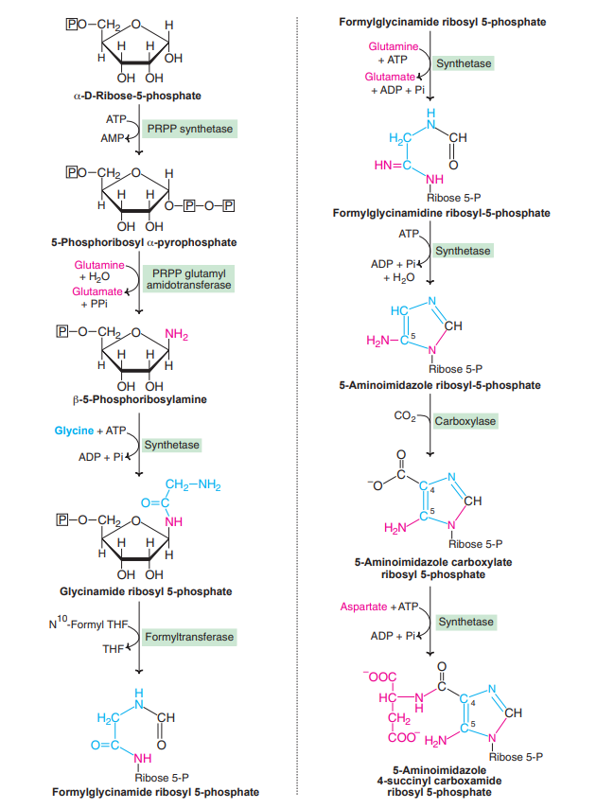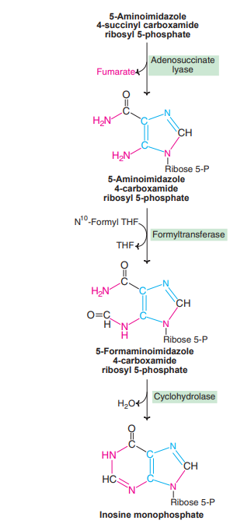

DEGRADATION OF PURINE NUCLEOTIDES:
The end product of purine metabolism in humans is uric acid. The sequence of reactions in purine nucleotide degradation.
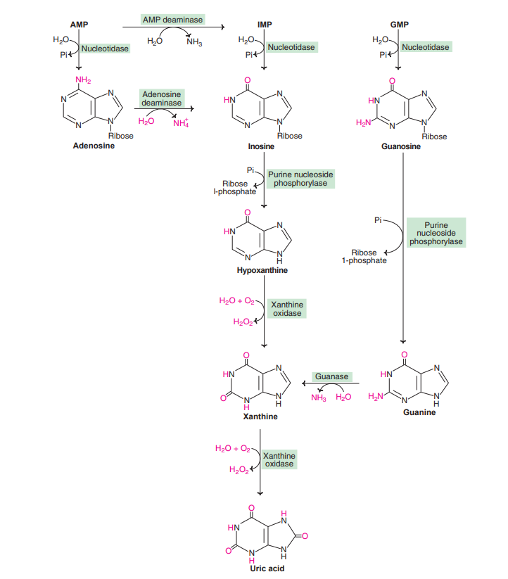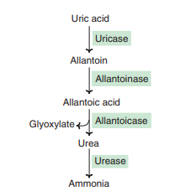
1. The nucleotide monophosphates (AMP, IMP and GMP) are converted to their respective nucleoside forms (adenosine, inosine and guanosine) by the action of nucleotidase. 2. The amino group, either from AMP or adenosine, can be removed to produce IMP or inosine, respectively. 3. Inosine and guanosine are, respectively, converted to hypoxanthine and guanine (purine bases) by purine nucleoside phosphorylase. Adenosine is not degraded by this enzyme, hence it has to be converted to inosine. 4. Guanine undergoes deamination by guanase to form xanthine. 5. Xanthine oxidase is an important enzyme that converts hypoxanthine to xanthine, and xanthine to uric acid. This enzyme contains FAD, molybdenum and iron, and is exclusively found in liver and small intestine. Xanthine oxidase liberates H2O2 which is harmful to the tissues. Catalase cleaves H2O2 to H2O and
O2.
DISORDERS OF PURINE METABOLISM:
Hyperuricemia and gout Uric acid is the end product of purine metabolism in humans. The normal concentration of uric acid in the serum of adults is in the range of 3-7 mg/dl. In women, it is slightly lower (by about 1 mg) than in men. The daily excretion of uric acid is about 500-700 mg. Hyperuricemia refers to an elevation in the serum uric acid concentration. This is sometimes associated with increased uric acid excretion (uricosuria). Gout is a metabolic disease associated with overproduction of uric acid. At the physiological pH, uric acid is found in a more soluble form as sodium urate. In severe hyperuricemia, crystals of sodium urate get deposited in the soft tissues, particularly in the joints. Such deposits are commonly known as tophi. This causes inflammation in the joints resulting in a painful gouty arthritis. Sodium urate and/or uric acid may also precipitate in kidneys and ureters that results in renal damage and stone formation. Historically, gout was found to be often associated with high living, over-eating and alcohol consumption. In the previous centuries, alcohol was contaminated with lead during its manufacture and storage. Lead poisoning leads to kidney damage and decreased uric acid excretion causing gout. In general, a diet rich is meat and seafoods is associated with increased risk of gout.
- Primary gout : It is an inborn error of metabolism due to overproduction of uric acid. This is mostly related to increased synthesis of purine nucleotides. The following are the important metabolic defects (enzymes) associated with primary gout
Glucose 6-phosphatase deficiency : In type I glycogen storage disease (von Gierke’s), glucose 6-phosphate cannot be converted to glucose due to the deficiency of glucose 6-phosphatase. This leads to the increased utilization of glucose 6-phosphate by hexose monophosphate shunt (HMP shunt), resulting in elevated levels of ribose 5-phosphate and PRPP and, ultimately, purine overproduction. von Gierke’s disease is also associated with increased activity of glycolysis.
Due to this, lactic acid accumulates in the body which interferes with the uric acid excretion through renal tubules.
- Secondary gout : Secondary hyperuricemia is due to various diseases causing increased synthesis or decreased excretion of uric acid. Increased degradation of nucleic acids (hence more uric acid formation) is observed in various cancers (leukemias, polycythemia, lymphomas, etc.) psoriasis and increased tissue breakdown (trauma, starvation etc.). The disorders associated with impairment in renal function cause accumulation of uric acid which may lead to gout.
Treatment of gout The drug of choice for the treatment of primary gout is allopurinol. This is a structural analog of hypoxanthine that competitively inhibits the enzyme xanthine oxidase. Further, allopurinol is oxidized to alloxanthine by xanthine oxidase. Alloxanthine, in turn, is a more effective inhibitor of xanthine oxidase. This type of inhibition is referred to as suicide inhibition . Inhibition of xanthine oxidase by allopurinol leads to the accumulation of hypoxanthine and xanthine. These two compounds are more soluble than uric acid, hence easily excreted. Besides the drug therapy, restriction in dietary intake of purines and alcohol is advised. Consumption of plenty of water will also be useful. The anti-inflammatory drug colchicine is used for the treatment of gouty arthritis. Other anti inflammatory drugs—such as phenylbutazone, indomethacin, oxyphenbutazone, corticosteroids— are also useful.
Hypouricemia:
Decreased uric acid levels in the serum (< 2 mg/dl) represent hypouricemia. This is mostly associated with a rare genetic defect in the enzyme xanthine oxidase. It leads to the increased excretion of xanthine and hypoxanthine. Xanthinuria frequently causes the formation of xanthine stones in the urinary tract.

