HUMAN ANATOMY AND PHYSIOLOGY-I (Theory)
Subject code: BP101T
Class – 03
STRUCTURE & FUNCTION OF CELL

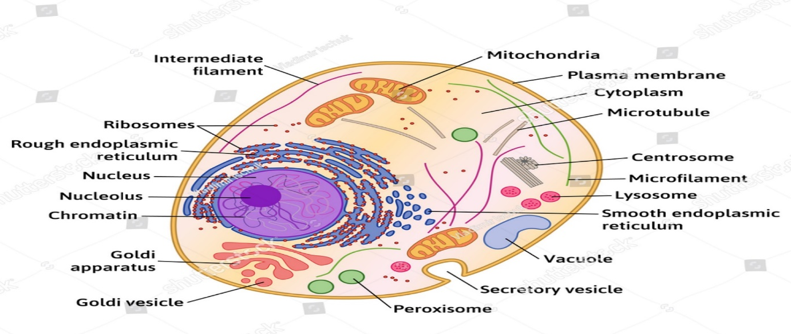

PARTS OF CELL:

- Plasma Membrane:
- It is the outer surface of cells. It separates cells from internal environments to external environments.
- It is a selective barrier that regulates the flow of materials into and out of a cell. This selectivity helps to maintain normal cellular activities.
FUNCTIONS:
- Protection: It protects cells from injury.
- Barrier: It holds or bound cell contents and maintains the individuality of the cell.
- The shape of the cell: It anchors structural elements of the cytoskeleton which provide distinct shapes to specific cells.
- Cell recognition: Glycoproteins and glycolipids function as receptors for specific chemical signals from outside and trigger specific processes within the cell. E.g. Immune response
- Cell junction: Membrane proteins help adjacent cells to form various types of junctions for keeping the cells together during the formation of tissues.
- Microvilli: These are membrane invaginations specialized for increasing the surface area for absorption.
- Cell movements: Movements like undulations e.g. fibroblasts and pseudopodia (macrophages) are formed by a cell membrane. They also form sheaths around flagella.
- Enzymes: Some membrane proteins catalyse biochemical reactions.
- Transport proteins: Many membrane proteins form channels that facilitate the transport of water, ions and nutrients like sugar and amino acids.
- Selective permeability: It allows entry to only selected substances and is impermeable to others.
- Bulk transport: Bulk intake of materials from outside by invagination of the plasma membrane to form vesicles is called endocytosis. Throwing out waste materials by the reverse process is called exocytosis.
- Impulse transmission: Nerve impulse travel through the plasma membrane of nerve cells.

- Cytoplasm :

It consists of all the cellular contains between the plasma membrane and nucleus. It consists of two components:

- Cytosol: The fluid portion of the cytoplasm contains water, dissolved solutes and Suspended particles.

b) Organelles: This is surrounded by cytosol. Each type of organelle has characteristics shapes and specific functions. E.g.: Ribosomes, Endoplasmic Reticulum, Golgi complex, Lysosomes, Peroxisomes and Mitochondria.

- Nucleus:

It is a large organelle. It is a house for most DNA, within the nucleus, each chromosome a single molecule of DNA associated with several proteins contains thousands of hereditary units called genes that Control cellular structures and functions.

THE PLASMA MEMBRANE

- It is a thin barrier that separates the internal components of a cell from extracellular Materials. It is also known as the cell membrane.
- It is well described by the fluid mosaic model. According to this model, the molecular arrangement of the plasma membrane resembles an ever-moving sea of fluid lipids that contains a mosaic of many proteins.

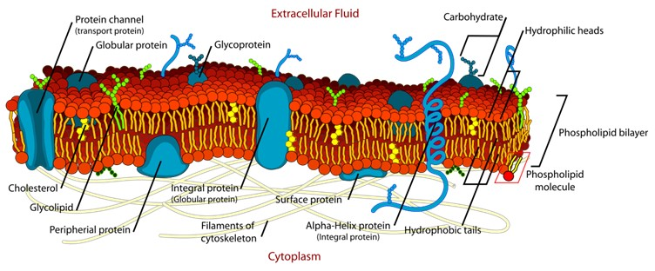
Some proteins float freely like ice bridges in the lipid sea, whereas others are anchored at specific locations like boats at a dock.

MEMBRANE CHEMISTRY AND ANATOMY:

- It consists 50:50 mix by weight of protein and lipids that are held together by noncovalent interactions.

- In the plasma membrane protein are large molecules than the lipid. So one protein molecule is surrounded by around 50 lipids molecules.

A) Membrane lipids:
- The plasma membrane is made up of a lipid bilayer.

- It consists of three types of lipids,

- Phospholipids: 75% of membrane lipids are phospholipids. It contains phosphate groups.

- Cholesterol: 20% of membrane lipids are cholesterol. Which is a steroid attached to the –OH group.

- Glycolipids: 5% of membrane lipids are glycolipids. Attached with carbohydrate groups.

- The lipid bilayer is amphipathic because it consists of both polar and non-polar parts.

- In phospholipids, the polar part is the phosphate-containing head which is hydrophilic (water-loving). The non-polar part contains two long fatty acid tails which are hydrophobic (water-hating) hydrocarbon chains.
- Cholesterol molecules are weakly amphipathic.

- In glycolipids, carbohydrate groups act head as the polar group while their fatty tail act as the non-polar group.

B) Membrane proteins:
- The plasma membrane consists of two types of proteins.
a) Integrated proteins:
- It extends across the phospholipids bilayer among the fatty acid tail.
- Most integral proteins are glycoprotein, it is attached to sugar groups.
- The portion of the attached sugar group faces the extracellular fluids.
- Peripheral proteins:

- They do not extend across the phospholipids bilayer.
- They are loosely attached to the inner and outer surfaces of the membrane and are easily separated from it.

►MOVEMENTS OF MATERIALS ACROSS THE PLASMA MEMBRANE:

The movement of the material across the plasma membrane is described by the two
Processes;
A) Passive process
B) Active process

- Passive process:

“When the movement is Depend on concentration gradient means the process is held from higher concentration to lower concentration is known as passive transport.”

- It is also known as non-ionic diffusion as well as the downhill process.
- Passive transfer is energy independent.

Passive transport is best expressed by Fick’s first law of diffusion, which state that the drug molecules transport from a region of higher concentration to a lower concentration until equilibrium is attained and that the rate is directly proportional to the concentration of gradient across the membrane.

Other passive transport processes are –
i) Diffusion:
- All substance has their kinetics energy. So the movement of the molecules or ions due to their kinetic energy is known as diffusion.
- When the two such areas are connected and one side area has more particles than the other side it will create the concentration gradient.
- So the substances move by their kinetic energy from higher concentration to lower concentration until the equilibrium is rich. It is known as net diffusion.
- Lipid-soluble molecules such as oxygen, nitrogen, steroids, fat-soluble vitamins (A, D, E & K), glycerol etc. cross the plasma membrane by simple diffusion.
- Diffusion is important in the movement of oxygen and carbon dioxide between blood and body cell and between blood and air within the lungs during breathing.
- Small molecules that are not lipid soluble may diffuse into or out of cells through water-filled pores of integral proteins. E.g.: Sodium ions (Na+), Potassium ions (K+), Calcium ions (Ca+), Chloride ions (Cl-), Bicarbonate ions (HCO3-), and Urea.

ii) Osmosis:
Another passive process is osmosis.

- In this process, water is moved by osmosis across a membrane from an area of higher water concentration (lower solute concentration in water) to an area of lower water concentration (higher solute concentration in water).
- For the description of this process take a sac made of cellophane (selectively permeable membrane) containing a sugar solution and it immersed in a beaker of pure water. It is only permeable for water not for sugar because sugar molecules are large in size.
- The water concentration on the two sides is different means lower water, Concentration inside the sac because the additional of sugar.

iii) Pore transport:
- It is also known as connective transport, bulk flow transport or filtration.
- The process is important for the absorption of lower-weight and lower-size molecules.
- Urea, water and sugars are transferred by this mechanism.

B) Active process:
“When the movement is against the concentration gradient energy is a required mean the transport of molecules is occurring with the help of ATP is known as active process”.
- The drug is transported from a region of lower to higher concentration i.e. against the concentration gradient.
- It is known as uphill transport.
- Energy is required for this transfer.
- Substances that transport actively is sodium, potassium, calcium, glucose, certain amino acids and vitamins like niacin, pyridoxine and ascorbic acid.

i) Primary active transport:
- Movement of ions or molecules across a selectively permeable membrane from a region of lower to higher concentration by pump protein that uses energy from the splitting of ATP. E.g.: Sodium ions (Na+), Potassium ions (K+), Calcium ions (Ca+), Chloride ions (Cl-) and other ions.
ii) Secondary active transport:
- When the simultaneous movements of two substances are held in which one substance is Na+ or transported by using energy is known as secondary active transport. E.g.: Glucose into the cells lining of the small intestine and the kidney tubules.
- In this transport, if both substances move in the same direction is known as Symporters and if both substances' movement is in opposite directions known as antiporters. E.g.: Sodium ions (Na+), Potassium ions (K+), Calcium ions (Ca+) etc.

iii) Endocytosis:
- It is a minor transport mechanism which involves engulfing extracellular materials within a cell.
- Vitamins like A, D, E, K and drugs like insulin refer to this phenomenon.
- Endocytosis includes two types of processes;
a) Phagocytosis:
- It is known as cell eating.
- Absorption of solid particles.
b) Pinocytosis:
- It is known as cell drinking.
- Absorption of fluid solute.

