HUMAN ANATOMY AND PHYSIOLOGY-I (Theory)
Subject code: BP101T
Class - 01

Introduction of the human body
Definition and scope of anatomy and physiology

Anatomy:

Study of the structure of the body and physical relationships involved between them. The term anatomy comes from Greek words meaning to cut (tomy) apart (ana.)Anatomy and physiology are concerned with the structures and functions of the human body.

- Anatomy describes the structures of the body — their scientific names, composition, location, and associated structures.
- Physiology studies the function of each structure, individually and in combination with other structures.
- Anatomy and physiology always work together. As we examine each part of the body, always consider its structure and function.
The study of anatomy is divided into 2 major fields:
- Gross anatomy is the study of large visible structures
- Microscopic anatomy is the study of structures that are too small to see, such as cells
and molecules.

Gross anatomy:
Gross anatomy, also called macroscopic anatomy, is separated into 5 major divisions:
- Surface anatomy describes surface forms and marks.

- Regional anatomy describes the organization of specific areas of the body such as the head or hand. This approach is used mostly in professional schools: medical, dental, and physical therapy.

- Systemic anatomy describes groups of organs that function together for a single purpose.

- Developmental anatomy describes the structural changes in an organism from fertilized egg to maturity. Embryology is the anatomical study of early development

- Clinical anatomy describes various medical specialities, including medical anatomy (changes that occur during illness), and radiographic anatomy

Microscopic anatomy
Microscopic anatomy is divided into two major divisions:
- Cytology is the study of cells and their structures
- Histology is the study of tissues and their structures

Physiology
Physiology has many specialities. The 4 basic divisions are:
- Cell physiology, including chemical and molecular processes within and between cells.
- Special physiology is the study of specific organs such as the heart.
- Systemic physiology is the cooperative functions of all the organs in an organ system. We will use a systemic physiology approach.
- Pathological physiology, the effects of diseases on organs and organ systems.
Level of Structural organization

It is divided into chemical and biological Chemicals, it is the lowest level of organization.
It is made up of atoms and molecules.
Atoms are the smallest and simplest. Atoms combine to form molecules.

Biological: It is made up of cells, tissues, organs, and organ systems. Cells are the smallest independent units. Many cells combine to form tissues and a number of tissues combine to form organs and organs, in turn, unite to form an organ system and a large number of organ systems form a human being.

Body system: There are a total of eleven systems in the human body. Each coordinates with one other for the effective functioning of the human body.

- Integumentary System: It contains skin and associated structures like hair and sweat glands, and oil glands.
Function:
- Body protection
- Regulation of temperature
- Elimination of waste
- Synthesis of Vitamin D
- The sensation of cold, touch, temperature and warmth

- Skeletal System: It Comprises bones, cartilage and associated joints.
Function:
- Support and protect the body
- Provides surface for muscle attachment

- Muscular System: It comprises Skeletal, smooth, and cardiac muscles.
- Function: It helps in body movement and maintenance of postures.

- Nervous System: It consists of Brain Spinal Cord and nerves.
- Function: Action potential Generation and conduction of nerve impulses

- Endocrine System: It contains hormone-producing glands and their secretions.
- Function: Regulation of body activities through hormones

- Cardiovascular system: It Comprises the heart, blood and blood vessels.
- Function: Pumping of Blood and transport of gases

- Lymphatic system: It contains lymphatic fluids and vessels, spleen, and thymus.
- Function: Defencing

- Respiratory System: It consists of the lungs, pharynx, larynx, and trachea.
- Function: Transport of respiratory gases

- Digestive System: It involves GIT (mouth, pharynx, oesophagus, stomach, small intestine & large intestine).
- Function: Physical and chemical digestion of food

- Urinary System: It consists of kidneys, ureters, urinary bladder and urethra.
- Function: Filtration of fluids

- Reproductive system: It consists of a pair of the testis, a scrotum, a pair of the epididymis, a pair of vas-deferens, an ejaculatory duct, a urethra, a penis and sex glands (pair of seminal vesicles), a prostate gland and pair of Cowper’s gland as part of the male reproductive system and it comprises pair of ovaries, pair of oviduct, uterus, vagina, hymen, and clitoris, as part of the female reproductive system.
- Function: Production of sperm in the male and ova in the female

Ability to maintain relatively stable internal conditions despite a changing external environment. The dynamic state of equilibrium, or balance. The body is said to be in homeostasis when its cellular needs are adequately met and functional activities are occurring smoothly. Virtually every organ system plays a role in maintaining the internal environment. A homeostatic regulatory mechanism consists of 5 parts:
- Receptors: They act as sensors/receiver that responds to a stimulus. It monitors changes in control conditions.
- Sensory Neurons: They send the input information/message to the control centre, which means information from cells/tissue/organs etc to the integrated system i.e brain and spinal cord.
- Integrated System: It analyses the incoming message from the sensory neurons and sends out commands/messages. In the body, there are hundred controlled conditions.
A few examples are heart rate, blood pressure, temperature and breathing rate.
- Motor Neurons: The output information/message from the integrated centre (brain and spinal cord) to cells/tissue/organs etc are travelled by motor neurons.
- Effectors: The cell/tissue/organ etc acts as an effector that responds according to the output command of the control/integrated centre.
Receptors, control centres and effectors maintain homeostasis through two mechanisms:

1. Negative Feedback
When the response of effectors opposes the original stimulus, it is called negative
feedback because it negates the stimulus.
- An example of negative feedback is the temperature thermostat in your home.
- Temperature sensors turn the air conditioner off and on to maintain air temperature within a specific, limited range.
- In the same way, the brain controls normal body-temperature homeostasis through negative feedback
- Some stimulus (Stress) disrupts homeostasis (control condition) by an increase in body temperature.
- Due to this condition thermoreceptors (temperature-sensitive receptors) in the skin and brain activate and send input messages via nerve impulses to the control centre.
The control centre analyses the input message and sends the output message to the effectors (skin).

2. Positive Feedback
The effector adds to the initial stimulus instead of negating it, speeding up the process. Labour contraction is an example of a positive feedback system.
- Labour contractions force the baby’s head or body into the birth canal.
- It produces an effect on the control condition and increases distention of the cervix of the uterus.
- It activates the stretch receptors of the cervix and sends input messages to the control centre via sensory nerve impulses.
- The control centre activates the hypothalamus and pituitary gland and sends the output message to increase oxytocin secretion in the blood.
- Oxytocin produces its effect on the effector (cervix of the uterus) and causes distension of the cervix of the uterus than the normal value to push the baby further into the birth canal.
- Birth of the baby decreases distention of the cervix of the uterus and interrupts the positive feedback cycle.

Basic Life Processes:

There are major six life processes-

- Metabolism: sum of all chemical processes that occur in the human body.
- Catabolism: Break down complex compounds into simpler ones.
- Anabolism: Building of complex molecules from simpler ones. e.g. Digestion of proteins is a catabolic process while the use of amino acids to build proteins is an anabolic process
- Responsiveness: Ability of the body to detect and respond to changes.
- Movement: Motion of a whole body
- Growth: Increase in body size
- Differentiation: Development of a specialized cell from an unspecialized group of cells.
- Reproduction: Formation of new cells

Homeostasis:

- Homeostasis refers to stability, balance, or equilibrium within a cell or the body.
- It is an organism’s ability to keep a constant internal environment. Homeostasis is an important characteristic of living things.
- Keeping a stable internal environment requires constant adjustments as conditions change inside and outside the cell.
- The adjusting of systems within a cell is called homeostatic regulation.

Basic anatomical terminology:

- Superior or cranial - toward the head end of the body; upper (for example, the hand is part of the superior extremity).
- Inferior or caudal - away from the head; lower (for example, the foot is part of the inferior extremity).
- Anterior or ventral-front (for example, the kneecap is located on the anterior side of the leg).
- Posterior or dorsal-back (for example, the shoulder blades are located on the posterior side of the body).
- Medial - toward the midline of the body (for example, the middle toe is located at the medial side of the foot).
- Lateral - away from the midline of the body (for example, the little toe is located at the lateral side of the foot).
- Proximal - toward or nearest the trunk or the point of origin of a part (for example, the proximal end of the femur joins with the pelvic bone).
- Distal - away from or farthest from the trunk or the point or origin of a part (for example, the hand is located at the distal end of the forearm).

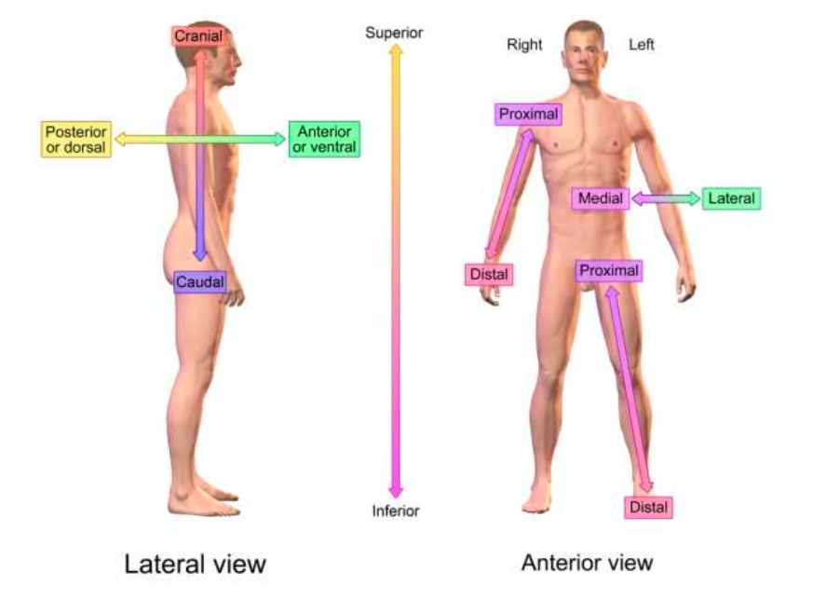

Reference: Mittal, P., Goswami, M. Human Anatomy and Physiology-I, Published by S. Vikas and Company, 2020 page no. 1-7.

