HUMAN ANATOMY AND PHYSIOLOGY-I (Theory)
Subject code: BP101T
Class – 09
General principles of cell communication:
- Communication between cells is mediated mainly by extracellular signal molecules. Some of these operate over long distances, signalling to cells far away; others signal only to immediate neighbours.
- Most cells in multicellular organisms both emit and receive signals. Reception of the signals depends on receptor proteins, usually (but not always) at the cell surface, which binds the signal molecule.
- The binding activates the receptor, which in turn activates one or more intracellular signalling pathways.
- These relay chains of molecules—mainly intracellular signalling proteins—process the signal inside the receiving cell and distribute it to the appropriate intracellular targets.
- These targets are generally effector proteins, which are altered when the signalling pathway is activated and implements the appropriate change of cell behaviour.
- Depending on the signal and the nature and state of the receiving cell, these effectors can be gene regulatory proteins, ion channels, components of a metabolic pathway, or parts of the cytoskeleton—among other things.
Intracellular signalling pathway activation by the extracellular signal molecule
The signal molecule usually binds to a receptor protein that is embedded in the plasma membrane of the target cell and activates one or more intracellular signalling pathways mediated by a series of signalling proteins. Finally, one or more of the intracellular signalling proteins alters the activity of effector proteins and thereby the behaviour of the cell.
- Signalling is endocrine, paracrine, synaptic, or direct cell contact
- Signal transduction is mediated by receptor proteins
- Receptors bind the primary signal (ligand)
- Some amplification event occurs
- Example: ligand-gated ion channel opens: Influx of ions triggers a change in activity (vesicle fusion in nerve end, contraction in muscle)
- Example: ligand binds to 7-pass membrane receptor catalyses GTP exchange to Ga subunit of trimeric G-protein active Ga-subunit-GTP is an allosteric activator of effector enzymes:
- ADENYLATE CYCLASE: makes cyclic AMP
- PHOSPHOLIPASE C: makes DAG and these second messengers activate target enzymes Trigger cascades
- Must shut off cascade: removal of ligand, hydrolysis of GTP, phosphodiesterase, protein phosphatases, Ca++ ion Pumps.
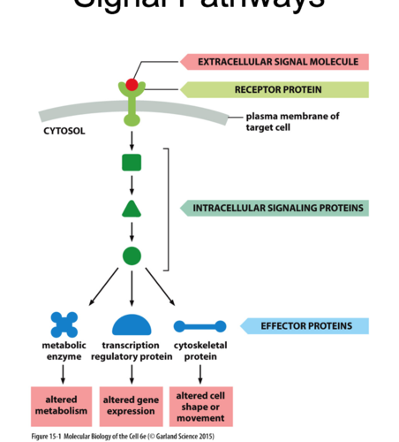

The binding of extracellular signal molecules to either cell surface receptors or intracellular receptors
A. Most signal molecules are hydrophilic and are therefore unable to cross the target cell’s plasma membrane directly; instead, they bind to cell-surface receptors, which in turn generate signals inside the target cell
B. Some small signal molecules, by contrast, diffuse across the plasma membrane and bind to receptor proteins inside the target cell— either in the cytosol or in the nucleus (as shown here). Many of these small signal molecules are hydrophobic and nearly insoluble in aqueous solutions; they are therefore transported in the bloodstream and other extracellular fluids bound to carrier proteins, from which they dissociate before entering the target cell.
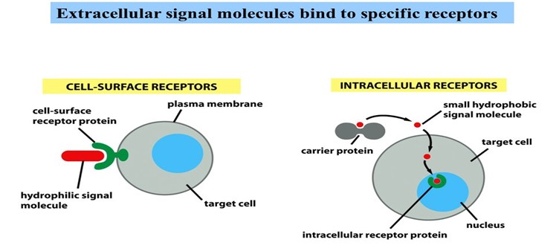

FORMS OF INTERCELLULAR SIGNALING
1. Direct cell contact: ex. delta/notch
Cells that maintain an intimate membrane-to-membrane interface can engage in Contact-dependent signalling.
2. Paracrine: local ex. nitric oxide, histamines, prostaglandins
Paracrine signals are released by cells into the extracellular fluid in their neighbourhood and act locally.
3. Synaptic: ex. Neurotransmitters
Neuronal signals are transmitted along axons to remote target cells.
4. Endocrine: long distance ex. oestrogen, epinephrine
Hormones produced in endocrine glands are secreted into the bloodstream and are often distributed widely throughout the body.

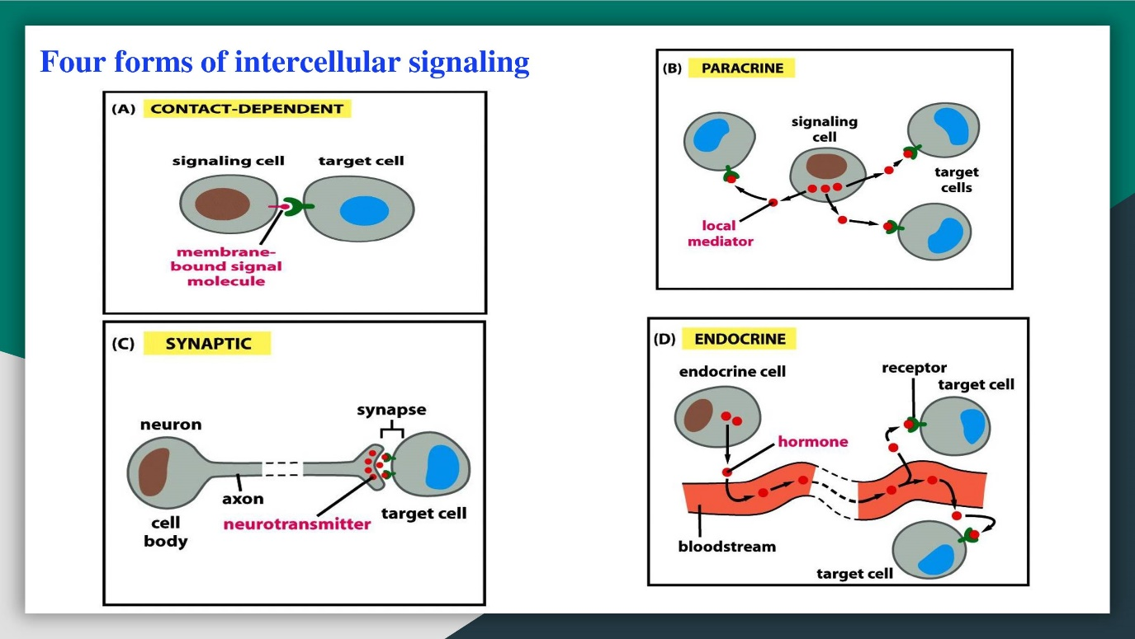

IMPORTANT QUESTIONS RELATED TO UNIT 1:
Short Questions (2M)
- Define Anatomy and Physiology
- Define Homeostasis
- Explain about basic life process
- Define Cell Communication
- Define cell Junction
- Explain about Cardiac Muscle Tissue
- Define Tissue
- What ate the structural levels of Organisation
- What are the Functions of Mitochondria
- What are the functions of lysosomes
Long Questions
- Explain in detail about structure of Plasma membrane
- Explain transport mechanisms in detail across the plasma membrane
- Define cell division and explain in detail about mitosis and meiosis
- Define Cell Junction and its types
- Define Cell communication and its types
- Explain about intracellular signalling pathway activation by Extracellular molecule
- Explain in detail about Feedback Mechanisms.
- Explain in detail about the structure of cell with labelled diagram
- Explain about tissue classification and their types in detail with examples and diagrams

