HUMAN ANATOMY AND PHYSIOLOGY-I (Theory)
Subject code: BP101T
Class – 06

CYTOPLASM
It consists of all the cellular contains between the plasma membrane and nucleus.
It consists of two components:

1. Cytosol:
- It is the unsaturated soluble portion of the cells.
- Chemically it is 75-90 % water plus solid components (protein, carbohydrate, lipids and inorganic substances).
- Inorganic substances and smaller organic substances such as simple sugar and amino acid are soluble in water and are present as solutes.
- While larger particle such as protein and polysaccharide glycogen is found as a colloidal particle in the surrounding medium and are not dissolved.
- The cytosol receives raw materials from the external environment and gains unstable energy from them by decomposition reactions.

2. Organelles:
- These are specialized structures that have characteristics appearance and specific roles in growth, maintenance, repair and control.
- The number and types of organelles vary in different kinds of cells depending on their function.
- Different types of organelles are:

- Mitochondria
- Mitochondria are the largest components of the cytoplasm.
- They are the powerhouse of the cell and each cell may contain from 50 to 2500 mitochondria depending upon the respiratory activity of the cells. For example, The cell of the skeletal muscle, kidney and liver contains a large number of mitochondria while heart muscles contain less.
- They vary in shape and size (0.5 to 3μ long and 0.1 to 0.6μ wide).
- They have two membranes, the outer is smooth but the inner is arranged series of folds that form ridges known as cristae.
- Mitochondria consist central cavity enclosed by an inner membrane known as a matrix.
- Folds increase the inner surface area which is useful for cellular respiration.
- The matrix and cristae contain the catalytic enzyme which produces the ATP.

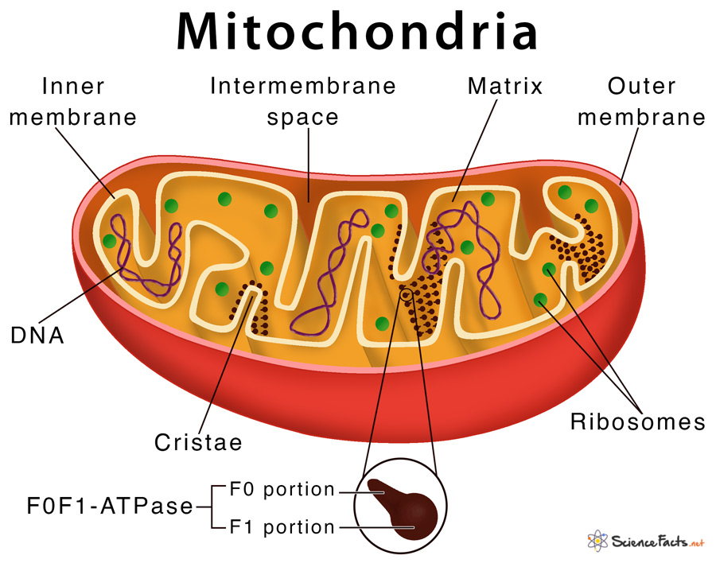

- Mitochondria swell in hypotonic solution and shrink in hypertonic solution.
- The mitochondria contain a large number of enzyme systems known as “cylophorase”, which are involved in:
a) Oxidation of pyruvic acid in Krebs cycle via acetyl CoA
b) Electron transport and oxidative phosphorylation
c) Synthesis of fatty acids

B) Endoplasmic Reticulum:
- This is the complicated and organized system of membranes in the cytoplasm of the cell.
- This membrane is constituted of a protein-lipid double layer and is very well developed in tissue with active protein synthesis.
- There are two types of endoplasmic reticules one is a rough or granular endoplasmic reticulum consist ribosomes on its surface and the second is smooth endoplasmic reticulum or agranular which has no ribosomes.
- The rough endoplasmic reticulum is associated with protein synthesis.
- It serves as a temporary storage area for newly synthesized molecules and may add sugar groups to certain proteins. E.g.: Glycoproteins.
- The smooth endoplasmic reticulum is the site for fatty acids, phospholipids and steroidal synthesis.
- Enzymes within the smooth ER can inactive or detoxified a variety of chemicals including alcohols, pesticides, and carcinogens.

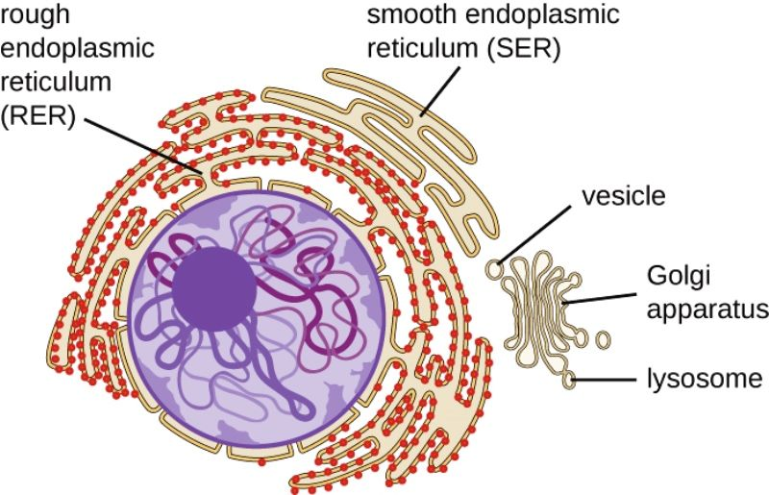

C) Ribosome:
- Ribosomes are tiny granules that contain ribosomal RNA (rRNA) and many ribosomal proteins.
- The size of the ribosomes ranges from 15 to 20 millimicrons and the diameter is 150Aº.
- The rRNA is synthesized by DNA in the nucleus.
- Functionally the ribosomes are the sites of protein synthesis.
- Some ribosomes known as free ribosomes, float in the cytosol. They are not attached to other organelles. Free ribosomes are formed singly or in clustered form.
- Other ribosomes are attached to a cellular structure called the endoplasmic reticulum.

D) Golgi Complex:
- The Golgi complex or apparatus is an organelle located near the nucleus.
- It consists of a flattened sac called a cistern which consists of small Golgi vesicles.
- The Golgi complex processes sort, package and deliver proteins and lipids to the plasma membrane and form lysosomes and secretory vesicles.
- All the proteins are exported from the cells by a similar route i.e ribosomes (site of protein synthesis) – rough endoplasmic reticulum cistern – transport vesicles – Golgi complex– secretary vesicles – release to the exterior of the cells by exocytosis.

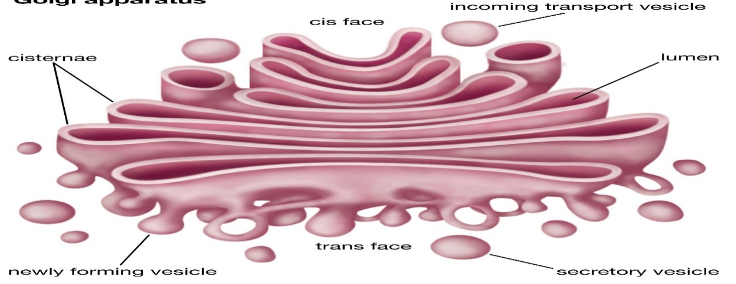

E) Lysosomes:
- Lysosomes are membrane-enclosed vesicles that form in the Golgi complex.
- Inside the lysosomes, there are as many as 40 kinds of powerful digestive (hydrolytic) enzymes capable of breaking down a wide variety of molecules.
- Some disorders are caused by faulty lysosomes. For example, Tay-Sachs disease is inherited and is caused by the absence of a single lysosomal enzyme. This enzyme is essential for the breakdown of membrane glycolipids which is essential for preventing the nerve cell’s function. In absence of this enzyme, nerve cells get damaged and produce blindness in children, are demented, and die usually before the age of 5.
- Lysosomes work best at acidic pH. The lysosome membrane has an active transport pump that drives hydrogen ions (H+) into the lysosomes. So the interior of lysosomes has a pH of 5, which is 100 times more acidic than the cytosolic pH of 7.
- Lysosomes digest the bacteria and other substances that enter the cell by phagocytosis or pinocytosis.
- Lysosomal enzymes may also destroy their host cells called autolysis.
- Lysosomes digest the old organelles and return the digested components to the cytosol for reuse. So old organelles are replaced by new organelles this process is known as autophagy.
- Lysosomal enzymes may digest the cellular debris at the site of injury.

F) Peroxisomes:
- It has a similar structure to lysosomes but is smaller than the lysosomes.
- It contains one or more enzymes that are used in oxygen to oxidize the process. The such reaction produces hydrogen peroxide.

G) The cytoskeleton:
- The coordination of cellular movements and cellular shape is maintained by the cytoskeleton.
- The cytoskeleton is responsible for the movement of whole cells, such as phagocytes and for the movement of organelles and some chemicals within the cells.
There are three main types of proteins that comprise the cytoskeletons:
- Microfilaments:
- It has rod-like structures of varying lengths that are formed from the protein actin.
- In muscle tissue actin filaments (thin filaments) and myosin filaments (thick filaments) are important for muscle contraction.
- In nonmuscle cells, actin microfilaments provide support and shape.
- Microtubules:
- It is larger than microfilaments.
- They are relatively straight and cylindrical in a structure that consists of a protein that is
known as tubulin.
- Microtubules also work as conveyer belts for the movement of various substances.
- Intermediate filaments:
- It is strong and tough.
- It holds the organelles in their position.

H) Centrosome and Centrioles:
- Near the nucleus is a dense area of cytoplasmic material with radiant microtubules called centrosomes.
- Centrosomes serve as a centre for organizing microtubules in non-dividing cells.
- It also forms the mitotic spindle during cell division.
- Within the Centrosomes, a pair of cylindrical structures is known as Centrioles.
- Each centriole is composed of nine clusters of three microtubules arranged in a circular pattern.
Nucleus
The nucleus is spherical or oval in shape and is the heaviest or largest structure in the cell. Within the nucleus are most of the hereditary units of the cell known as genes, which control cellular structure and direct many cellular activities.

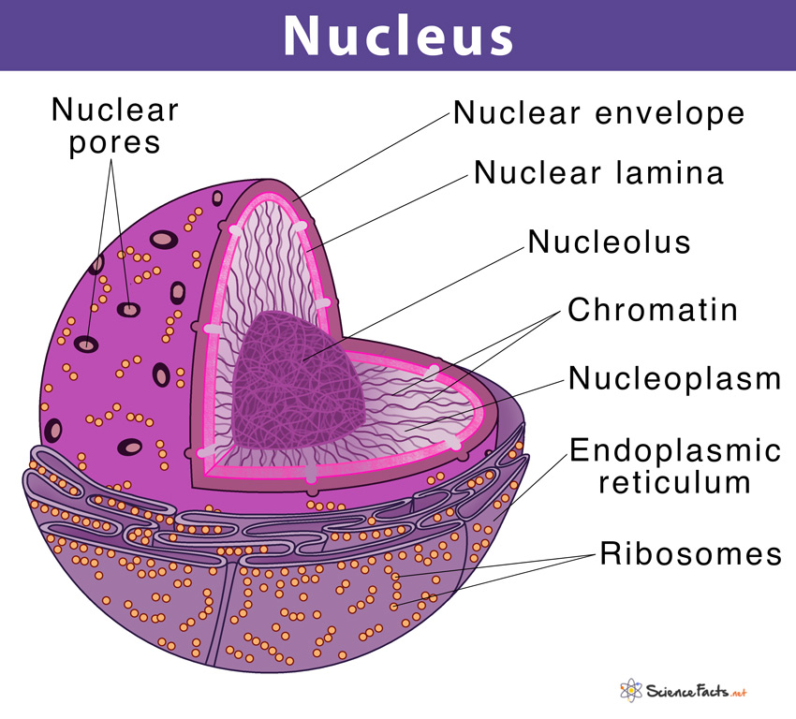

- The nuclear genes are arranged side by side and form a specific structure known as chromosomes.
- Human somatic cells have 46 chromosomes, 23 inherited from each parent.
- A double membrane called the nuclear envelope separates the nucleus from the cytoplasm. Both layers of the nuclear layer envelop are phospholipids bilayer similar to the plasma membrane.
- The two membranes are separated from each other by the perinuclear cisterns and join at intervals to form pores which allow the passage of materials from the cytoplasm to the nucleus and vice versa these pores are 10 times larger than the pores of channels in the plasma membrane, even larger molecules such as RNA and various protein can also pass.
- Inside the nucleus, one or more spherical bodices are presently known as nucleoli (Singular is nucleolus). They contain a bunch of protein, DNA and RNA that are not enclosed by a membrane.
- Nucleolus or Nucleoli contains ribosomes as well as ribosomal RNA and it plays a key role in protein synthesis.
- A chromosome is a very long DNA molecule that is coiled and packed in an amazing compact structure together with several proteins.
- In chromosomes, two identical pairs consist of nucleoprotein strands that are joined at the centromere and separated during cell division known as chromatids. It forms a tough thread-like structure in not dividing 46 chromosomes.
- Chromatin has a “beads on a string (thread)” structure. Each beads known as
- nucleosomes consist of eight protein molecules called histone which is wrapped by double-strand DNA twice around it.

