HUMAN ANATOMY AND PHYSIOLOGY-I (Theory)
Subject code: BP101T
Class – 07

Cell Division

“Cell division is the process by which cells produce themselves.”

Two kinds of cell division are recognised:-

1) Somatic cell division:
- In this process parent cell produces two identical daughter cells. This process consists of
- Nuclear division is known as mitosis and
- The cytoplasmic division is known as cytokinesis.

- In this process, the daughter cell has the same number and kind of chromosomes as the original parent cell.
2) Reproductive cell division:
- In this process sperm and egg cells are produced. These are the cell which produces new organism.
- The process consists of a special nuclear division called meiosis (reduction division) followed by cytokinesis.
1) SOMATIC CELL DIVISION:
- Human cells, except for egg and sperm, contain 23 pairs of chromosomes.
- Two chromosomes that belong to a pair, one contributed by the mother and one contributed by the father known as homologous chromosomes.
- It is described by following two steps:
- Interphase: The cell is between divisions, and chromosomes are not seen under a light microscope. It includes G1 Phase, S Phase and G2 Phase
- Cell division: parent cell produces two identical daughter cells, and chromosomes are visible under a light microscope. It includes Mitosis and Cytokinesis.

Nuclear Division Mitosis
The process called mitosis is the distribution of two sets of chromosomes into two separate and equal nuclei. It results in the exact duplication of genetic information.

Mitosis is divided into four stages prophase, metaphase, anaphase and telophase.
1) Prophase:
As the mitotic spindle develops three types of microtubules form:
1) nonkinetochore microtubules grow from centrosomes, and extend inward but do not bind to kinetochores.
2) Kinetochore microtubules grow from centrosomes, extend inward and attached to kinetochore It is the first stage of mitosis. Each prophase chromosome contains a pair of identical double-strand chromatids.
- Each chromatid pair is held together by a small spherical body known as a centromere that is required for the proper segregation of chromosomes.
- Attached to the outside of each centromere is a protein complex known as the
- kinetochore.
- Later in prophase, the nucleoli disappear and the nuclear envelope breaks down and dissolves into the cytosol.
- In addition, each centrosome and its Centrioles move to the opposite pole (ends) of the cell.
- So the centrosomes start to form a mitotic spindle, a football-shaped assembly of microtubules that are responsible for the movement of chromosomes.

3) Aster microtubules go out of the centromere.
- The spindle is the attachment site for the chromosomes and it also distributes chromosomes to opposite poles of the cells.

2) Metaphase:
- In this phase, the centromeres of the chromatid pairs line up at the exact centre of the mitotic spindle. This portion is known as the equatorial plane region.
3) Anaphase:
- It is characterized by the splitting and separation of centromeres and the movement of two sister chromatids of each pair toward opposite poles of the cells.
- Separated chromatids have known as daughter chromosomes.
- The movement is due to the shortening of kinetochore microtubules and elongation of the nonkinetochore microtubules. These processes increase the distance between separated chromosomes. They are also pulled by the microtubules so appear as V-shapes from the centromeres.
4) Telophase:
- It is the final stage of mitosis.
- In this phase, the identical sets of chromosomes at opposite poles of the cells are uncoiled and revert to the thread-like chromatin form.
- A new nuclear envelope is formed around each chromatin mass, new nuclei appear in the daughter nuclei and eventually, the mitotic spindle breaks up.
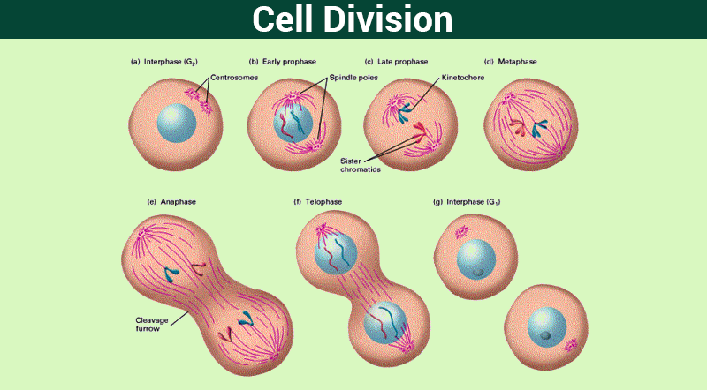

Cytoplasmic Division:

Cytokinesis
- The division of the parent cell cytoplasm and organelles is called cytokinesis.
- It begins in late anaphase and earlier telophase with the formation of the cleavage furrow.
- The furrow gradually deepens until opposite surfaces of the cells make contact and the cell are split in two. When cytokinesis is complete, interphase begins.

