Tissues:
The tissues of the body consist of large numbers of cells and they are classified according to their size, shape and functions of these cells. There are four main types of tissue, each of which has subdivisions.
They are:
- epithelial tissue or epithelium
- connective tissue
- muscle tissue
- nervous tissue.
Epithelial tissue
This group of tissues is found covering the body and lining cavities and tubes. It is also found in glands. The structure of epithelium is closely related to its functions which include:
- protection of underlying structures from, for example, dehydration, chemical and mechanical damage
- secretion
- absorption.
The cells are very closely packed and the intercellular substance, called the matrix, is minimal. The cells usually lie on a basement membrane, which is an inert connective tissue.
Epithelial tissue may be:
- simple: a single layer of cells
- stratified: several layers of cells.
- Simple epithelium
The simple epithelium consists of a single layer of identical cells and is divided into four types. It is usually found on absorptive or secretory surfaces, where the single layer enhances these processes, and not usually on surfaces subject to stress. The types are named according to the shape of the cells, which differs according to their functions. The more active the tissue, the taller the cells.
Squamous (pavement) epithelium
This is composed of a single layer of flattened cells. The cells fit closely together like flat stones, forming a thin and very smooth membrane. Diffusion takes place freely through this thin, smooth, inactive lining of the following structures:
- Heart
- blood vessels
- lymph vessels
- alveoli of the lungs, Where it is known as the endothelium

Cuboidal (cubical) epithelium
- This consists of cube-shaped cells fitting closely together and lying on a basement membrane. It forms the tubules of the kidneys and is found in some glands. Cuboidal epithelium is actively involved in secretion, absorption and excretion.
Columnar epithelium
- This is formed by a single layer of cells, rectangular in shape, on a basement membrane. It is found lining the organs of the alimentary tract and consists of a mixture of cells; some absorb the products of digestion and others secrete mucus. Mucus is a thick sticky sub- stance secreted by modified columnar cells called goblet cells.
Ciliated epithelium
- This is formed by columnar cells each of which has many fine, hair-like processes, called cilia. The cilia consist of microtubules inside the plasma membrane that extends from the free border (luminal border) of the columnar cells. The wave-like movement of many cilia propels the contents of the tubes, which they line in one direction only.
- Ciliated epithelium is found lining the uterine tubes and most of the respiratory passages. In the uterine tubes, the cilia propel the ova towards the uterus and in the respiratory passages they propel mucus towards the throat.
Stratified epithelia
- Stratified epithelia consist of several layers of cells of various shapes. The superficial layers grow up from below. Basement membranes are usually absent. The main function of stratified epithelium is to protect underlying structures from mechanical wear and tear. There are two main types: stratified squamous and transitional.
Stratified squamous epithelium
- This is composed of a number of layers of cells of different shapes representing newly formed and mature cells. In the deepest layers, the cells are mainly columnar and, as they grow towards the surface, they become flattened and are then shed.
Non-keratinised stratified epithelium.
- This is found on wet surfaces that may be subjected to wear and tear but are protected from drying, e.g. the conjunctiva of the eyes, the lining of the mouth, the pharynx, the oesophagus and the vagina.
Keratinised stratified epithelium.
- This is found on dry surfaces that are subjected to wear and tear, i.e. skin, hair and nails. The surface layer consists of dead epithelial cells to which the protein keratin has been added. This forms a tough, relatively waterproof protective layer that prevents drying of the underlying live cells. The surface layer of skin is rubbed off and is replaced from below
Transitional epithelium
- This is composed of several layers of pear-shaped cells and is found lining the urinary bladder. It allows for stretching as the bladder fills.
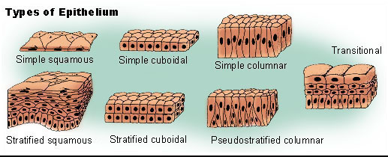

Connective tissue
Connective tissue is the most abundant tissue in the body. The cells forming the connective tissues are more widely separated from each other than those forming the epithelium, and intercellular substance (matrix) is present in considerably larger amounts. There may or may not be fibres present in the matrix, which may be of a semisolid jelly-like consistency or dense and rigid, depending upon the position and function of the tissue.
The major functions of connective tissue are:
- binding and structural support
- protection
- transport
- insulation.
Cells of connective tissue
Connective tissue, excluding blood, is found in all organs supporting the specialised tissue. The different types of cells involved include:
- fibroblasts
- fat cells
- macrophages
- leukocytes
- mast cells.
Fibroblasts.
- Fibroblasts are large flat cells with irregular processes. They produce collagen and elastic fibres and a matrix of extracellular material. Very fine collagen fibres, sometimes called reticulin fibres, are found in very active tissue, such as the liver and lymphoid tissue. Fibroblasts are particularly active in tissue repair (wound healing) where they may bind together the cut surfaces of wounds or form granulation tissue following tissue destruction
Fat cells.
- Also known as adipose these cells occur singly or in groups in many types of connective tissue and are especially abundant in adipose tissue. They vary in size and shape according to the amount of fat they contain.
Macrophages.
- These are irregular-shaped cells with granules in the cytoplasm. Some are fixed, i.e. attached to connective tissue fibres, and others are motile. They are an important part of the body's defence mechanisms as they are actively phagocytic, engulfing and digesting cell debris, bacteria and other foreign bodies. Their activities are typical of those of the macrophage/monocyte defence system, e.g. monocytes in the blood, phagocytes in the alveoli of the lungs, Kupffer cells in liver sinusoids, fibroblasts in lymph nodes and spleen and microglial cells in the brain.
Leukocytes.
- White blood cells are normally found in small numbers in healthy connective tissue but migrate in significant numbers during infection when they play an important part in tissue defence. Lymphocytes synthesise and secrete specific antibodies into the blood in the presence of foreign material, such as microbes
Mast cells.
- These cells are similar to basophil leukocytes. They are found in loose connective tissue and under the fibrous capsule of some organs, e.g. liver and spleen, and in considerable numbers round blood vessels. They produce granules containing heparin, histamine and other substances, which are released when the cells are damaged by disease or injury.
Muscle tissue
There are three types of muscle tissue, which consist of specialised contractile cells:
  - skeletal muscle
  - smooth muscle
  - cardiac muscle.
Skeletal muscle tissue
  - This may be described as skeletal, striated, striped or voluntary muscle. It is called voluntary because contraction is under conscious control.
When skeletal muscle is examined microscopically the cells are found to be roughly cylindrical in shape and may be as long as 35 cm. Each cell, commonly called a fibre, has several nuclei situated just under the sarcolemma or cell membrane of each muscle fibre.
Sarcoplasm, the cytoplasm of muscle fibres, contains:
- bundles of myofibrils, which consist of filaments of contractile proteins including actin and myosin
- many mitochondria, which generate chemical energy (ATP) from glucose and oxygen through aerobic respiration
- glycogen, a carbohydrate store which is broken down into glucose when required
- myoglobin, a unique oxygen-binding protein molecule, similar to haemoglobin in red blood cells, which stores oxygen within muscle cells.
A myofibril has a repeating series of dark and light bands, consisting of units called sarcomeres. A sarcomere represents the smallest functional unit of skeletal muscle fibre and consists of:
- thin filaments of actin
- thick filaments of myosin.

Smooth (visceral) muscle tissue
Smooth muscle may also be described as non-striated or involuntary. It is not under conscious control. It is found in the walls of hollow organs:
- regulating the diameter of blood vessels and part of the respiratory tract
propelling contents of the ureters, ducts of glands and alimentary tract
- expelling contents of the urinary bladder and uterus.
Cardiac muscle tissue
- This type of muscle tissue is found exclusively in the wall of the heart. It is not under conscious control but, when viewed under a microscope, cross-stripes characteristic of voluntary muscle can be seen. Each fibre (cell) has a nucleus and one or more branches. The ends of the cells and their branches are in very close contact with the ends and branches of adjacent cells.
The function of muscle tissue
- Muscle functions by alternate phases of contraction and relaxation. When the fibres contract they become thicker and shorter. Skeletal muscle fibres are stimulated by motor nerve impulses originating in the brain or spinal cord and ending at the neuromuscular junction contraction is stimulated by autonomic nerve impulses, some hormones and local metabolites.
- When muscle fibres contract they follow the all or none law; i.e. each fibre contracts to its full capacity or not at all. The strength of contraction, e.g. lifting a weight, depends on the number of fibres contracting at the same time.
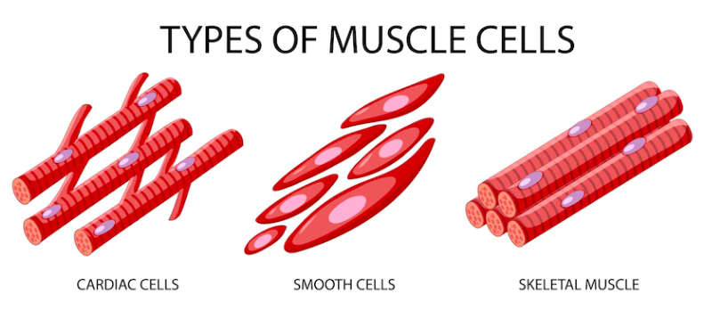
Nervous tissue
Two types of tissue are found in the nervous system:
- excitable cells —these are called neurones and they initiate, receive, conduct and transmit information
- non-excitable cells —these support the neurones.
Tissue regeneration
When tissue regeneration occurs it is essential that some of the original cells are available to replicate by mitosis. The extent to which regeneration is possible depends on the normal rate of physiological turnover of particular types of cells. Those with a rapid turnover regenerate most effectively. There are three types.
Labile cells. Labile cells are those in which replication is normally a continuous process. They include cells in:
- epithelium for example.., skin, mucous membrane, secretory glands, ducts, the uterus lining
- bone marrow
- blood
- spleen
- lymphoid tissue.
Stable cells.
Stable cells have retained the ability to replicate but do so infrequently. They include:
- liver, kidney and pancreatic cells fibroblasts
- smooth muscle cells
- osteoblasts and osteoclasts in bone.
Permanent cells.
Permanent cells are unable to replicate after normal growth is complete. They include:
- nerve cells (neurones)
- skeletal and cardiac muscle.

