EYE:
The eyes are responsible for the detection of visible light, the part of the electromagnetic spectrum with wavelengths ranging from about 400 to 700 nm.

Accessory Structure of Eye:
The accessory structures of the eye include the eyelids, eyelashes, eyebrows, the lacrimal (tearing) apparatus, and extrinsic eye muscles.
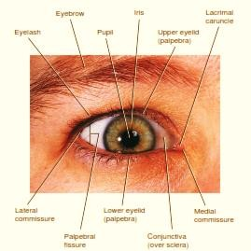

Eyelids

- The upper and lower eyelids shade the eyes during sleep, protect the eyes from excessive light and foreign objects, and spread lubricating secretions over the eyeballs.
- The upper eyelid is more movable than the lower.

Eyelashes and Eyebrows
- The eyelashes from the border of each eyelid and the eyebrows which located transversely above the upper eyelids.
- It helps to protect the eyeballs from foreign objects, perspiration, and the direct rays of the sun.
- Sebaceous glands at the base of the hair follicles of the eyelashes, called sebaceous ciliary glands, release a lubricating ﬂuid into the follicles.
- Infection of these glands is called a sty.

The Lacrimal Apparatus
- The lacrimal apparatus is a group of structures that produces and drains lacrimal ﬂuid or tears.
- The lacrimal glands, each about the size and shape of an almond, secrete lacrimal ﬂuid, which drains into 6–12 excretory lacrimal ducts that empty tears onto the surface of the conjunctiva of the upper lid.
- From here the tears pass medially over the anterior surface of the eyeball to enter two small openings called lacrimal puncta.
- Tears then pass into two ducts, the lacrimal canals, which lead into the lacrimal sac and then into the nasolacrimal duct.
&

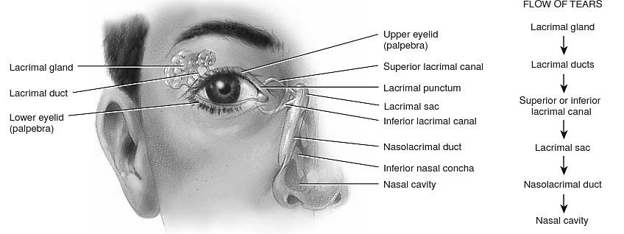

Anatomy of the Eye Ball:
The adult eyeball size is about 2.5 cm (1 in.) in diameter. Out of total surface area, only the anterior one-sixth is exposed and the remaining part is protected by the orbit in to which it ﬁts. The wall of the eyeball consists of three layers:

Fibrous tunic:
- The ﬁbrous tunic is the superﬁcial layer of the eyeball and consists of the anterior cornea and posterior sclera.
- The cornea is a transparent coat that covers the colored iris. Because it is curved, the cornea helps focus light onto the retina.
- The sclera is the white portion of the eye.
- The sclera covers the entire eyeball except the cornea.
- It gives shape to the eyeball.
- At the junction of the sclera and cornea is an opening known as the scleral venous sinus (canal of Schlemm). A ﬂuid called aqueous humor drains into this sinus
- Vascular tunic:
- The vascular tunic also known as uvea. It is the middle layer of the eyeball.
- It is composed of three parts: choroid, ciliary body, and Iris.
Choroid
- It is the posterior portion of the vascular tunic and its lines most of the internal surface of the sclera.
- It is highly vascularized and numerous blood vessels provide nutrients to the posterior surface of the retina.
- The choroid also contains melanocytes that produce the pigment melanin, which causes this layer to appear dark brown in color.
- Melanin in the choroid absorbs stray light rays so it prevents reﬂection and scattering of light in to the eyeball. Due to that, the image cast on the retina by the cornea and lens remains sharp and clear.
- In the anterior portion of the vascular tunic, the choroid consist the ciliary body.

Ciliary processes
- These are protrusions or folds on the internal surface of the ciliary body.
- They contain blood capillaries that secrete aqueous humor.

Iris
- It is the colored portion of the eyeball.
- It is located between the cornea and the lens and is attached at its outer margin to the ciliary processes.
- It consists of melanocytes and circular and radial smooth muscle ﬁbers.
- The amount of melanin in the iris determines the eye color.
- The eyes appear brown to black when the iris contains a large amount of melanin, blue when its melanin concentration is very low, and green when its melanin concentration is moderate.
- A principal function of the iris is to regulate the amount of light entering the eyeball through the pupil, the hole in the center of the iris.

Retina:

- It is the third and inner layer of the eyeball.
- The retina, lines the posterior three-quarters of the eyeball and is the beginning of the visual pathway.
- The surface of the retina is the only place in the body where blood vessels can be viewed directly and examined for pathological changes, such as those that occur with hypertension, diabetes mellitus, cataracts, and age-related macular disease.
- The retina consists of a pigmented layer and a neural layer.
- The pigmented layer is a sheet of melanin-containing epithelial cells located between the choroid and the neural part of the retina.
- The neural (sensory) layer of the retina is a multilayered outgrowth of the brain that processes visual data extensively before sending nerve impulses into axons that form the optic nerve.
- Three distinct layers of retinal neurons are: The photoreceptor layer, The bipolar cell layer and The ganglion cell layer which are separated by two zones, the outer and inner synaptic layers
  - Photoreceptors are specialized cells that begin the process by which light rays are ultimately converted to nerve impulses.
  - There are two types of photoreceptors: rods and cones.
  - Each retina has about 6 million cones and 120 million rods.
  - Rods allow us to see in dim light, such as moonlight. Because rods do not provide color vision, in dim light we can see only black, white, and all shades of gray in between.
&
  - Brighter lights stimulate cones, which produce color vision. Three types of cones are present in the retina: (1) blue cones, which are Sensitive to blue light, (2) green cones, which are sensitive to green light, and (3) red cones, which are sensitive to red light.
  - From photoreceptors, information ﬂows through the outer synaptic layer to bipolar cells and then from bipolar cells through the inner synaptic layer to ganglion cells.
  - The axons of ganglion cells extend posteriorly to the optic disc and exit the eyeball as the optic (II) nerve.
  - The optic disc is also called the blind spot.
  - Because it contains no rods or cones, we cannot see an image that strikes the blind spot.
  - Normally, we are not aware of having a blind spot, but we can easily demonstrate its presence.
  - Hold this page about 20 in. from your face with the cross shown below directly in front of your right eye. You should be able to see the cross and the square when you close your left eye.
  - Now, keeping the left eye closed, slowly bring the page closer to your face while keeping the right eye on the cross.
  - At a certain distance the square will disappear from your ﬁeld of vision because its image falls on the blind spot.


- The macula lutea is in the exact center of the posterior portion of the retina, at the visual axis of the eye.
- The fovea centralis a small depression in the center of the macula lutea, contains only cones.
&
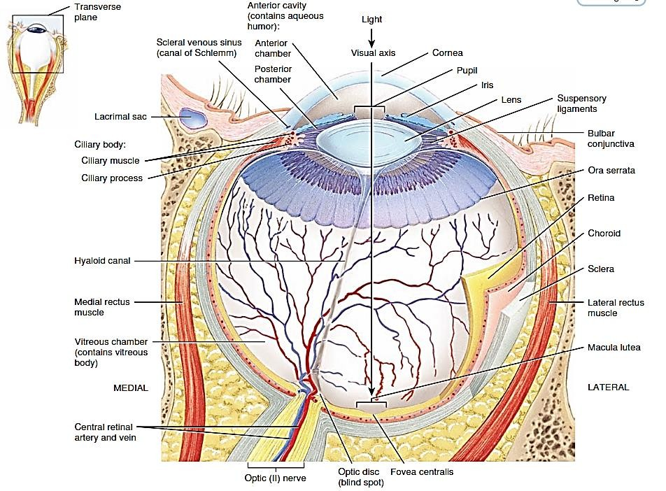

Lens
D.
- It is located behind the pupil and iris, within the cavity of the eyeball.
- It is made up by proteins called crystalline.
- The lens divides the interior of the eyeball into two cavities
The anterior cavity:
- The anterior cavity—the space anterior to the lens—consists of two chambers. The anterior chamber lies between the cornea and the iris.
- The posterior chamber lies behind the iris and in front of the zonular ﬁbers and lens.
- Both chambers of the anterior cavity are ﬁlled with aqueous humor a transparent watery ﬂuid that nourishes the lens and cornea.
- Vitreous chamber:
  - Vitreous chamber lies between the lens and the retina.
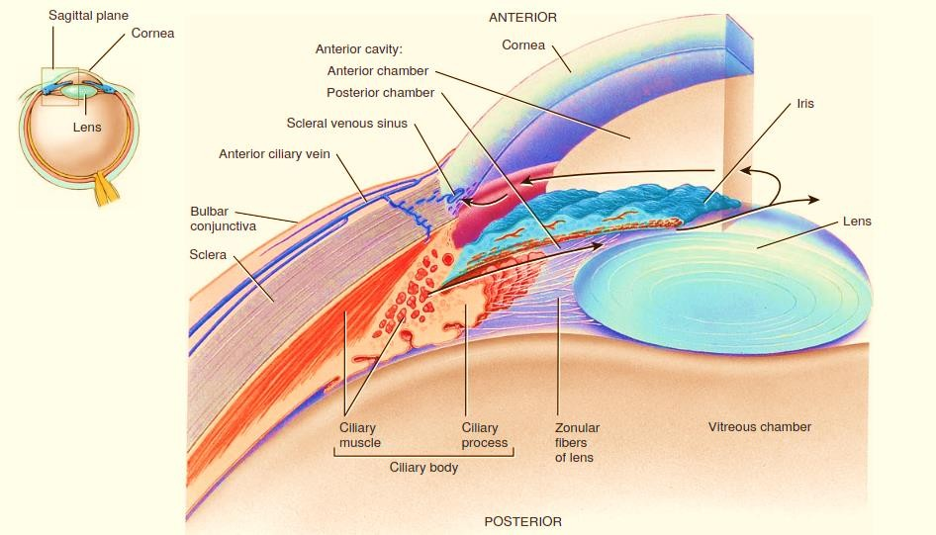
  - It is a transparent jellylike substance that holds the retina ﬂush against the choroid.
&
TRIVEDI

Physiology of Vision:
- The ﬁrst step in visual transduction is absorption of light by a photo pigment, a colored protein that undergoes structural changes when it absorbs light, in the outer segment of a photoreceptor.
- Light absorption initiates the events that lead to the production of a receptor potential.
- The single type of photo pigment in rods is rhodopsin
- Three different cone photo pigments are present in the retina, one in each of the three types of cones.
- Color vision Photo pigments respond to light in the following cyclical process
- In darkness, retinal has a bent shape, called cis-retinal, which ﬁts tightly into the opsin portion of the photo pigment.
- When cis-retinal absorbs a photon of light, it straightens out to a shape called trans- retinal.
- This cis-to-trans conversion is called isomerization and is the ﬁrst step in visual transduction.
- After retinal isomerizes, several unstable chemical intermediates form and disappear.
- These chemical changes lead to production of a receptor potential.
- In about a minute, trans-retinal completely separates from opsin.
- The ﬁnal products look colorless, so this part of the cycle is termed bleaching of Photo pigment.
- An enzyme called retinal isomerase converts trans-retinal back to cis-retinal.
- The cis-retinal then can bind to opsin, reforming a functional photo pigment.
- This part of the cycle—resynthesis of a photo pigment—is called regeneration.
&


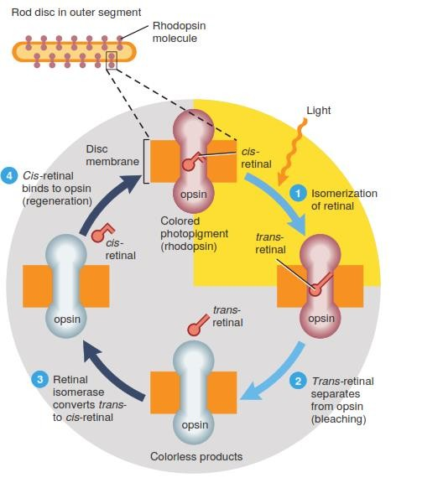

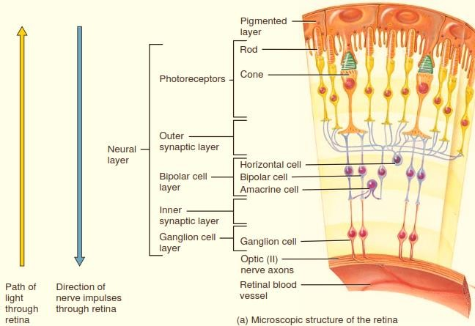
Visual Pathway:
N.

- Within the retina, certain features of visual input are enhanced while other features may be discarded.
- Input from several cells may either converge upon a smaller number of postsynaptic neurons or diverge to a large number.
- Overall, convergence predominates or strong: There are only 1 million ganglion cells, but 126 million photoreceptors in the human eye.
- Once receptor potentials arise in the outer segments of rods and cones, they spread through the inner segments to the synaptic terminals.
- Neurotransmitter molecules released by rods and cones induce local graded potentials in both bipolar cells and horizontal cells.
- Between 6 and 600 rods synapse with a single bipolar cell in the outer synaptic layer of the retina; a cone more often synapses with a single bipolar cell.
- The convergence of many rods onto a single bipolar cell increases the light sensitivity of rod vision but slightly blurs the image that is perceived.
- Cone vision, although less sensitive, is sharper because of the one to-one synapses between cones and their bipolar cells.
- Stimulation of rods by light excites bipolar cells; cone bipolar cells may be either excited or inhibited when a light is turned on.
- Horizontal cells transmit inhibitory signals to bipolar cells in the areas lateral to excited rods and cones.
- This lateral inhibition enhances contrasts in the visual scene between areas of the retina that are strongly stimulated and adjacent areas that are more weakly stimulated.
- Horizontal cells also assist in the differentiation of various colors.
- Amacrine cells, which are excited by bipolar cells, synapse with ganglion cells and transmit information to them that signals a change in the level of illumination of the retina. When bipolar or amacrine cells transmit excitatory signals to ganglion cells, the ganglion cells become depolarized and initiate nerve impulses.

Brain Pathway and Visual Fields:
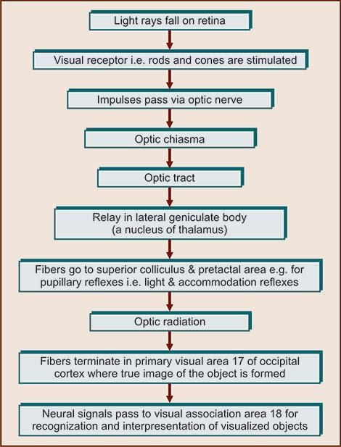

- The axons within the optic nerve pass through the optic chiasm a crossing point of the optic nerves.
- Some axons cross to the opposite side, but others remain uncrossed.
- After passing through the optic chiasm, the axons become a part of the optic tract and entered the brain and terminate in the lateral geniculate nucleus of the thalamus.
- Here they synapse with neurons whose axons form the optic radiations, which project to the primary visual areas in the occipital lobes of the cerebral cortex and visual perception begins.
- Everything that can be seen by one eye is that eye’s visual ﬁeld.
- As noted earlier, because our eyes are located anteriorly in our heads, the visual ﬁelds overlap considerably.
- We have binocular vision due to the large region where the visual ﬁelds of the two eyes overlap—the binocular visual ﬁeld.
- The visual ﬁeld of each eye is divided into two regions: the nasal or central half and the temporal or peripheral half.
- For each eye, light rays from an object in the nasal half of the visual ﬁeld fall on the temporal half of the retina, and light rays from an object in the temporal half of the visual ﬁeld fall on the nasal half of the retina.
- Visual information from the right half of each visual ﬁeld is conveyed to the left side of the brain, and visual information from the left half of each visual ﬁeld is conveyed to the right side of the brain, as follows:
- The axons of all retinal ganglion cells in one eye exit the eyeball at the optic disc and form the optic nerve on that side.
- At the optic chiasm, axons from the temporal half of each retina do not cross but continue directly to the lateral geniculate nucleus of the thalamus on the same side.
- In contrast, axons from the nasal half of each retina cross the optic chiasm and continue to the opposite thalamus.
- Each optic tract consists of crossed and uncrossed axons that project from the optic chiasm to the thalamus on one side.
- Axon collaterals (branches) of the retinal ganglion cells project to the midbrain, where they participate in neural circuits that govern constriction of the pupils in response to light and coordination of head and eye movements.
- Collaterals also extend to the suprachiasmatic nucleus of the hypothalamus, which establishes patterns of sleep and other activities that occur on a circadian or daily schedule in response to intervals of light and darkness.
- The axons of thalamic neurons form the optic radiations as they project from the thalamus to the primary visual area of the cortex on the same side.

