INSTRUMENTAL METHODS OF ANALYSIS- BP701T

UNIT : 5 - Ion exchange chromatography, Gel chromatography, Affinity chromatography
CLASS: 7
TOPIC: AFFINITY CHROMATOGRAPHY

INSTRUMENTATION:
The instrumentation for affinity chromatography typically includes:
- Affinity Column: This is a column packed with a chromatography matrix functionalized with the specific ligand. The column can vary in size and dimensions depending on the scale of the purification.
- Pump System: A pump system is used to control the flow of buffer solutions through the column. This ensures efficient sample loading, washing, and elution.
- Detectors: Various detectors such as UV-visible spectrophotometers, fluorescence detectors, or mass spectrometers can be used to monitor the eluate for the presence of the target biomolecule. These detectors provide information on the purity and concentration of the purified product.
- Fraction Collector: A fraction collector is used to collect and store the eluted fractions containing the purified target biomolecule. These fractions can be further analyzed or used for downstream applications.
- Control and Data Analysis Software: Sophisticated software is often employed to control the chromatography system parameters, monitor the chromatograms, and analyze the data generated during the purification process.
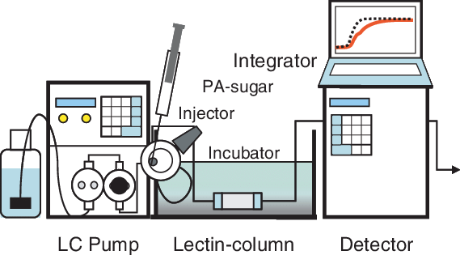
Fig. Instrumentation of Affinity Chromatography
APPLICATIONS:
Affinity chromatography can be used to:
- Purify and concentrate a substance from a mixture into a buffering solution.
- Discern what biological compounds bind to a particular substance, such as drugs.
- For the affinity purification of antibodies from blood serum.
- For the purification of recombinant proteins.
- Lectin affinity chromatography used to separate components within the sample.
- To save time, the HiTrap column range is excellent for routine laboratory scale applications in which the risk of cross-contamination must be eliminated for fast method development before scale up purification.

