INSTRUMENTAL METHODS OF ANALYSIS- BP701T

UNIT : 5 - Ion exchange chromatography, Gel chromatography, Affinity chromatography
CLASS: 6
TOPIC: AFFINITY CHROMATOGRAPHY

INTRODUCTION:
Affinity chromatography also known as bio-selective adsorption is a method of separating biochemical mixtures, based on a highly specific biological interaction between one kind of solute molecule and a second molecule covalently attached (immobilized) to the stationary phase.

PRINCIPLE:
The principle of affinity chromatography relies on the specific binding interactions between a target biomolecule (e.g., protein, nucleic acid, or enzyme) and a ligand immobilized on a chromatography matrix. The ligand is selected based on its affinity for the target molecule. Common types of interactions exploited in affinity chromatography include antigen-antibody, enzyme-substrate, receptor-ligand, and DNA-protein interactions.
PROCEDURE:
COMPONENTS OF AN AFFINITY PHASE:

Matrix: for ligand attachment. Matrix should be chemically and physically inert. It must be easily coupled to a ligand or spacer arm. Sepharose provides a macro porous matrix with high chemical and physical stability.
Sepharose is the bead form of agarose gel. Agarose is the most popular polymer of D-galactose and 3,6-anhydro-L-galactose. Glass, cellulose, dextran or a duel composition of polyacrylamide can also be used.
It must exhibit good flow properties and have large surface area for attachment.
Spacer arm: used to improve binding between ligand and target molecule by overcoming any effects of stearic hindrance.
Ligand: molecule that binds reversibly to a specific target molecule or group of target molecules.
Two general types of ligands:
Specific : binds only to one species.
antibody/antigen.
General : group specific. Binds to specific groups on target species.

The process typically involves several steps:
- Matrix Preparation: The chromatography matrix is functionalized or modified to immobilize the ligand. The ligand can be covalently attached or adsorbed onto the matrix surface.
- Sample Loading: The sample containing the target biomolecule is applied to the affinity column. The target molecule selectively interacts with the immobilized ligand, while non-specific molecules are washed away.
- Washing: Non-bound molecules are washed out of the column, leaving only the target biomolecule bound to the ligand.
- Elution: The bound target biomolecule is eluted from the column using a suitable elution buffer or changing the conditions to disrupt the binding interaction. Elution can be achieved by altering pH, ionic strength, or adding competitive ligands that displace the target molecule from the ligand.
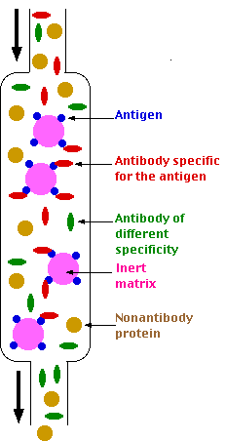
ELUTION METHODS:
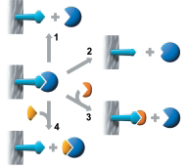
Method 1:
The simplest case. A change of buffer composition elutes the bound substance without harming either it or the ligand.
Method 2:
Extremes of pH or high concentrations of chaotropic agents are required for elution, but these may cause permanent or temporary damage.
Methods 3 and 4:
Specific elution by addition of a substance that
competes for binding. These methods can enhance the specificity of media that use group-specific ligands.
Different elution methods:
- Selective elution methods- group specific ligands.
- Non-selective elution-highly specific ligands.
- pH elution
- Ionic strength elution.Ex: sodium chloride.
- Competitive elution
- Reduced polarity of eluent. Ex: dioxane.
- Chaotropic eluents.Ex: guanidine hydrochloride.

Samples Types of ligand used
Enzymes - substrate, inhibitor, cofactor.
Antibody - antigen, virus, cell.
Lectin - polysaccharide, glycoprotein.
Nucleic acid - histone, binding protein, etc.
Hormones - receptor, carrier protein.

