INSTRUMENTAL METHODS OF ANALYSIS- BP701T

UNIT : 5 - Ion exchange chromatography, Gel chromatography, Affinity chromatography

CLASS: 4
TOPIC: GEL CHROMATOGRAPHY

INTRODUCTION:
Gel Chromatography is a liquid - liquid chromatography known as gel permeation, molecular sieving or size exclusion chromatography. It is a chromatographic technique in which the separation of components occurs based on the molecular size of the solute molecules.
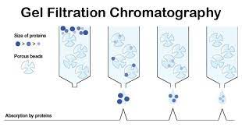
PRINCIPLE:
The stationary phase in this method is an open network of polymers(sephadex) which are cross-linked to each other to form the pores of consistent size.
The degree of cross- linking of polymer mainly governs the pore size.
When the mobile phase containing mixture of solutes of various sizes is passed through the column, the molecules which are too large to enter the pores are “excluded” completely and get eluted with the mobile phase.
The molecules which are smaller in size diffuse in and out of the pores, thus the path travelled by them through the column is quite longer and they are eluted later.
Thus, the components of mixture get eluted from the column in the order of their relative molecular sizes.
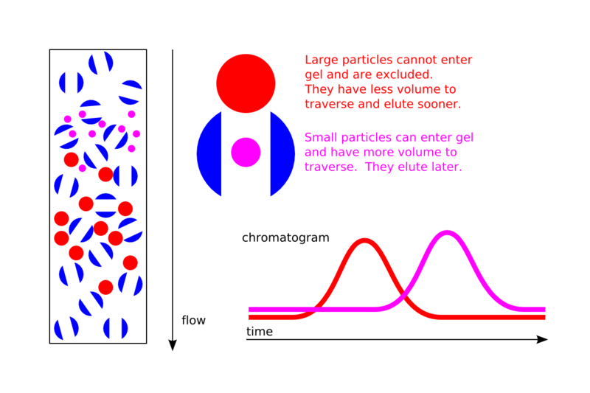
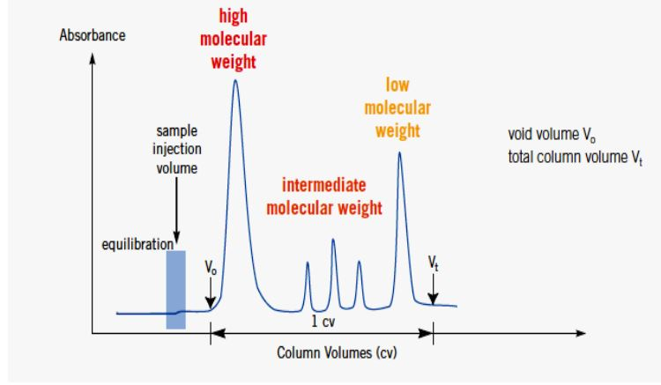
Fig.: Typical chromatogram obtained in gel filtration chromatographic technique
THEORY OF SEPARATION
A column is made up of swollen gel particles and solvent is used to swell the gel in a suitable tubular container.
An equation is given below:
Vt = Vg + Vl + Vo
Where,
Vt = the total volume of the column (which can be measured),
V0 = free volume outside the gel matrix (also known as void or dead volume),
Vl = volume of solvent held in the pores or interstices.
Vg = volume occupied by the solid matrix of the gel.
Nature of Gel:
• Chemically inert
• Mechanically stable
• Ideal porous structure (Wide pore size gives low resolution)
• Uniform particle size
TYPES OF GELS USED
• The gels used as molecular sieves are cross linked polymers.
• They are uncharged and inert i.e., don’t bind or react with the materials being analyzed.
• Three types of gels are used:
1. Dextran (Sephadex)
2. Agarose gel
3. Acrylamide gels (synthetic gel)
1. DEXTRAN (SEPHADEX):
Dextran is a homopolysaccharide of glucose residues. • It is prepared with various degrees of cross-linking to control pore size.
It is bought as dry beads, the beads swell when water is added.
1-6 polymer of glucose is prepared by microbial fermentation of sucrose (glucose + fructose). • The resulting glucose provides the required α 1-6 glucosan polymer called dextran.
The resulting dextran is treated with epichlorohydrin to give several types of cross- linked dextran (sephadex).
It is mainly used for separation of small peptides and globular proteins with small to average molecular mass.
Sephadex is obtained in different degrees depending on the pore size. High percentage of epichlorohydrin give high degree of cross linking (small pore size), lower percentage produce sephadex with large pore size.
Characters of Sephadex:
Highly stable gels. • Stable at pH 2-12.
Their particles are free from ions.
Insoluble in water and organic solvent.
They swell in water and other hydrophilic solvent.
They require bactericidal such as Hg acetate.
2. AGAROSE GEL:
Obtained from agar and composed of alternating units of 1,3 linked β-D-gal and 1,4 linked 3,6-anhydro-α, L-galactose.
This was subjected to epichlorohydrin to give sepharose.
It dissolves in H2O at 50ºC and on cooling form gel. Insoluble below 40ºC. Freezing destroys the gel.
3. ACRYLAMIDE GELS (SYNTHETIC GEL):
It is not dextran polymer. It is a polymerized acrylamide or methylene-bis-acrylamide. The separation properties of polyacrylamide gels are mainly the same as those of dextrans.
The xerogels of the polyacrylamide (Bio-gel) are semi rigid gels. The dextrans and the polyacrylamide gels are unable to withstand the high pressure in HPLC. Hence modern stationary phases consist of microparticles of styrene divinyl benzene copolymers (ultrastyragel), silica or porous glass.

