INSTRUMENTAL METHODS OF ANALYSIS- BP701T

UNIT : 5 - Ion exchange chromatography, Gel chromatography, Affinity chromatography

CLASS: 2
TOPIC: ION EXCHANGE CHROMATOGRAPHY

PRACTICAL REQUIREMENTS:
Column material and dimension:
Glass, high quality stainless steel or polymers which are resistant to strong acids and alkalis.
The column dimensions length: diameter ratio of 20: 1 to 100: 1 for higher efficiency.
2. Selection of type of ion exchange resin depends on following properties
a.) type of ions - anions or cations
b.) nature of ions - stong or weak
c.) efficiency of resin - measured by ion exchange capacity
m.eq/g = 1000/eq.wt
d.) Particle size - 50 -100 mesh or 100 - 200 mesh
e.) Structural type - porous or pellicular etc.
3. Packing of column - wet packing method is used
4. Mobile phase – acids like 0.1N HCl, alkali like 1N NaOH, and buffers like phosphate, acetate and borate. Organic solvents are not used.
5. Development of chromatogram - Isocratic and gradient elution technique (for complex mixtures).
6. Analysis of the elute - depending on the nature and quantity of the sample several methods are there: Spectrophotometric method, Polarographic method, Conductometric method, Amperometric method, Flame photometric method, Radio chemical methods.
7. Regeneration of ion exchange resin - replacement of the exchangeable cations or anions present in the original resin. cation exchange resin is done by charging the column with strong acid like HCl. Anion exchange resin is done by using strong alkali like sodium hydroxide or potassium hydroxide.
PROCEDURE:
The basic process of chromatography using ion exchange can be represented in 5 steps:
- Eluent loading
The eluent loaded onto the column displaces any anions bonded to the resin and saturates the resin surface with the eluent anion.
2. Sample injection:
A sample containing anion A and anion B are injected onto the column. This sample could contain many different ions.
3. Separation of sample:
After the sample has been injected, the continued addition of eluent causes a flow through the column. As the sample elutes anion A and anion B adhere to the column surface differently.
4. Elution of analyte A:
As the eluent continues to be added, the anion A moves through the column in a band and ultimately is eluted first.
5. Elution of analyte B:
The eluent displaces anion B, and anion B is eluted off the column. The overall 5 step process can be represented pictorally.
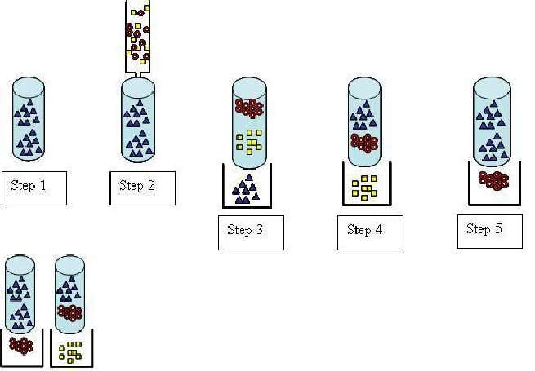

INSTRUMENTATION OF IEC:
1. Pump:
The IEC pump is considered to be one of the most important components in the system which has to provide a continuous constant flow of the eluent through the IEC injector, column, and detector.
2. Sample introduction:
The simplest method is to use an injection valve. Liquid samples may be injected directly and solid samples need only to be dissolved in an appropriate solvent.
Injectors should provide the possibility of injecting the liquid sample within the range of 0.1 to 100 ml of volume with high reproducibility and under high pressure (up to the 4000 psi).
3. Columns:
Depending on its ultimate use and area of application, the column material may be stainless steel, titanium, glass or an inert plastic such as PEEK.
The column can vary in diameter from about 2 mm to 5 cm and in length from 3 cm to 50 cm depending on whether it is to be used for normal analytical purposes, micro analysis, high speed analysis or preparative work.
4. Suppressor:
The suppressor reduces the background conductivity of the chemicals used to elute samples from the ion-exchange column which improves the conductivity measurement of the ions being tested.
IC suppressors are membrane-based devices which are designed to convert the ionic eluent to water as a means of enhancing the sensitivity.
5. Detectors:
Electrical conductivity detector is commonly used.
6. Data system:
In routine analysis, where no automation is needed, a pre-programmed computing integrator may be sufficient.

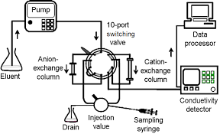
Fig. Block diagram of instrumentation of IEC

