INSTRUMENTAL METHODS OF ANALYSIS- BP701T

UNIT : 5 - Ion exchange chromatography, Gel chromatography, Affinity chromatography

CLASS: 1
TOPIC: ION EXCHANGE CHROMATOGRAPHY

INTRODUCTION
The most popular method for the purification of proteins and other charged molecules is ion exchange chromatography (IEC).
It is a type of liquid- solid chromatography that is specially applicable to ionic species.
PRINCIPLE:
This form of chromatography relies on the attraction between oppositely charged stationary phase, known as an ion exchanger and an analyte.
The ion exchangers basically contain charged groups covalently linked to the surface of an insoluble matrix.
The charged groups of the matrix can be positively or negatively charged.
When suspended in an aqueous solution, the charged groups of the matrix will be surrounded by ions of the opposite charge.
In this “ion cloud”, ions can be reversibly exchanged without changing the nature and the properties of the matrix.
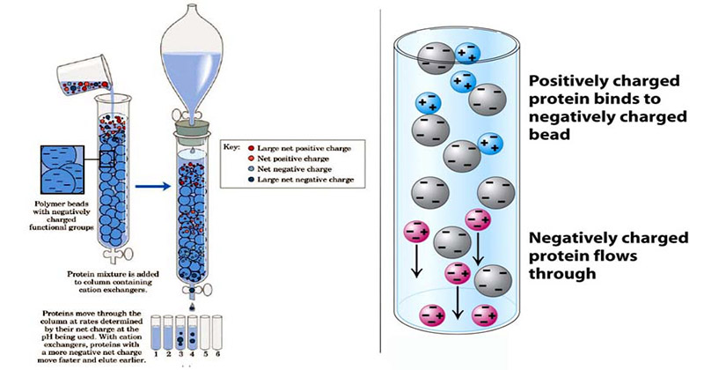
The technique of IEC can be studied with respect to the following:
- Ion exchange resins - Classification of resins
- Practical requirements
- Factors affecting ion exchange resins
- Procedure
- Instrumentation
- Advantages and Limitations
- Applications
Classification of ion exchange resins:
Two types of ion exchangers are used: i.e., cationic and anionic exchangers.

1. Cationic exchangers possess negatively charged group, and these will attract positively charged cations.
the cations retained by the solid matrix can be eluted by using buffers of different strength and hence seperation of cations can be effected.
These exchangers are also called “Acidic ion exchange” materials, because their negative charges result from the ionization of acidic group.
A cation is an ion with a positive charge. Common cations include Ca+2, Mg+2, Fe+2, and H+1
- Anionic exchangers have positively charged groups that will attract negatively charged anions.
The anions retained by the solid matrix can be eluted by using buffers of different strength and hence seperation of anions can be effected.
These are also called “Basic ion exchange” materials.
An anion is an ion with a negative charge. Common anions include Cl-1, SO4-2, and OH-1
Chemically, both types are similar and belong to a group of compounds called polymers, which are extremely large molecules that are formed by the combination of many molecules of one or two compounds in a repeating structure that produces long chains.
Ion exchange resins consists of beads of highly polymerized, crosslinked, organic materials containing large number of acidic or basic groups.
Although the resins are insoluble in water, the active sites are hydrophillic and have varying degrees of affinity for ionic solutes.
- There are FOUR BASIC TYPES of IEC:
1. Strongly Acidic Cation Exchange Resin:
Sulphonated polystyrene resins. pH range: 1-14
2. Weakly Acidic Cation Exchange Resin:
Carboxylic polymethacrylate. pH range: 5-14
3. Strongly Basic Anion Exchange Resin:
Quaternary ammonium polystyrene. pH range: 0-12
4. Weakly Basic Anion Exchange Resin:
Phenol formaldehyde and polyamine polystyrene. pH range: 0-9
- According to the source they are divided into two,
1. Natural:
Cation – Zeolytes, Clay, etc ✓
Anion – Dolomite
2. Synthetic: ✓
In organic and Organic resins
Of the above types organic resins are most widely used.
- Depending on the structure IEC contains 4 types. They are:
1. Pellicular type with ion exchange film:
less efficient
2. Porous resin coated with exchanger beads:
totally porous and highly efficient. 0.5-2 meq/g of IEC
3. Macro reticular resin bead: less efficient
4.Surface sulfonated and bonded electro statically with anion exchanger: less efficient
