INSTRUMENTAL METHODS OF ANALYSIS- BP701T

UNIT : 4 GC and HPLC
CLASS: 8
TOPIC: GAS CHROMATOGRAPHY
DETECTORS
Characteristics of an ideal detector:
- Adequate sensitivity (application specific, i.e. adequate for certain tasks).
- Sensitivity should lie in the range 10-8 to 10-15 g/mL.
- Good stability and reproducibility
- A linear response to solutes that extends over several orders of magnitude (calibration purposes).
- A wide temperature range.
- A short response time independent of flow rate
- High reliability and ease of use .
1. KATHAROMETER/ Thermal Conductivity Detector (TCD):
It works on the principle of Wheat stone's bridge.
The differential technique is based on the measurement of the difference in thermal conductivity and resistance between the carrier gas and the sample mixture in effluent when the platinum wires are heated electrically is amplified and recorded.
the thermal conductivity of some carrier gases are:
H2 - 32.7, He - 33.9, N2 - 5.2, Methane - 6.5, Hexane - 3.0
Advantages:
Simplicity, applicable to most compounds
large linear dynamic range,
non destructive, used in preparative scale.
Disadvantages:
Low sensitivity
affected by fluctuations in temperature and flow rate
not used for biological samples
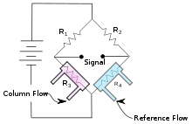
2. Flame Ionization Detector (FID):
Based upon electrical conductivity of carrier gases.
The flame ionization detector passes sample and carrier gas from the column through a hydrogen-air flame.
The hydrogen gas alone creates few ions, but when an organic compound is burned there is an increase in ions produced.
A polarizing voltage attracts these ions to a collector located near the flame.
The current produced is proportional to the amount of sample being burned.
This current is sensed by an electrometer, converted to digital form, and sent to an output device.
Advantages:
Universal detector for organics
Does not respond to common inorganic compounds
Carrier gases not detected
Limit of detection: FID is 1000x better than TCD
Linear and dynamic range better than TCD
Disadvantage:
Destructive detector

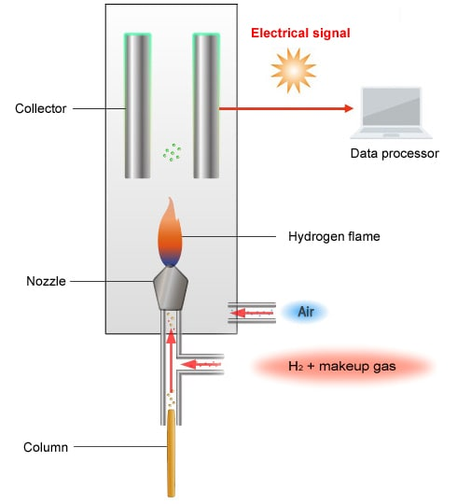
3. ARGON IONISATION DETECTOR
Irradiating the carrier gas {ARGON} with radiation α (from radium -D) and β particles (Sr and Tritium). - high energy particles - ARGON -Metastable state - collide with effluent molecules - ionises the sample - increase in current when these sample ions reach the detector.
- ELECTRON CAPTURE DETECTOR
Consists of two electrodes, one electrode is treated with radioactive isotope
A electric potential of 20 V is applied between them.
For compounds with high e affinity - ARGON
For compounds with low e affinity -N2, H2, He, CO2 as carrier gas.
Advantages:
1. Useful for environmental testing detection of chlorinated pesticides or herbicides; polynuclear aromatic carcinogens, organ metallic compounds selective for halogen- (I, Br, Cl, F).
2. Nitro and sulfur-containing compounds detects polynuclear aromatic compounds, anhydrides and conjugated carbonyl compounds.
3. used for nanogram quantity.
Disadvantages:
Electron capture detector could be affected by the flow rate, only for compounds with electron affinity.
