INSTRUMENTAL METHODS OF ANALYSIS- BP701T

UNIT : 4 GC and HPLC
CLASS: 7
TOPIC: GAS CHROMATOGRAPHY

COLUMN
The column is the most important component of gas chromatography.
Made up of glass (are inert - used for steroids) or stainless steel.
The main chemical attribute when choosing a column is the polarity of mixture, but functional groups can also play a large part in column selection.
The polarity of the sample must closely match the polarity of column stationary phase to increase resolution and separation while reducing run time.
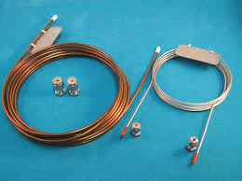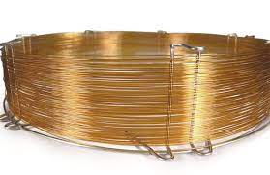
A. Depending On Use:
1. ANALYTICAL COLUMN: 1-1.5 metres, outer diameter: 3-6mm
2. PREPARATIVE COLUMN: 3 - 6 metres, outer diameter: 6-9mm

B. Depending On Its Nature
1. PACKED COLUMN: ex: polydimethyl siloxane{non-polar}, PEG{polar}
2. OPEN TUBULAR COLUMN/ CAPILLARY COLUMN/ GOLAY COLUMN
30 - 90 metres length, inner diameter: 0.025= 0.075cm. inner liquid film(0.5-1µ), show least resistance to carrier gas flow
Disadvantage- small sample load
3. SCOT COLUMNS(Support coated open tubular column) micron size porous layer of support material on inner wall
Advantage - more sample load.
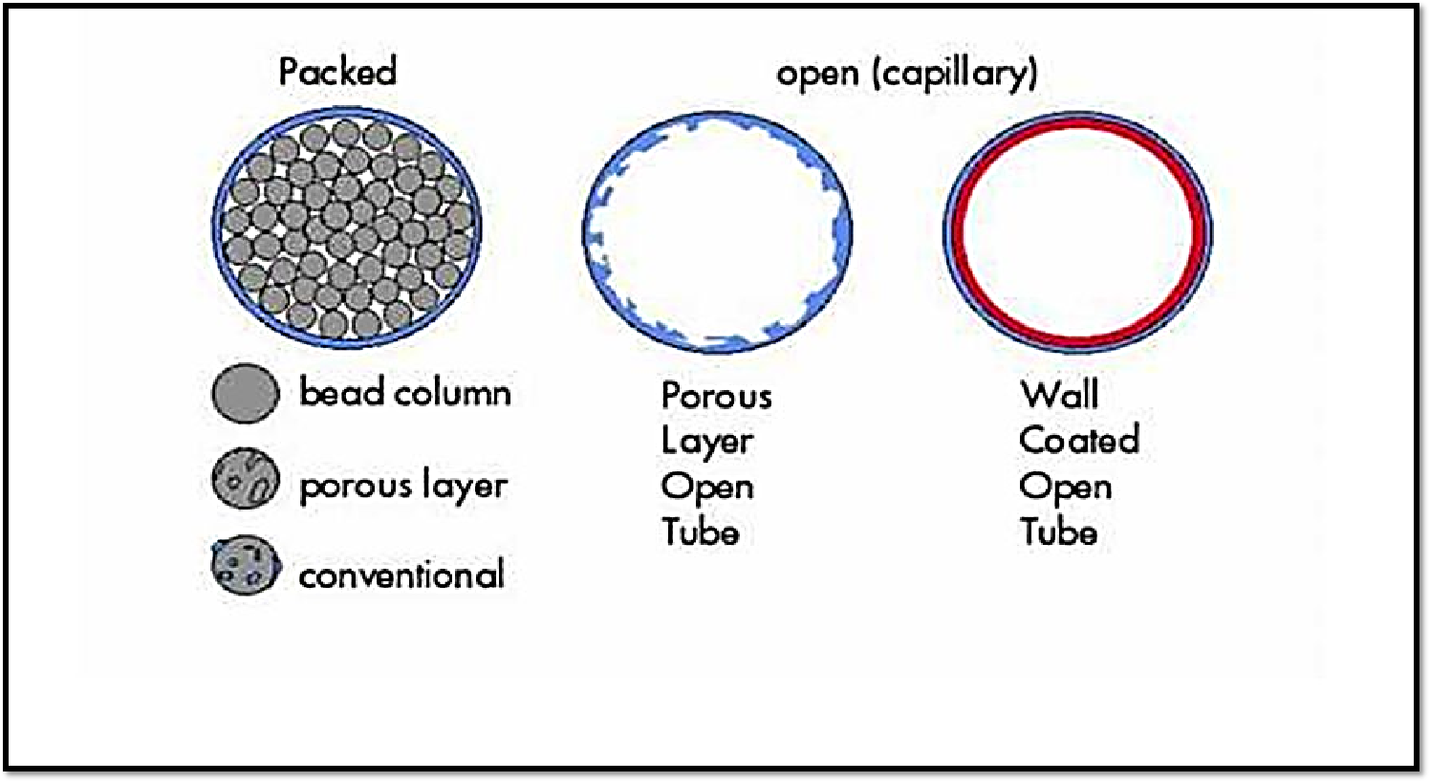
PACKED COLUMNS:
Packed columns contain a finely divided, inert, solid support material (commonly based on diatomaceous earth) which absorbs liquid used as stationary phase.
Most packed columns are 2-20m in length and have an internal diameter of 1 -8mm.
Advantages: Large sample capacity
Disadvantages: Less applicable - fixed gas analysis
Lower column efficiency than that of capillary column
CAPILLARY COLUMNS
Thin fused silica, 10 – 100m in length and 250mm in diameter.
Stationary phase is coated on the inner column.
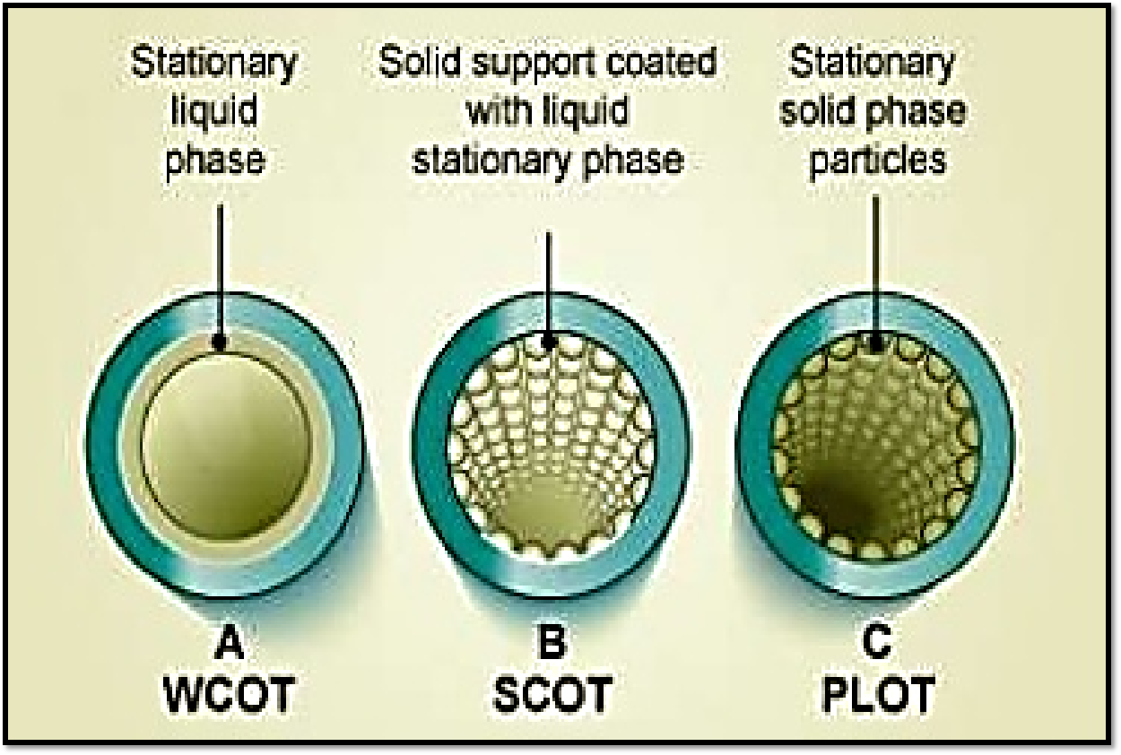

TEMPERATURE CONTROL DEVICES
The optimum column temperature depends upon the boiling point of the sample and the degree of separation required.
1. PREHEATERS: to convert sample into vapour form
2. THERMOSTATICALLY CONTROLLED OVEN: can maintain temperature nearest to 0.1℃
Two types of operations
1) Isothermal programming
2) Linear programming: initial 150℃ to 200℃ at end of seperation

