INSTRUMENTAL METHODS OF ANALYSIS- BP701T

UNIT : 4 GC and HPLC
CLASS: 6

TOPIC: GAS CHROMATOGRAPHY

INSTRUMENTATION OF GAS CHROMATOGRAPHY:
- Carrier gas (mobile phase)
- Flow regulators/ flow meters
- Sample injection systems
- Column (Stationary phase)
- Temperature control devices
- Detectors
- Recorders and Integrators
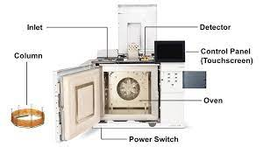

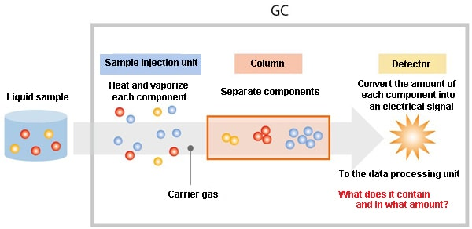
CARRIER GAS (MOBILE PHASE)
Carrier gases, which must be chemically inert, include hydrogen (it reacts with unsaturated compounds), helium(expensive), nitrogen(reduced sensitivity).
Associated with the gas supply there are pressure regulators, gauges, and flow meters.
In addition, the carrier gas system often contains a molecular sieve to remove water or other impurities.
Choice of the carrier gas depends on the factors like
- inertness
- nature of the sample
- high purity
- easily available
- column efficiency
- type of the detector used.
- cheap
- less risk of explosion/fire hazards.
- Nitrogen and Helium are generally preferred.
FLOW REGULATORS AND FLOW METER
In gas chromatography (GC), both rotameters and soap bubble meters are used for flow measurement.
- Rotameter: This is a simple device used to measure the flow rate of a gas or liquid in a closed tube. It consists of a tapered tube with a float inside that rises as the flow rate increases. The position of the float indicates the flow rate. Rotameters are commonly used in GC systems to regulate carrier gas flow rates.
- Soap Bubble Meter: In gas chromatography, a soap bubble meter is often used to precisely measure and control the flow of gases, particularly carrier gases. It works by capturing a known volume of the carrier gas in a soap film bubble. The volume of gas captured in the bubble can be determined by measuring the diameter of the bubble, which is typically done using a calibrated microscope. This method allows for accurate control of the carrier gas flow rates in GC systems.
Both devices are essential for maintaining precise and accurate flow rates in gas chromatography, which is critical for achieving reproducible and reliable separation of analytes.
ROTAMETER SOAP BUBBLE METER
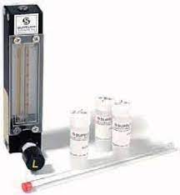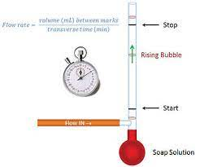
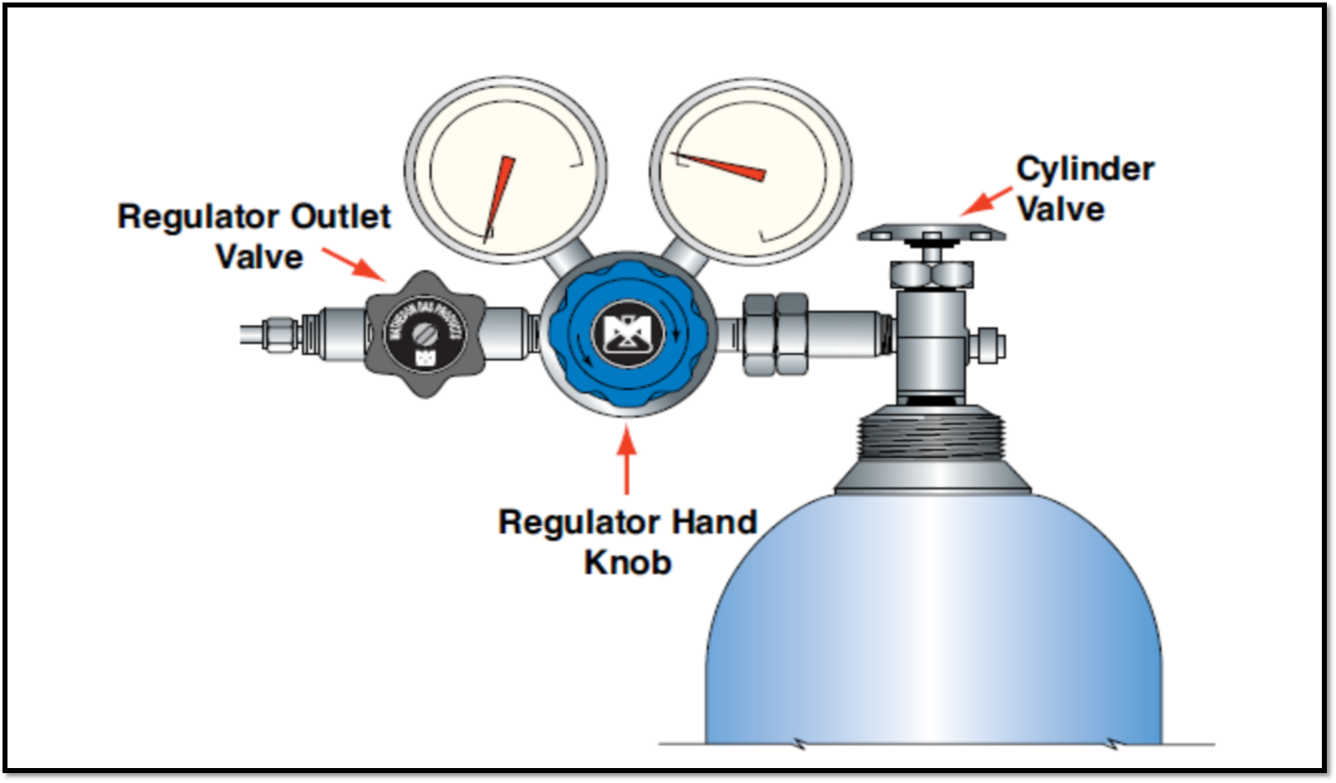
Sample Injection System
Column efficiency requires that the sample be of suitable size and be introduced as a “plug” of vapour.
Slow injection of oversized samples causes band spreading and poor resolution.
Sample is injected by a hypodermic needle through a self-sealing silicone rubber septum into a heated metal block at the head of the column.
The temperature of the sample port should be such that the liquid is rapidly vaporised but without decomposition of sample.
SAMPLES:
GAS - By valve devices
Liquids - loop/ septum devices( high quality silicone rubber septum)
Solids- dissolved in suitable solvent and then injected through septum

