INSTRUMENTAL METHODS OF ANALYSIS- BP701T

UNIT : 4 GC and HPLC
CLASS: 3

TOPIC: THEORY IN HIGH PERFORMANCE LIQUID CHROMATOGRAPHY
DATA INTERPRETATION IN HPLC WITH SYSTEM SUITABILITY RESULTS
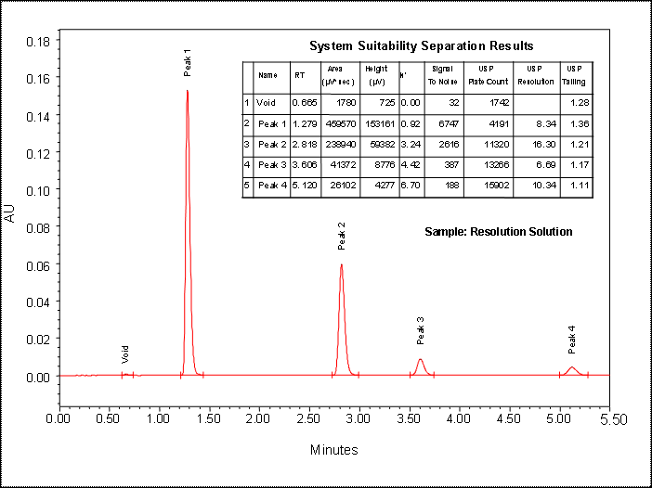
Column efficiency calculation
Theoretical plates: A chromatographic column does not consist of any physical plates which can be measured from time to time to rate a column’s performance efficiency.
The larger the number of theoretical plates per column, the sharper the peak. Calculate the number of theoretical plates per meter, using the following equation:
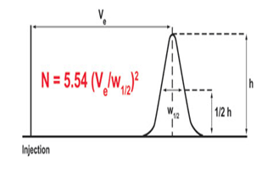
THEORY OF CHROMATOGRAPHY
Band broadening and column efficiency
To obtain optimal separations, sharp, symmetrical chromatographic peaks must be obtained. This means that band broadening must be limited. It is also beneficial to measure the efficiency of the column.

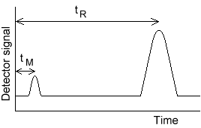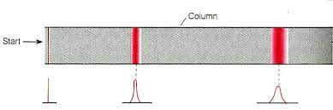
t R – retention time of sample
tM - time taken for MP to pass through column
1. The Plate Theory of Chromatography:
The plate model supposes that the chromatographic column is contains a large number of separate layers, called theoretical plates. Separate equilibrations of the sample between the stationary and mobile phase occur in these "plates". The analyte moves down the column by transfer of equilibrated mobile phase from one plate to the next.
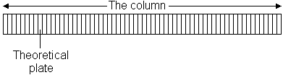

They also serve as a way of measuring column efficiency, either by stating the number of theoretical plates in a column, N (the more plates the better), or
By stating the plate height; the Height Equivalent to a Theoretical Plate (the smaller the better).
If the length of the column is L, then the HETP is HETP = L / N
The number of theoretical plates that a real column possesses can be found by examining a chromatographic peak after elution;
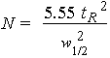

where w1/2 is the peak width at half-height.
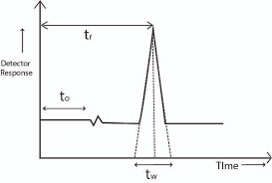
2. The Rate Theory of Chromatography:
The time taken for the solute to equilibrate between the stationary and mobile phase (unlike the plate model, which assumes that equilibration is infinitely fast). The resulting band shape of a chromatographic peak is therefore affected by the rate of elution.
It is also affected by the different paths available to solute molecules as they travel between particles of stationary phase. If we consider the various mechanisms which contribute to band broadening, we arrive at the
Van Deemter equation for plate height:
HETP = A + B / u + C u
where u is the average velocity (flow rate) of the mobile phase.
A, B, and C are factors which contribute to band broadening.
A -Eddy diffusion
Solute molecules will take different paths through the stationary phase at random. This will cause broadening of the solute band, because different paths are of different lengths.
B - Longitudinal diffusion
The concentration of analyte is less at the edges of the band than at the center. Analyte diffuses out from the center to the edges. This causes band broadening. If the velocity of the mobile phase is high then the analyte spends less time on the column, which decreases the effects of longitudinal diffusion.
C - Resistance to mass transfer
The analyte takes a certain amount of time to equilibrate between the stationary and mobile phase. If the velocity of the mobile phase is high, and the analyte has a strong affinity for the stationary phase, then the analyte in the mobile phase will move ahead of the analyte in the stationary phase. The band of analyte is broadened. The higher the velocity of mobile phase, the worse the broadening becomes.
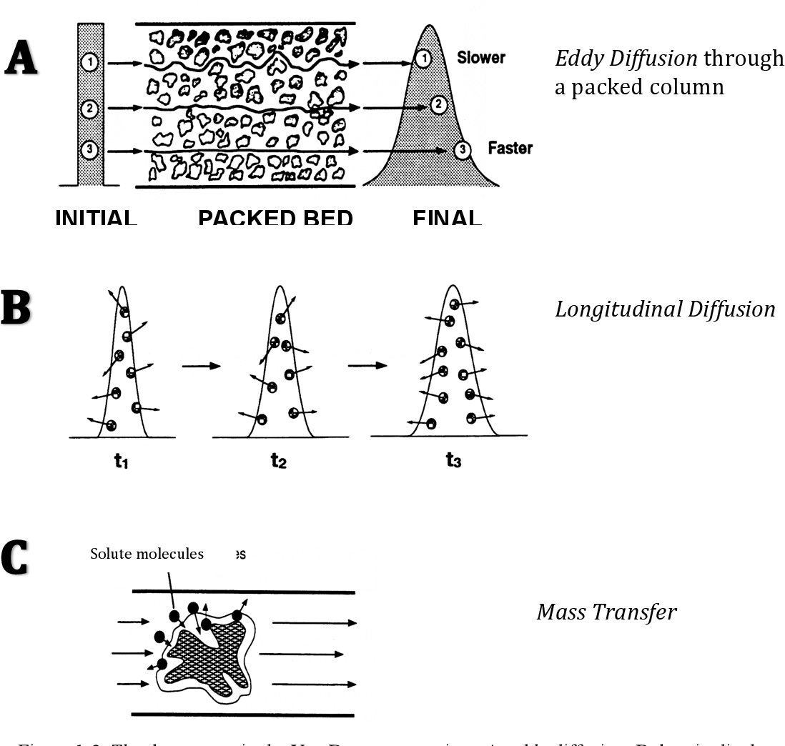
Height equivalent to a theoretical plate (HETP).
Martin and Synge also referred to this factor as the plate’s thickness.
HETP = L/N, where L is the column’s length and N is the number of plates.
So the shorter we keep the height, the better efficiency can be obtained because of the reduced depth of the stationary phase.
- Effects on Plate Number
Few factors that impose strong to medium effect on the number of theoretical plates:
- Size of the particle (very strong impact)
- Inter-connecting tubing’s dead volume (very strong impact)
- Profile of gradient (strong impact)
- Temperature of column (strong impact)
- Length of column (strong impact)
- Composition of stationary phase (medium impact)
- Composition of mobile phase (medium impact)
- Shape of the particle (medium impact)
- Uniformity of the particle’s shape (medium impact)
Peak Asymmetry Factor
Peak Asymmetry Factor (As) As = b/a
where b = distance from the peak midpoint (perpendicular from the peak highest point) to the trailing edge of the peak measured at 10% of peak height.
a = distance from the leading edge of the peak to the peak midpoint (perpendicular from the peak highest point) measured at 10% of peak height.
If As > 1 : tailing,
As < 1 : fronting
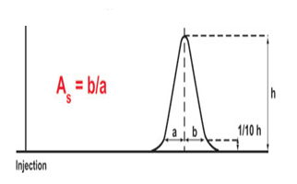
Tailing Factor
Tailing Factor (Tf) is the USP coefficient of the peak symmetry.
It is calculated using the following equation: Tf = (a+b)/2a
where a is the distance from the leading edge of the peak to the peak midpoint (perpendicular from the peak highest point) measured at 5% of peak height and
b is the distance from the peak midpoint (perpendicular from the peak highest point) to the trailing edge of the peak measured at 5% of peak height.
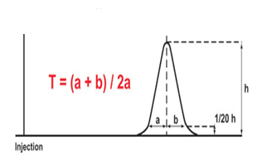
Resolution
Resolution (Rs) is a measure of the separation quality by how quickly and how completely target components in a sample separate as they pass through a column..
In order to determine the resolution between 2 peaks we need to measure the retention times of the 2 peaks of interest (tr2 and tr1) and the width of the 2 peaks at baseline (w1 and w2) between tangents drawn to the sides of the peaks. It is normally calculated as:
Rss = (tr2 – tr1) / ((0.5 * (w1 + w2)
Since nearly every peak shows some degree of tailing, so to allow for a small amount of tailing and still retain a bit of flat baseline between the peaks, Rs ≥ 2.0 generally is desired for proper resolution between 2 peaks of interest.

