INSTRUMENTAL METHODS OF ANALYSIS- BP701T

UNIT : 4 GC and HPLC
CLASS:1

TOPIC: HIGH PERFORMANCE LIQUID CHROMATOGRAPHY (HPLC)

INTRODUCTION

High-performance liquid chromatography (HPLC) is the fastest growing analytical technique for analysis of drugs. Its simplicity, high specificity and wide range of sensitivity make it ideal for the analysis of many drugs in both dosage forms and biological fluids.
According to IUPAC, chromatography is a physical method of separation in which components will be separated or distributed between stationary and mobile phases. High Performance Liquid Chromatography (HPLC) is the term used to describe liquid chromatography in which the liquid mobile phase is forced through the column at high speed as a result, the analysis time is reduced by 1-2 orders of the magnitude relative to classical column chromatography and the use of much smaller particles of the adsorbent or support becomes possible increasing the column efficiency substantially. The importance of chromatography is increasing rapidly in pharmaceutical analysis for the exact differentiation, selective identification and quantitative determination of structurally closely related compounds. Another important field of application of chromatographic methods is the purity testing of final products and the intermediates. The reasons for the popularity of the method is its sensitivity, its ready adaptability to accurate quantitative determinations, its suitability for separating non-volatile species or thermally fragile ones and its wide spread applicability to substances that are of prime interest to the industry.
Sensitive detectors have transformed liquid column chromatography into high speed, efficient, accurate and highly resolved method of separation.
The HPLC is the method of choice in the field of analytical chemistry, since this method is specific, robust, linear, precise and accurate and the limit of detection is low.
TYPES OF HPLC TECHNIQUES:
Based on modes of chromatography:
- Normal phase chromatography
- Reverse phase chromatography
Based on principle of separation:
- Adsorption chromatography
- Ion exchange chromatography
- Size exclusion chromatography
- Affinity chromatography
- Chiral phase chromatography

Base on elution technique:
- Isocratic separation
- Gradient separation
Based on the scale of operation:
- Analytical HPLC
- Preparative HPLC

Reversed Phase Chromatography:
In 1960s, chromatographers started modifying the polar nature of the silanol group by chemically reacting silicon with organic silanes. The object was to make silica less polar or non-polar so that polar solvents can be used to separate water-soluble polar compounds. Since the ionic nature of the chemically modified silica is now reversed i.e., it is non-polar or the nature of the phase is reverted, the chromatographic separation carried out with such silica is referred to as reversed-phase chromatography.
A large number of chemically bonded silica based stationary phases are available commercially. Silica based stationary phases are still more popular in reversed phase chromatography; however other adsorbents based on polymer (styrene divinyl benzene copolymer) are slowly gaining ground.
The less water-soluble compounds are better retained by the reversed phase surface. The retention time decreases in the following order: Aliphatic > induced dipoles (E.g. CCl₄) > permanent dipoles (E.g. CHCl₃) > weak Lewis bases (Ethers, aldehydes, ketones) > strong Lewis bases (amines) > weak Lewis acids (alcohols, phenols) > strong Lewis acids (carboxylic acids). Also the retention increases as the number of carbon atoms increases.
As a general rule the retention increases with an increase in the contact area between sample molecule and stationary phase i.e., with an increase in the number of water molecules, which are released during the adsorption of a compound. Branched chain compounds are eluted more rapidly than their corresponding normal isomers.
In reversed phase system the strong attractive forces between water molecules arising from the 3-dimensional intermolecular hydrogen bonded network present in the structure of water must be distorted or disrupted when a solute is dissolved. Only higher polar or ionic solutes can interact with the water structure. Non polar solutes are squeezed out of the mobile phase and are relatively insoluble in it but bind with the hydrogen carbon moieties of the stationary phase.
Chemically bonded octadecyl silane (ODS) and alkane with 18 carbon atoms is the most popular stationary phase used in pharmaceutical industry. Since most pharmaceutical compounds are polar and water soluble, the majority of HPLC methods used for quality assurance, decomposition studies, quantitative analysis of both bulk drugs and their formulations use ODS HPLC columns. The solvent strength in reverse phase chromatography is reversed from that of adsorption chromatography (silica gel) as stated earlier. Water interacts strongly and highly with silanol groups, so that, adsorption of sample molecules become highly restricted and they are rapidly eluted as a result. Exactly opposite applies in reversed phase system; water cannot wet the non-polar (hydrophobic) alkyl group such as C₁₈ of ODS phase and therefore does not interact with the bonded moiety. Hence water is the weakest solvent of all and gives slowest elution rate. The elution time (retention time) in reversed phase chromatography increases with increasing amount of water in the mobile phase.
Normal Phase Chromatography:
In normal phase chromatography, the stationary phase is polar adsorbent. The mobile phase is generally a mixture of non-aqueous solvents. The silica structure is saturated with silanol group at the end in normal phase separations. These OH groups are statistically distributed over the whole of the surface. The silanol groups represent the active sites (very polar) in the stationary phase.
This forms a weak bond with many molecules in the vicinity when any of the following interactions are present. Dipole-induced dipole, dipole-dipole, hydrogen bonding, π-complex bonding. These situations arise when the molecule has one or several atoms with lone pair electrons or a double bond. The adsorption strengths and hence ‘K¹ value (elution series) increase in the following order. Saturated hydrocarbon < olefins < aromatic < organic < halogen compounds < sulphides < ethers < esters < aldehydes and ketones < amines < sulphones < amides < carboxylic acids. The strength of interactions depends not only on the functional groups in the sample molecule but also on stearic factors. If a molecule has several functional groups, then the most polar one determines the reaction properties.
Chemically modified silica, such as aminopropyl, cyanopropyl and diol phases are the stationary phases alternative to silica gel in normal phase chromatography. The aminopropyl and cyanopropyl phases provide opportunities for specific interactions between the analyte and the stationary phase and thus offer additional options for the optimizations of separations. Other advantages of bonded phases lie in the increased homogeneity of the stationary phase surface.
Polar modifiers such as acetic acid or triethylamine (TEA) are added to the mobile phase, to deactivate the more polar adsorption sites on the surface of stationary phase, which in turn will improve peak shape as well as the reproducibility of the retention times.

INSTRUMENTATION OF HPLC:
The main components of HPLC are:
- Solvent Reservoir
- Pump
- Injector
- Column
- Detector
- Data Acquisition System

SOLVENT DELIVERY SYSTEM:
The mobile phase is pumped under pressure from one or several reservoirs and flows through the column at a constant rate. With micro particulate packing, there is a high-pressure drop across a chromatography column. Eluting power of the mobile phase is determined by its overall polarity, the polarity of the stationary phase and the nature of the sample components. For normal phase separations, eluting power increases with increasing polarity of the solvent but for reversed phase separations, eluting power decreases with increasing solvent polarity. Optimum separating conditions can be achieved by making use of mixture of two solvents. Some other properties of the solvents, which need to be considered for a successful separation, are boiling point, viscosity, detector compatibility, flammability and toxicity.

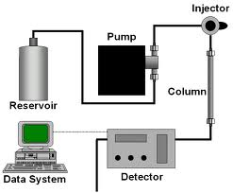
Fig 1: Systematic diagram of high performance liquid chromatography

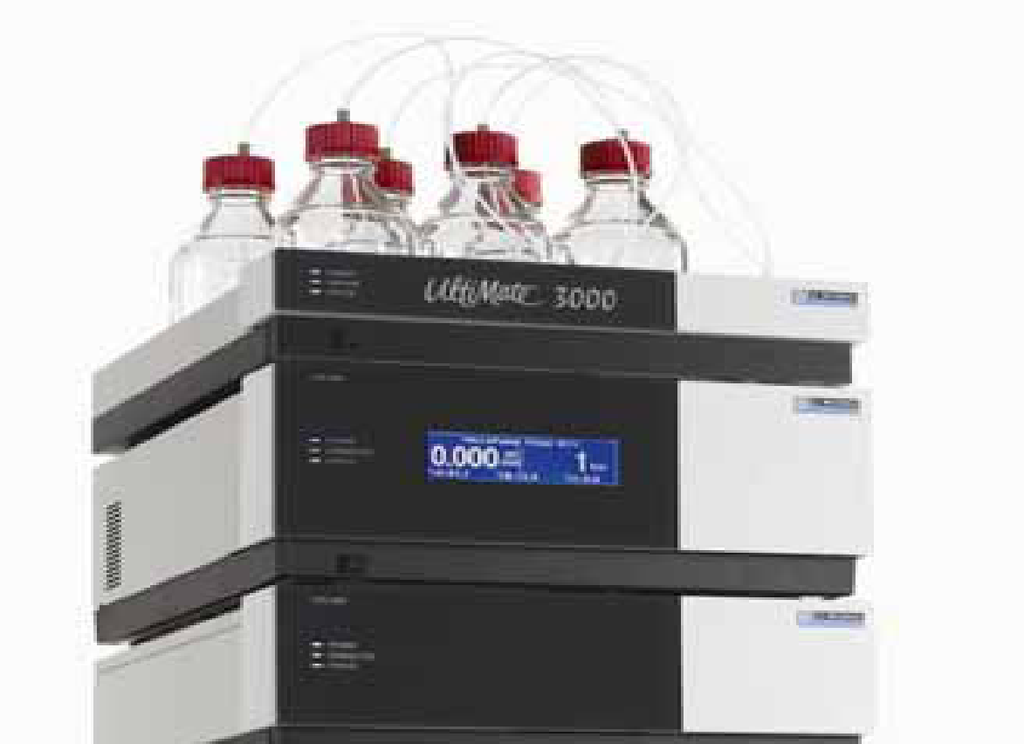
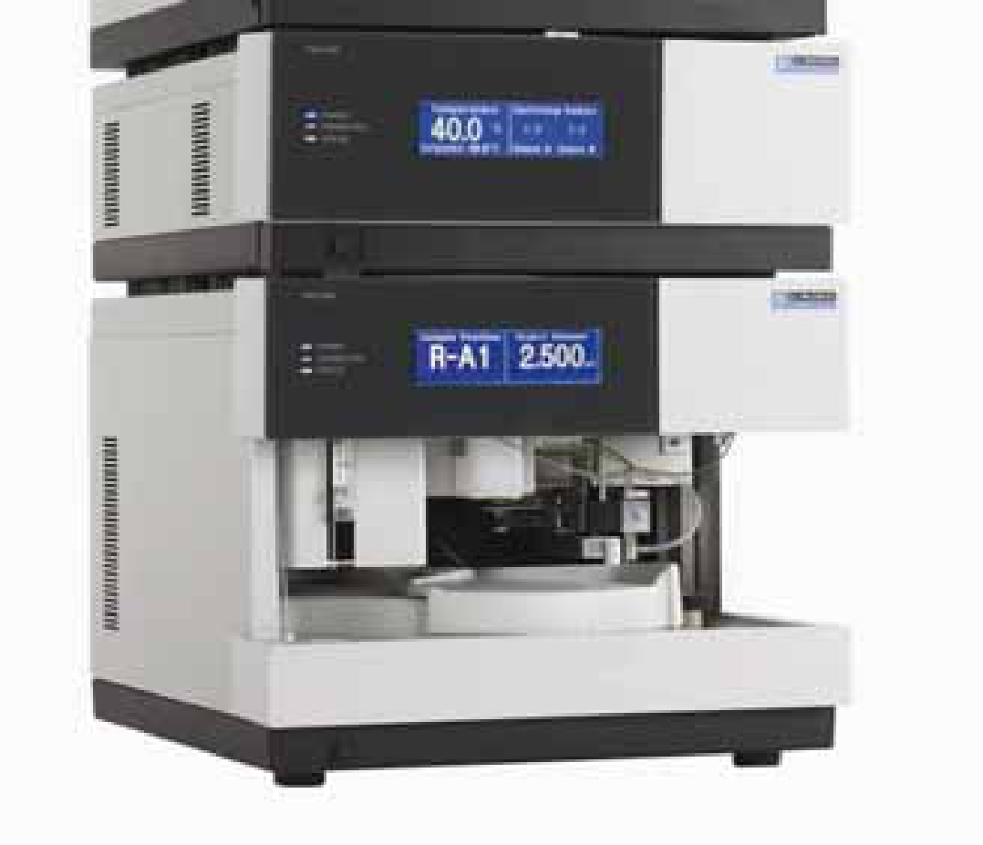
Fig. 2: Dionex UltiMate 3000 HPLC system

Solvent Reservoir:
Solvent Reservoirs are used to store Mobile-Phase. Scott Duran bottles are commonly used as solvent reservoirs. The solvent reservoir must be made of inert material such as glass and must be smooth so as to avoid growth of microorganisms on its walls. It can be transparent or can be amber colored. A graduated bottle gives a rough estimate of mobile-phase volume in the bottle. Solvent reservoirs are placed above HPLC system (at higher level) in a tray.
Pump:
- The most important component of HPLC in solvent delivery system is the ‘pump’ because its performance directly effects the retention time, reproducibility and detector sensitivity.
Low pressure mixing gives you a choice of three or four mobile phases. In High pressure mixing, generally two pumps are used and hence the choice is of two different mobile phases.
Among the several solvent delivery systems, reciprocating pump with twin or triple pistons is widely used, as this system gives less baseline noise, good flow rate and reproducibility.
Pump is an important part because its performance directly effects the retention time, reproducibility and detector sensitivity.
In HPLC pressure upto 6000 psi (pounds per square inch) can be used for faster and better separation efficiency
There are four types of pumps:
- Pneumatic pumps:
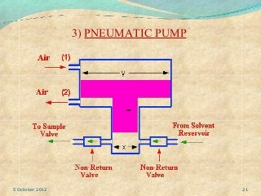
Operate by gas pressure. Mostly used for preparative scale and column packing. High pressure liquid at constant pressure.
- Syringe type pumps
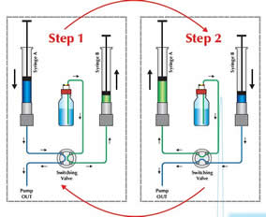
Positive solvent displacement by a piston. 250-500ml capacity with the generation of pulseless flow with high pressure capabilities. Double piston pump - 1- solvent to column. 2- other pump refilled from column.
- Reciprocating pumps
It is widely used as this system gives less baseline noise, good flow rate and reproducibility.
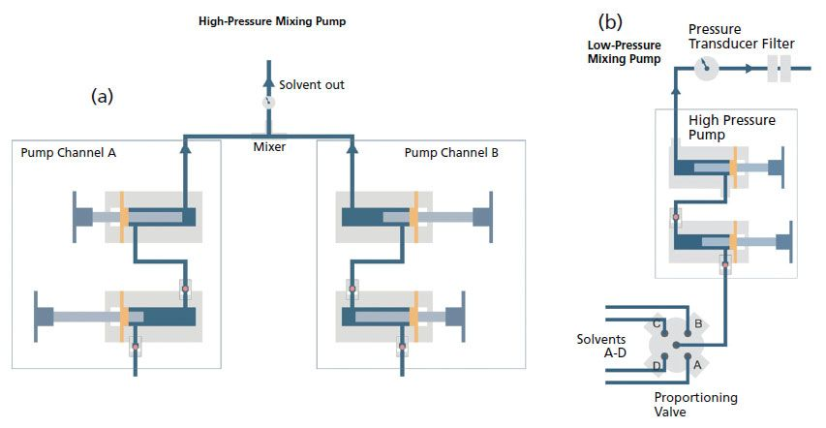
Reciprocating pump are again classified into 3 types
Single piston reciprocating pump
Dual piston in parallel
Dual piston in series
Based on the pressure/mixing unit
a) High pressure mixing pump
b) Low pressure mixing pump
- Hydraulic amplifier pumps
The hydraulic amplifier system includes a hydraulic cylinder comprising a primary piston chamber in which a primary piston is disposed and a secondary piston chamber in which a secondary piston is disposed. The cross-sectional area of the primary piston is larger than the cross-sectional area of the secondary piston. The difference in the cross-sectional areas of the pistons creates an amplification of the pressure in the primary piston chamber and a reduction in flow rate.
CHECK VALVES: To control flow rate
PULSE DAMPNERS: dampen the pulses from wavy baseline caused by pumps.
MIXING UNIT: low pressure (helium) and high pressure mixing chamber (static mixer - beads, dynamic mixer- magnetic stirrer).
GRADIENT CONTROLLER
Isocratic Elution
- A single composition of solvents is used for the duration of the separation
- Later eluting peaks are broader than earlier eluting peaks because of dispersion
- Steps must be taken to periodically flush the column at higher solvent strength to clean it of intractable materials that build up from sample injections
Gradient Elution
- The composition of solvents is changed either continuously or stepwise
- In general, peaks are sharper throughout the chromatogram when compared to isocratic elution
- Some separations may be achieved which are not possible using isocratic elution
- Chromatogram run times may be shorter when compared to isocratic elution

