INSTRUMENTAL METHODS OF ANALYSIS- BP701T

UNIT : 3 Introduction to chromatography
CLASS:4

TOPIC: GEL ELECTROPHORESIS
INTRODUCTION
- Separation is brought about through molecular sieving technique, based on the molecular size of the substances. Gel material acts as a "molecular sieve”. Gel is a colloid in a solid form (99% is water).It is important that the support media is electrically neutral.
- Different types of gels which can be used are; Agar and Agarose gel, Starch, Sephadex, Polyacrylamide gels. A porous gel acts as a sieve by retarding or, in some cases, by completely obstructing the movement of macromolecules while allowing smaller molecules to migrate freely. Agar gel is used for separation of different types of protein mixtures as well as nucleic acids. Polyacrylamide is most suitable for separation of nucleic acids. It is also frequently used in separating proteins, peptides and amino acids from microgram quantities of mixed samples.
Gel electrophoresis is carried out in two ways: vertical and horizontal gel electrophoresis.
Gel electrophoresis classified as starch gel electrophoresis, agarose gel electrophoresis and poly acrylamide gel electrophoresis ( PAGE)

Agarose gel electrophoresis:
Commonly used support medium. Less expensive than cellulose acetate. Equally good separation. Agar is a complex acidic polysaccharide containing monomers of sulfated galactose. Agarose is a sulfate free fraction of Agar. Gel is prepared in buffer and spread over a microscopic slide. A small sample of serum or biological fluid is applied by cutting in to the gel with a sharp edge.The electrophoretic rum takes about 90 minutes
Agar and Agarose Gel
- Agar is a mixture of poly saccharides extracted from sea weeds.
- Agarose is a highly purified uncharged polysaccharide derived from agar.
- Agarose is chemically basic disaccharide repeating units of 3,6-anhydro-L-galactose.
- Agarose dissolves when added to boiling liquid. It remains in a liquid state until the temperature is lowered to at bout 40° C at which point it gels.

The pore size may be predetermined by adjusting the concentration of agarose in the gel.
- Agarose gels are fragile. They are actually hydrocolloids, and they are held together by the formation of weak hydrogen and hydrophobic bonds.
- The pores of an agarose gel are large, agarose is used to separate macromolecules such as nucleic acids, large proteins and protein complexes.

ADVANTAGES:
- Easy to prepare and small concentration of agar is required.
- Resolution is superior to that of filter paper.
- Large quantities of proteins can be separated and recovered.
- Adsorption of negatively charged protein molecule is negligible.
- It adsorbs proteins relatively less when compared to other medium.
- Sharp zones are obtained due to less adsorption.
- Recovery of protein is good, good method for preparative purpose.

DISADVANTAGES:
- Electro osmosis is high.
- Resolution is less compared to polyacrylamide gels.
- Different sources and batches of agar tend to give different results and purification is often necessary.
- APPLICATION:
- Widely used in Immuno electrophoresis.
- To separate different types of protein mixtures as well as nucleic acids.

- 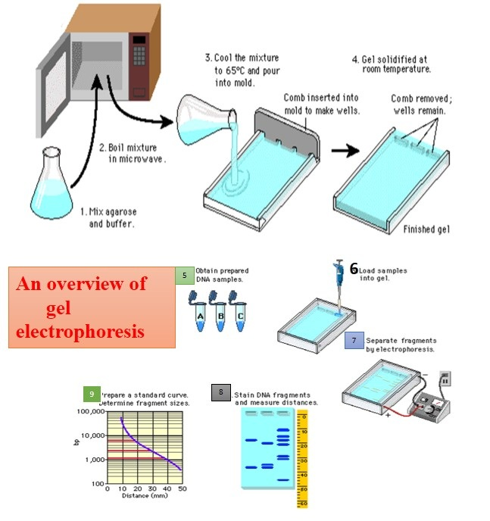

Poly acrylamide gel electrophoresis

PAGE is a technique that separates macromolecules such as proteins based on their electrophoretic mobility, that is, the ability of analytes to move towards an electrode of the opposite charge. In PAGE, this is determined by the charge, size (molecular weight) and shape of the molecule. Analytes move through pores formed in polyacrylamide gel. Unlike DNA and RNA, proteins vary in charge according to the amino acids incorporated, which can influence how they run. Amino acid strings may also form secondary structures that impact their apparent size and consequently how they are able to move through the pores. It may therefore sometimes be desirable to denature proteins prior to electrophoresis to linearize them if a more accurate estimate of size is required.
The pores formed in polyacrylamide are smaller than those of agarose, used for agarose gel electrophoresis. This makes it more suitable for the separation of proteins over large polynucleotide DNA or RNA fragments and allows the separation of relatively small proteins. Consequently, when people refer to “protein electrophoresis”, the separation technique they will most often be referring to is PAGE.

SDS PAGE vs native PAGE

PAGE can be run under denaturing or non-denaturing conditions, depending on the purpose of the analysis.

The anionic detergent, sodium dodecyl sulphate (SDS), in combination with heat and sometimes a reducing agent is used to denature proteins prior to electrophoretic separation in a process known as SDS PAGE. The heat disrupts the hydrogen bonds that hold secondary and tertiary structures while a reducing agent, such as β-mercaptoethanol, cleaves disulfide bridges. Proteins are linearized and complex with the SDS so that all have a similar mass-to-charge ratio. This eliminates the influence of structure and charge, and proteins are separated solely on the basis of differences in their molecular weight (Figure 1). This system was developed¹ by Ulrich K. Laemmli and is typically used to separate proteins of 5–250 kDa.
In native PAGE, these bonds are left intact, preserving the protein’s higher order structure. Consequently, the distribution of proteins through the gel is mainly influenced by the protein’s charge (determined by its amino acid sequence and post-translational modifications) and the pH of the separation rather than its size in kDa. However, it allows researchers to analyze proteins in their natural or “native” state. This may be desirable when analyzing bound proteins or complexes, for example, when it is important their biological activity remains intact. As the aim here is to preserve the natural state of the protein, SDS, reducing agents and heat are not used in sample preparation and lower voltages may also be used for separation.

Starch Gel Electrophoresis
A suspension of granular starch should be boiled in a buffer to give a clear colloidal suspension.The suspension on cooling sets as a semisolid gel due to intertwining of the branched chains of amylopectin. In order to avoid swelling and shrinking petroleum jelly is used.
ADVANTAGES:
- High resolving power and sharp zones are obtained.
- The components resolved can be recovered in reasonable yield especially proteins.
- Can be used for analytical as well as preparative electrophoresis.
DISADVANTAGES:
- Electro osmotic effect.
- Variation in pore size from batch to batch.

Denaturing
Denaturing gels are run under conditions that disrupt the natural structure of the analyte, causing it to unfold into a linear chain.
Thus, the mobility of each macromolecule depends only on its linear length and its mass-to-charge ratio. Thus, the secondary, tertiary, and quaternary levels of biomolecular structure are disrupted, leaving only the primary structure to be analyzed.

Buffers
Used to provide ions that carry a current and to maintain the pH at a relatively constant value. These buffers have plenty of ions in them, which is necessary for the passage of electricity through them.
for nucleic acids Tris/Acetate/EDTA (TAE), Tris/Borate/EDTA.

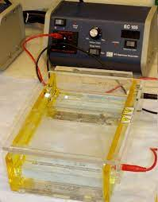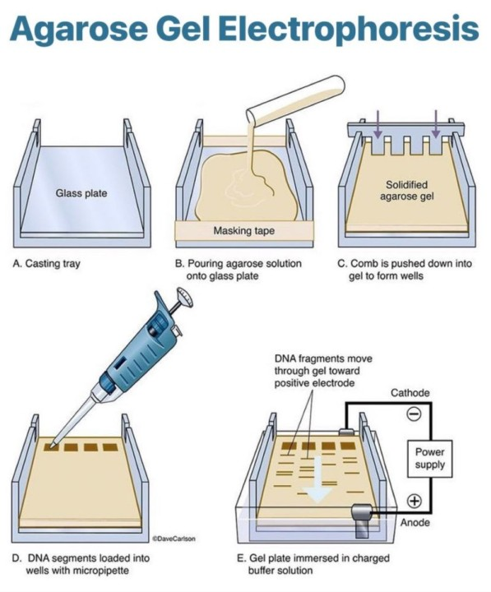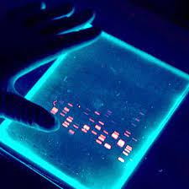

Visualization
After the electrophoresis is complete, the molecules in the gel can be stained to make them visible.
DNA may be visualized using ethidium bromide which, when intercalated into DNA, fluoresce under ultraviolet light,
Protein may be visualised using silver stain or Coomassie brilliant blue dye.
Samples containing radioactivity, for example in a DNA sequencing gel, an autoradiogram is recorded.
Analyte Stain
Amino acids Ninhydrin
Proteins Ponceau S, Comassie blue 250, Silver stain, Amido black

Lipoproteins Sudan black B, Oil red O
Glycoproteins Periodic Acid-Schiff (PAS) stain
Hemoglobin Ponceau S, O Dianisidine, ferricyanide
Nucleic acid Silver stain, Ethidium bromide

APPLICATIONS
- Used for estimation of molecular weight of proteins and nucleic acids.
- Determination of subunit structure of proteins.
- Purification of isolated proteins.
- Monitoring changes of protein content in body fluids.
- Identifying disulfide bonds between protein
- Quantifying proteins, Blotting applications

