INSTRUMENTAL METHODS OF ANALYSIS- BP701T

UNIT : 3 Introduction to Chromatography
CLASS: 4

TOPIC: PAPER CHROMATOGRAPHY
INTRODUCTION

Paper chromatography in analytical chemistry, is a technique for separating dissolved chemical substances based on different rates of migration across sheets of paper. It is an inexpensive but powerful analytical tool that requires very small quantities of material.
The paper is called the stationary phase while the solvent is referred to as the mobile phase. In order to obtain a measure of the extent of movement of a component in a paper chromatography experiment, we can calculate an “Rf value” for each separated component in the developed chromatogram. An Rf value is a number that is defined as: distance traveled by component from application point.

PRINCIPLE

Paper chromatography is based on partition principle, where the components of the mixture are distributed and duly partitioned within the mobile solvent phase. The solvent phase, usually water, is trapped within the pores of the stationary phase of filter paper, whereas the mobile phase mixture moves over the paper. This is an adsorption type of chromatography, which exists between the solid and liquid phase. The constituents of the coloured mixture get separated because of the difference in affinity existing for each of these mixture components.

PRACTICAL REQUIREMENTS

- Stationary phase and papers used.
- Application of sample.
- Mobile phase.
- Development technique.
- Detecting or visualizing agents.

- Stationary phase and papers used

Paper chromatography makes use of paper which acts as a stationary phase. The paper essentially consists of cellulose fibers which are polymers having – OH functional groups sticking out of the polymer chains.
Different types of paper have been tried, but Whatman No1 and 3 filter papers are found more suitable for analytical work.Choice of filter paper depends upon thickness, flow rate, purity technique, etc.
Modified papers: Acid or base washed filter paper, glass fiber type paper.
Hydrophilic papers: Papers modified with methanol, formamide, glycol, glycerol etc.
Hydrophobic papers: Acetylation of OH groups leads to hydrophobic nature, hence can be used for reverse phase chromatography.
Size of the paper used: Paper of any size can be used paper should be kept in a chamber of suitable size.

- Application of sample

Spotting of the sample is done with the help of a capillary tube or automated applicator. The sample is applied as a neat spot on a horizontal line drawn with a pencil close to one edge. Allow the spots to dry and then immerse the paper in the developing chamber as per the selected technique with the marked spots above the solvent level.

- Mobile phase

Pure solvents, buffer solution or mixture of solvents are used. Some of the examples of the mobile phase used are:

- Hydrophilic mobile phase
Isopropanol:Ammonia: water - 9:1:2
N-butanol: glacial acetic Acid: water - 4:1:5
Methanol: water - 3:1 or 4:1
t- Butanol: water: formic acid - 40:20:5

- Hydrophobic mobile phases
Kerosene: 70% Iso propanol
Dimethylether: cyclohexane
Single/ two phases or three phase’s solvent system is also used
.
- Development Techniques

There are three methods for developing a paper chromatogram. They are:

- Ascending development

In ascending technique the chromatogram is attached in a way that the spot is touched with the solvent where the solvent is at the bottom. The development of the chromatogram or the separation of the spot is against the gravity. This is why this is termed as ascending technique.
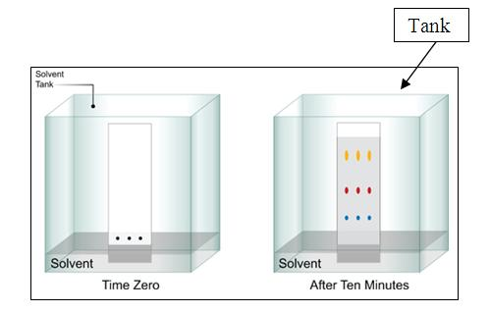

Figure 15.1 Ascending development

- Descending development

The descending technique is a complex setup. This is built due to its time consuming ability. This develops along the gravity. Thus, there is a force which will make the separation quick and easy. The filter paper is attached to a paper support. And the developing solvent (mobile phase) is filled into a chamber. The filter paper is saturated with the stationary phase before it is hung. The mobile phase will gradually move downwards carrying the spot of the test sample along the paper. The term descending is given because the separation or the development of the chromatogram is taking place towards down.
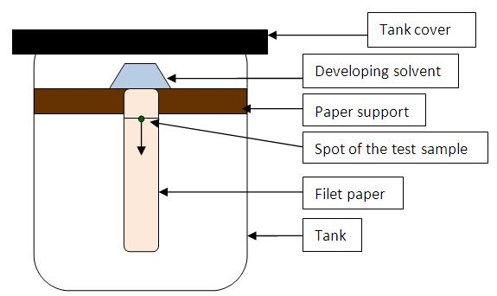

Figure 15.2 Descending development

- Two dimensional development

Two dimensional technique is another complex setup which is used to separate complex mixtures. In this method the development of the chromatogram is done as in the previous methods.

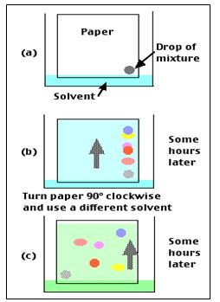
Figure 15.3 Two dimensional development

- Detecting or visualizing agents

Coloured spots are easily observed on developed chromatograms. However, different approaches need to be adopted when colourless components are to be observed. It is convenient to classify such methods as non-specific or specific.

Non-specific methods: Where the number of spots can be detected, but not the exact nature or type of compound.
Iodine chamber: The developed plate is suspended in a closed jar containing a few crystals of iodine for about a minute. In the presence of iodine vapors most organic compounds appear as brown spots.
UV viewing cabinet: Majority of colourless compounds can be viewed under illumination with UV light in a UV viewing cabinet. Commonly the cabinets are equipped with a long wavelength (366 nm) and short wavelength (254 nm) light sources. Under exposure of selected source coloured spots appear on a dark background and under exposure to light from short wavelength source dark spots are seen against a bright background. In either case the spots should be marked with a pencil while observing in the cabinet for Rf calculations.

- Specific Methods: Specific spray reagents or detecting agents or visualizing agents are used to find out the nature of the compounds or for identification purpose.
Amino acids, primary and secondary amines: 0.2% ninhydrin solution in water, saturated with butanol is sprayed on briefly heated paper chromatogram when deep blue or purple spots begin to appear.
Alkaloids: Dragendroff’s agent gives orange or orange – red precipitates in presence of alkaloids.
Phenols: Ferric chloride solution spray results in the appearance of different coloured spots – read, blue, green or purple when phenols are present.
Aldehydes and Ketones: 2, 4 – dinitro phenyl hydrazine in a mixture of methanol and sulphuric acid (Brady’s reagent) spray results in bright orange or yellow colour spots in the presence of aldehydes and ketones.

QUANTITATIVE ANALYSIS

Direct technique

Densitometer is an instrument which measures quantitatively the density of the spots. When the optical density of the spots for standard and test solution are determined, the quantity of the substance can be calculated. The papers are neither destroyed, nor eluted with solvents to get the compounds. This method is called as in-situ method.

Indirect technique

In this technique the spots are cut in to portion and eluted with solvents. This solution can be analyzed by any conventional techniques’ of analysis like spectrophotometer, electrochemical methods etc.

QUALITATIVE ANALYSIS

Rf Value

The retardation factor R_{f} is defined as the ratio of the distance traveled from the center of a spot to the distance traveled by the solvent front.
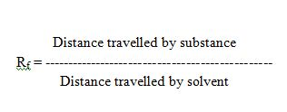

Rx value
Rx value is nothing but the ratio of distance travelled by the sample and the distance travelled by standard.Rx value is always closer to 1.

Rm value
Rm value is used in qualitative analysis to find out whether the compounds belong to a homologous series. If they belong to a homologous series the ∆ Rm values are constant. The ∆ values for pair of adjacent member of a homologous series is determined by using the formula:
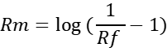

APPLICATION

Paper chromatography has evolved over the years and has found widespread applications in separation of molecules of different polarities. Separation of mixtures of drugs of chemical or biological origin, plant extracts etc. can be done by using this chromatography. Innumerable applications have been reported during analysis of different classes of compounds such as:

- Amino acids and organic acids.
- Alkaloids.
- Polysaccharides.
- Proteins and peptides.
- Natural and artificial pigments.
- Inorganic cations.
- Plant extracts.

