INSTRUMENTAL METHODS OF ANALYSIS- BP701T

UNIT : 3 Introduction to chromatography
CLASS:1

TOPIC: INTRODUCTION TO CHROMATOGRAPHY
Chromatography is the science of separating mixtures from complex to simple. Chromatography techniques are either preparative or analytical. These chromatography techniques are used by researchers and scientists throughout the world. It is indeed a need for researchers because these techniques can simplify the complex problem. Chromatography technology is used by several science related fields such as medicine, microbiology, pharmacology, botany, chemistry, physics etc.
Chromatography is a physicochemical method for separation of complex mixtures. This was discovered at the very beginning of the twentieth century by Russian Italian botanist M. S. Tswett. Tswett gave a very detailed description of the newly discovered phenomena of adsorption-based separation of complex mixtures, which he later called “chromatography” as a transliteration from Greek “color writing”. Unexpectedly, the meaning of the Russian word “Tswett” actually means color, although in all his publications Tswett mentioned that the origin of the name of his new method was based on the colorful picture of his first separation of plant pigments. He involuntarily incorporated his own name in the name of the method he invented.
He was successful in doing the separation of chlorophyll, xanthophylls and several other colored substances by percolating vegetable extracts through a column of calcium carbonate. The calcium carbonate column acted as an adsorbent and the different substances got adsorbed to different extents and this gives rise to the colored bands at different positions, in the column Figure 13.1,Tswett termed this system of colored bands as the chromatogram and the method as chromatography after the Greek wordchroma and graphs meaning “color” and “writing” respectively. However, in the majority of chromatographic procedures no coloured products are formed and the term is a misnomer.
Considerable advances have since been made and the method is used to separate colored as well as colourless substances. The column of calcium carbonate, used in Tswett’s method, remains stationary and is therefore termed as the stationary phase. The solution of vegetable extracts moves or flows down the column and is therefore termed as the mobile phase. Chromatography may be regarded as a method of separation in which separation of solutes occurs between a stationary phase and a mobile phase.
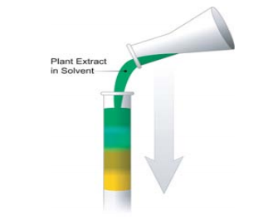

Figure Tswett's Experiment
DEFINITION OF CHROMATOGRAPHY

Chromatography may be defined as a method of separating a mixture of components into individual components through equilibrium distribution between two phases. Essentially, the technique of chromatography is based on the differences in the rate at which the components of a mixture move through a porous medium (called stationary phase) under the influence of some solvent or gas (called mobile phase).
The chromatography method of separation, in general involves the following steps:
1. Adsorption or retention of a substance.
2. Separation of the adsorbed substances by the mobile phase.
3. Recovery of the separated substances by a continuous flow of the mobile phase, the
method being called elution.
4. Qualitative and quantitative analysis of the eluted substances.
TYPES OF CHROMATOGRAPHY

Chromatography can be classified based on different methods.
1. Based on mechanism of separation.
- Adsorption chromatography.
- Partition chromatography.
2. Based on phases.
- Solid phase chromatography.
  - Solid-liquid chromatography.
  - Solid-gas chromatography.
- Liquid phase chromatography.
  - Liquid-liquid chromatography.
  - Liquid-gas chromatography.
3. Based on shape of chromatographic beds.
- Planar chromatography.
  - Paper chromatography.
  - Thin layer chromatography.
- Column chromatography.
  - Packed column chromatography.
  - Open tubular column chromatography.

Adsorption Chromatography

Adsorption chromatography is a process of separation of components in a mixture introduced intoa chromatography system based on the relative difference in adsorption of components to stationary phases present in chromatography. The equilibration between the mobile and stationary phase accounts for the separation of different solutes. It utilizes a mobile liquid or gaseous phase that is adsorbed onto the surface of a stationary solid phase.

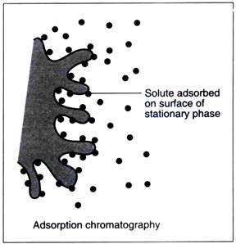

Figure 13.2 Adsorption phenomena in chromatography

Partition Chromatography

Chromatography in which separation is based mainly on differences between the solubility of the sample components in the stationary phase or on differences between the solubility of the components in the mobile and stationary phase. This form of chromatography is based on a thin film formed on the surface of a solid support by a liquid stationary phase.

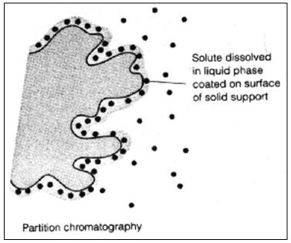

Figure 13.3 Partition phenomena in chromatography

Solid-liquid chromatography
Liquid chromatography is a separation in which the mobile phase is a liquid. The preferred mobile phase is a non-polar or slightly polar.

Solid-gas chromatography
This chromatography employs an inert gas as the mobile phase. It is rare chromatography and used for the separation of atmospheric gases.

Liquid-liquid chromatography
In this mobile phase is liquid and the stationary phase is also liquid.

Liquid-gas chromatography
The mobile phase is an unreactive gas such as nitrogen.The stationary phase comprises of a small amount of liquid held in a finely divided inert solid support.

Planar chromatography
Planar chromatography is a separation technique in which the stationary phase is present on a plane. The plane can be a paper, serving as such or impregnated by a substance as the stationary bed(paper chromatography) or a layer of solid particles spread on a support such as a glass plate (thin layer chromatography).

Column chromatography
It is a separation in which the stationary bed is within a tube. The particles of the solid stationary phase or the support coated with a liquid stationary phase may fill the whole inside volume of the tube (packed column) or to be concentrated on or along the inside tube wall, leaving an open,unrestricted path for the mobile phase in the middle part of the tube(open tubular column).

