INSTRUMENTAL METHODS OF ANALYSIS- BP701T

UNIT : 2 Nephlometry& turbidometry
CLASS: 9

TOPIC: NEPHLOMETRY& TURBIDOMETRY

Nephlometry and turbidimetry, in analytical chemistry, methods for determining the amount of cloudiness or turbidity, in a solution based upon measurement of the effect of this turbidity upon the transmission and scattering of light. Turbidity in a liquid is caused by the presence of finely divided suspended particles. If a beam of light is passed through a turbid sample, its intensity is reduced by scattering, and the quantity of light scattered is depend upon the concentration and size distribution of the particles. In nephlometry the intensity of the scattered light is measured, while, in turbidimetry, the intensity of light transmitted through the sample is measured. Nephlometric and turbidimetric measurements are used in the determination of suspended material in natural waters and in processing streams. The technique is also used for determination of sulfur in coal, oil, and other organic materials.

PRINCIPLE OF NEPHELOMETRY AND TURBIDIMETRY

The principle of nephelometry and turbidimetry is based on the scattering or absorption of light by solid or colloidal particles suspended in solution. When light is passed through the suspension, part of incident radiant energy is dissipated by absorption, reflection, and reaction while remainder is transmitted. In fact the measurement of the intensity of transmitted light is a function of the concentration of dispersed phase and this becomes the basis of turbid metric analysis.
This is given in the following diagram.

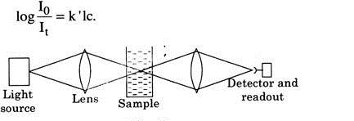

Fig 9.1 Transmission of light by sample

Nephelometry is somewhat different from turbidimetry. In nephelometry light is passed through the sample solution (suspended particles) directly and the amount of scattered radiation is measured generally at 90°C. The measurement of intensity of scattered light as a function of concentration of dispersed phase is the basis of analysis of nephelometry.

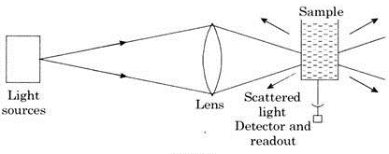

Fig 9.2 Scattering of light by sample

It is very important to note that in nephelometry incident and scattered light are of same wavelength whereas in fluorimeter (in fluorimetry) scattered light is of longer wavelength than incident light.

INSTRUMENTATION

The instruments used in nephelometry and turbidimetry are similar as used in spectrophotometry.
Sources:

Monochromatic radiation is used both in turbidimeter and nephelometer. Generally a mercury arc or a laser with special filter combinations for isolating one of its emission lines is the most suitable source.
The tungsten lamp (which is polychromatic source) is used when one has to determine the concentration of a particular substance. It has been observed that even in such a case blue spectral region gives the best results.

Filters and monochromators:

When a white light or polychromatic light is used, filters and monochromators are required but when monochromatic light is required, a filter or monochromator are not used. In a turbidimeter, blue filter or 540nm is used. In a nephlometer, visible filter is used as secondary filter.

Sample Cells:

Generally a cell with a rectangular cross section is selected for the study. We can also use cylindrical cells having flat faces where entering and existing beams are passed. The octagonal faces allow measurements to be made at 145°C, 90° 45° or 0° to primary beam. The walls through which light beam are not to pass, are coated black so as to absorb unwanted radiation.

Detectors:

In turbidimeters, phototubes are used as detectors.
The photo-mutliplier tubes are used as detectors in case of nephelometers because intensity of scattered radiation is generally very small. Generally the detector is fixed at 90° to primary but for maximum sensitivity the detector angle should vary. There are some nephelometers where detector is mounted on a circular disc which allows measurement at many angles. 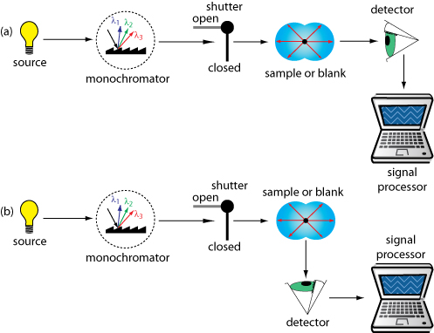
Figure 9.3 (a) Turbidometer, (b) Nephlometer

