INSTRUMENTAL METHODS OF ANALYSIS- BP701T

UNIT : 2 Atomic absorption spectroscopy
CLASS:6 Principle & interferences

TOPIC: PRINCIPLE &INTERFERENCES OF AAS

Principle:
In AAS, measurement of unexcited atoms is done by flame method. The ground state atoms in gaseous state absorb energy and excited from ground state to excited state. When ground state atoms absorb energy, they changes their position from lower energy to higher energy and electronic transition of valence electron take place, this give rise to narrow lines called as atomic absorption spectra When solution containing metal salt /metallic compound is aspirated in to the flame, it undergoes vaporization and gaseous atoms are formed. Some atoms gain energy and get excited while large number of atoms remain in ground state.(unexcited)
In AAS, measurement of unexcited (Ground state) atoms is done by flame method. When solution containing metal salt /metallic compound is aspirated in to the flame, it undergoes vaporization and gaseous atoms are formed. Some atoms gain energy and get excited while large number of atoms remain in ground state.(unexcited)
Ground state atoms are capable of absorbing radiant energy at their resonance wavelength. When radiation passed through the flame having gaseous state atoms, then part of radiation is absorbed by these atoms. Extent of absorption is proportional to the number of ground state atom present in the flame. Total amount of radiation absorbed is given by
υ = π𝑒 2 𝑚.𝐶 .Nf
m = mass of electron
υ =Frequency absorbed by the atoms
C= velocity of light e= charge on electron
N= Total number of atoms
f= oscillator strength
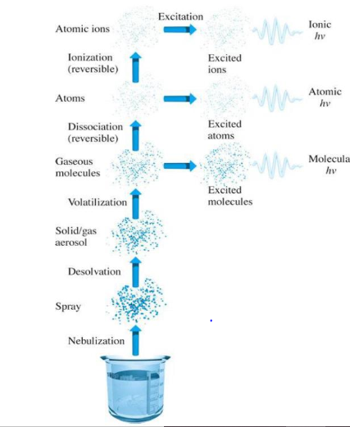

Interferences :
Any process which causes error in determination is called interference. Interferent is the substance present in the sample, blank or standard solution which affects the signal of the analyte.
1) Chemical Interference: Because of formation of stable compound which cannot undergo decomposed at flame temperature. Example Aluminum and magnesium form a thermally stable mixed oxide, thus low results are obtained for magnesium in presence of aluminum.. Chemical interference affect the number of free atoms reaching to the optical path to be absorbed. Precipitation, viscosity, surface tension and pH are some factors which causes chemical interference. Atomic Absorption Spectroscopy Interferences in AAS:
2) Spectral Interference: When spectral lines overlap with each other then this kind of interference is observed. Absorption or emission of an interfering species either overlaps or lies so close to the analyte band that resolution by the monochromator become difficult. In AAS spectral interference is rare.
3) Ionization Interference: Due to high flame temperature (air -acetylene or nitrous acid-acetylene) ionization of atoms take place. Atoms with low ionization potential undergo ionization and reduce the population of ground state atom and excited state atoms. To overcome this effect easily ionizable elements such as K, Na, Cs are added to the sample ( 1000 microgram/ liter) Due to easily ionizable atoms large number of electrons are produced which suppressed the ionization of analyte atoms. Atomic Absorption Spectroscopy Interferences in AAS:
4) Background Absorption: It is caused by absorption of the species other than the atoms at resonance wavelength. This is observed due to scattering of light due to small, un-volatilized particles present in the flame. It is wavelength dependent phenomenon and gives a positive error in the analysis. It can be minimized by using Deuterium arc background correction (continuum source) A

