INSTRUMENTAL METHODS OF ANALYSIS- BP701T

UNIT :2 Flame photometry
CLASS:5 Instrumentation & applications

TOPIC: INSTRUMENTATION & APPLICATIONS
INSTRUMENTATION

Parts of a flame photometer include,

- Sample Delivery System: There are three components for introducing liquid sample.

- Nebulizer: - It breaks up the liquid into small droplets. Nebulization is conversion of a sample to a mist of finely divided droplets using a jet of compressed gas. The flow carries the sample into the atomization region. most commonly used nebulizer is Pneumatic Nebulizers.

(ii) Aerosol modifier: - It removes large droplets from the stream and allows only smaller droplets than a certain size to pass.

(iii) Flame or Atomizer: - It converts the analyte into free atoms.

- Source: - A Burner used to spray the sample solution into fine droplets. Several burners and fuel, oxidant combinations have been used to produce analytical flame including Premixed, Mecker, Total consumption, Lundergarh, Shielded burner, and Nitrous oxide-acetylene flames.

Pre-mixed Burner: - Widely used because uniformity in flame intensity. In this type of burner, aspirated sample, fuel and oxidant are thoroughly mixed before reaching the burner opening.

Total Consumption Burner: - In this fuel and oxidant are hydrogen and oxygen gases. Sample solution is aspirated through a capillary by high pressure of fuel and Oxidant and burnt at the tip of burner. Entire sample is consumed.

- Monochromator: - It includes prism and grating. Quartz material is used for making prism, as quartz is transparent over entire region. It employs a grating which is essentially a series of parallel straight lines cut into a plane surface

- Detectors: - Detect the emitted light and measure the intensity of radiation emitted by the flame. That is, the emitted radiation is converted to an electrical signal with the help of photo detector. The produced electrical signals are directly proportional to the intensity of light. Different types of detectors include Photomultiplier tubes, Photo emissive cell and Photo voltaic cell.

- Read-out Device: - It is capable of displaying the absorption spectrum as well absorbance at specific wavelength. Nowadays the instruments have microprocessor controlled electronics that provides outputs compatible with the printers and computers thereby minimizing the possibility of operator error in transferring data.
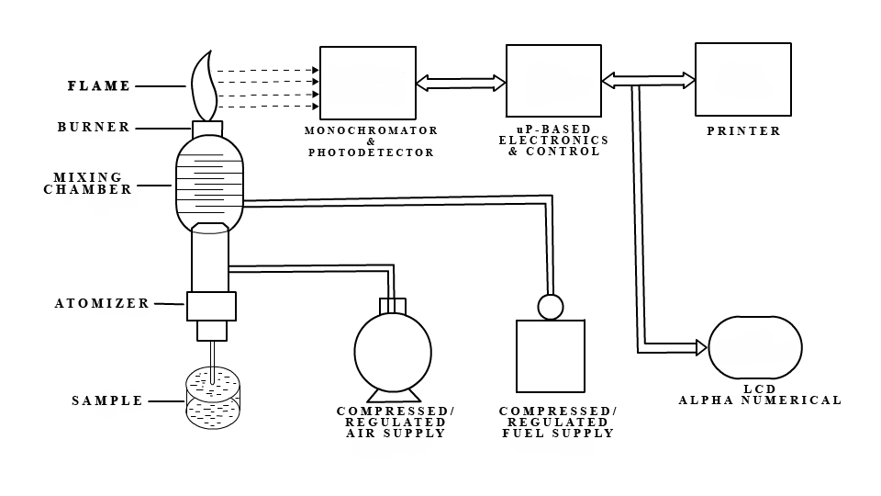
Figure 5.1 Schematic representation of flame photometer

5.6 MECHANISM OF WORKING

The working of the flame photometer involves a series of steps which is discussed in the following sections:-
The solution of the substance to be analyzed is first aspirated into the burner, which is then dispersed into the flame as fine spray particles.

A brief overview of the process:

1. The solvent is first evaporated leaving fine divided solid particles.
2. This solid particles move towards the flame, where the gaseous atoms and ions are produced.
3. The ions absorb the energy from the flame and excited to high energy levels.
4. When the atoms return to the ground state radiation of the characteristic element is emitted.
5. The intensity of emitted light is related to the concentration of the element.

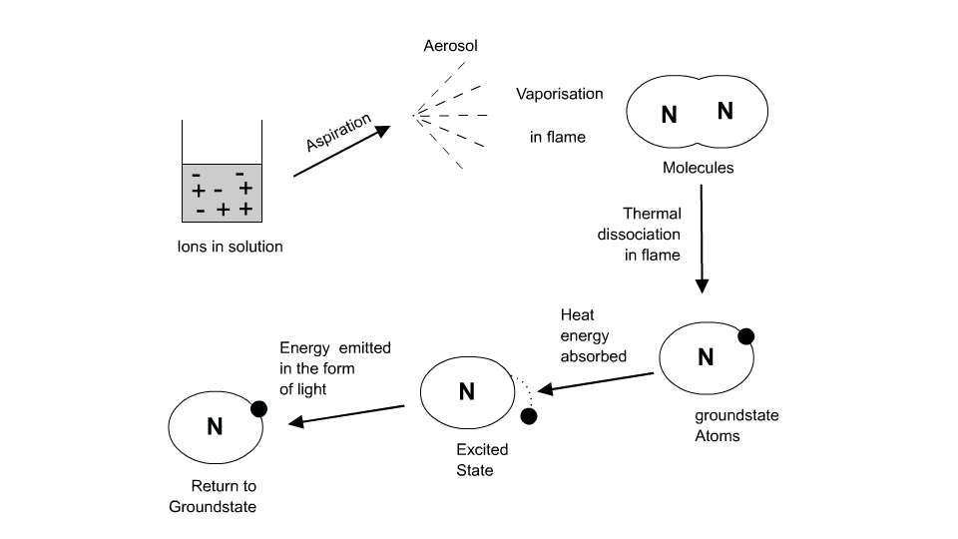

Events occurring in the flame:

Flame photometry employs a variety of fuels mainly air, oxygen or nitrous oxide (N₂O) as oxidant. The temperature of the flame depends on fuel-oxidant ratio.

The various processes in the flame are discussed below:

Desolvation: The metal particles in the flame are dehydrated by the flame and hence the solvent is evaporated.

Vaporization: The metal particles in the sample are dehydrated. This also led to the evaporation of the solvent.

Atomization: Reduction of metal ions in the solvent to metal atoms by the flame heat.

Excitation: The electrostatic force of attraction between the electrons and nucleus of the atom helps them to absorb a particular amount of energy. The atoms then jump to the exited energy state.

Emission process: Since the higher energy state is unstable the atoms jump back to the stable low energy state with the emission of energy in the form of radiation of characteristic wavelength, which is measured by the photo detector.

The intensity of the light emitted could be described by the Scheibe-Lomakin equation:

Where,
I= Intensity of emitted light
C = the concentration of the element
K = constant of proportionality
n =1 (at the linear part of the calibration curve)
Then,

I =K×C

That is the intensity of emitted light is directly related to the concentration of the sample.

The comparison of emission intensities of unknown samples to either that of standard solutions (plotting calibration curve), or to those of an internal standard (standard addition method), helps in the quantitative analysis of the analyte metal in the sample solution.

Name of the element | Emitted wave length range (nm) | Observed color  of the flame
Potassium (K) | 766 | Violet
Lithium (Li) | 670 | Red
Calcium (Ca) | 622 | Orange
Sodium (Na) | 589 | Yellow
Barium (Ba) | 554 | Lime green

Table 5.1 Flame emissions of the alkali and alkaline earth metals

5.7 APPLICATIONS

1. Flame photometer has both quantitative and qualitative applications.
2. Flame photometer with monochromators emits radiations of characteristic wavelengths which help to detect the presence of a particular metal in the sample. This help to determine the availability of alkali and alkaline earth metals which are critical for soil cultivation.
3. In agriculture, the fertilizer requirement of the soil is analyzed by flame test analysis of the soil.
4. In clinical field, Na⁺ and K⁺ ions in body fluids, muscles and heart can be determined by diluting the blood serum and aspiration into the flame.
5. Analysis of soft drinks, fruit juices and alcoholic beverages can also be analyzed by using flame photometry.

Advantages:

- Simple quantitative analytical test based on the flame analysis.
- Inexpensive.
- The determination of elements such as alkali and alkaline earth metals is performed easily with most reliable and convenient methods.
- Quite quick, convenient, and selective and sensitive to even parts per million (ppm) to parts per billion (ppb) range.

Disadvantages:

Moreover the flame photometer has a wide range of applications in the analytical chemistry, it possess many disadvantages which are explained below:

- The concentration of the metal ion in the solution cannot be measured accurately..
- A standard solution with known molarities is required for determining the concentration of the ions which will corresponds to the emission spectra.
- It is difficult to obtain the accurate results of ions with higher concentration.
- The information about the molecular structure of the compound present in the sample solution cannot be determined.
- The elements such as carbon, hydrogen and halides cannot be detected due to its non radiating nature.

