INSTRUMENTAL METHODS OF ANALYSIS- BP701T

UNIT : 1 Fluorimetry
CLASS: 9

TOPIC: THEORY AND CONCEPT INVOLVED IN FLUORIMETRY
INTRODUCTION

Fluorimetry is an analytical method for the measurement of fluorescence, based upon emission of absorbed radiation by the molecules. When a molecule absorbs incident electromagnetic radiations, it is excited to higher energy level, where it is unstable. Therefore, it returns to the ground state by emitting the absorbed radiations. When the emission occurs directly from singlet excited state to singlet ground state without any transitions and without any change in spin orientation, it is referred as fluorescence. This study of measurement of this emitted radiation is called as fluorimetry.
When the emission occurs within a fraction of second to few days of absorption of radiations due to transition from singlet excited state to triplet state and then to singlet ground state, it is referred as phosphorescence. It involves the change in spin orientation during the transition from excited singlet to triplet and from triplet to singlet ground state. The movement of electrons from excited singlet state to triplet state, ie from unpaired electrons with opposite spin to unpaired electrons with same spin is termed as intersystem crossing. Fluorescence and phosphorescence are combinely called photoluminescence. The energy emitted by this mechanism has a wavelength larger than that of absorbed radiation.

PRINCIPLE

Molecule contains ∏ electrons, σ electrons and non bonding (n) electron. The electrons may be present in bonding molecular orbital. It is called as highest occupied molecular orbital (HOMO). It has least energy and more stable. When the molecules absorbs radiant energy from a light source, the bonding electrons may be promoted to anti bonding molecular orbital (LUMO). It has more energy and hence less stable.

The process of promotion of electrons from′ HOMO to LUMO with absorption of energy is called as excitation.

Singlet state: - A state in which all the electrons in a molecule are paired ( ↑↓ )
Doublet state: - A state in which un paired electrons are present (↑ or ↓)
Triplet state: - A state in which unpaired electrons of same spin present ( ↑ ↑ )
Singlet excited state: - A state in which electrons are unpaired but of opposite spin (↓) (↑).
When light of appropriate wavelength is′ absorbed by a molecule the electrons are promoted from singlet ground state to singlet excited state. Once the molecule is in this excited state relaxation can occur via several process.

For example by emission of radiation. The following process can be the observed:-

- Collisional deactivation
- Fluorescence
- Phosphorescence

Collisional deactivation: - In which entire energy lost due to collision de activation and no radiation emitted.

Fluorescence:-Excited singlet state is highly unstable. Relaxation of electrons from excited singlet to singlet ground state with emission of light.

Phosphorescence:-At favorable condition like low temperature and absence of oxygen there is transition from excited singlet state to triplet state which is called as inner system crossing. The emission of radiation when electrons undergo transition from triplet state to singlet ground state is called as phosphorescence.

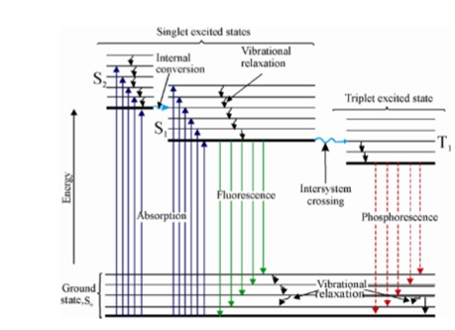

Figure 9.1 Jablonski Diagram showing florescence and phosphorescence

