INSTRUMENTAL METHODS OF ANALYSIS- BP701T

UNIT : 1 UV Visible spectroscopy
CLASS:8 Multi component analysis

TOPIC: MULTI COMPONENT ANALYSIS

MULTI COMPONENT ANALYSIS

Simultaneous multi-component analysis by absorption measurements based upon ultraviolet and visible radiation is one of the most extensively used tools by analysts for quantitative and qualitative analysis. This process avoids the prior separation procedures involving, extraction, concentration of constituents, and the cleanup steps that make the process time consuming. Simultaneous multi-component analysis by absorption measurements is one of the most sensitive measuring techniques and is fast and simple but lacks the inherent selectivity to allow direct application to highly complex materials that analyst are faced with in modern times because the absorption spectra overlap severely.
- Simultaneous Equation Method
- Q-Absorbance Ratio Method
- Derivative Spectroscopy
- Difference Spectroscopy
- SIMULTANEOUS EQUATION METHOD
Principle: If a sample contains two absorbing substances, X and Y, each of which absorbs at the λ max (maximum absorption wavelength) of the other, it is possible to determine both substances' concentrations if the following criteria are satisfied:
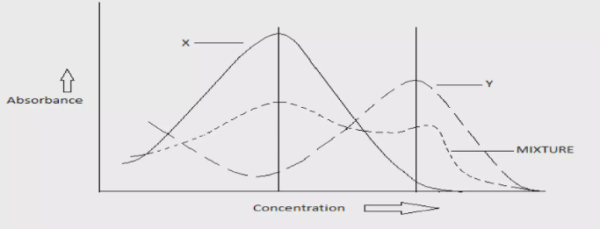

The absorptivities (molar absorptivities or extinction coefficients) of X at λ1 and λ2, denoted as ax1 and ax2, respectively.
The absorptivities of Y at λ1 and λ2, denoted as ay1 and ay2, respectively.
The absorbance of the diluted sample at λ1 and λ2, denoted as A1 and A2, respectively. Two equations are constructed based on the fact that at λ1, the absorbance of the mixture is the sum of the individual absorbances of X and Y:
Equation 1: A1 = (ax1 * Cx) + (ay1 * Cy)
Equation 2: A2 = (ax2 * Cx) + (ay2 * Cy)
Where: • A1 and A2 are the absorbances at λ1 and λ2, respectively.
• Cx and Cy are the concentrations of X and Y, respectively.
• ax1, ax2, ay1, and ay2 are the absorptivities of X and Y at the respective wavelengths. Derivation: For measurements in a 1 cm cell (b = 1 cm), Eq. (2) can be rearranged as follows:
Equation 3: Cy = (A2 - ax2 * Cx) / ay2 Substituting the expression for Cy from Eq. (3) into Eq. (1) and rearranging gives:
Equation 4: A1 = (ax1 * Cx) + (ay1 * [(A2 - ax2 * Cx) / ay2]) Solving Eq. (4) for Cx yields:
Equation 5:Cx = (A1 * ay2 - A2 * ay1) / (ax1 * ay2 - ax2 * ay1)
Criteria for Precision: To obtain maximum precision in this method, certain criteria based on absorbance ratios are suggested. These criteria specify that the ratios A1/A2 and ax1/ay1 should lie outside the range of 0.1 to 2.0 for the precise determination of Y and X, respectively. These criteria are met when the λ max values of the two components are reasonably dissimilar, and if the two components do not chemically interact, which would invalidate the assumption that the total absorbance is the sum of the individual absorbances.
- Q-ABSORBANCE RATIO METHOD
The Q-absorbance ratio method, also known as the absorption ratio method, is a variation of the simultaneous equation method used for quantitative analysis. This method relies on the principle that for a substance obeying Beer's law, the ratio of absorbance at two wavelengths is a constant value regardless of concentration and path length. This constant is referred to as "Hufner's Quotient" or Q-value. The technique involves measuring absorbance at two specific wavelengths: one corresponds to the λ max of one of the components (λ2), and the other wavelength where both components have equal absorptivity, known as the iso-absorptive point (λ1).

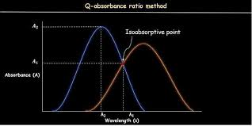

To determine the concentrations of drugs X and Y using the Q-absorbance ratio method, the following equations are applied:
For drug X: Cx = ((QM - Qy) / (Qx - Qy)) × (A1 / ax1)
For drug Y: Cy = ((QM - Qx) / (Qy - Qx)) × (A1 / ay1)
In these equations: - Cx and Cy represent the concentrations of drugs X and Y, respectively. - QX, QY, and QM are computed based on the average absorptivity values of the drugs at specific wavelengths.
- QX = ax2 / ax1 - QY = ay2 / ay1 - QM = A2 / A1
Where, ax1 and ax2 are the absorptivities of drug X at wavelengths λ1 and λ2.
ay1 and ay2 are the absorptivities of drug Y at wavelengths λ1 and λ2.
A1 and A2 indicate the absorbances of the sample solution at wavelengths λ1 and λ2.

