INSTRUMENTAL METHODS OF ANALYSIS- BP701T

UNIT : 1 UV Visible spectroscopy
CLASS:6 Instrumentation of UV Visible spectrophotometer

TOPIC: INSTRUMENTATION OF UV VISIBLE SPECTROPHOTOMETER
INSTRUMENTATION
All spectrophotometer instruments designed to measure the absorption of radiant energy have the basic components as follows:
i) A stable source of radiant energy (Light)
ii) A wavelength selector to isolate a desired wavelength from the source (filter or monochromator)
iii) Transparent container (cuvette) for the sample and the blank
iv) A radiation detector (phototube) to convert the radiant energy received to a measurable signal
v) A readout device that displays the signal from the detector.

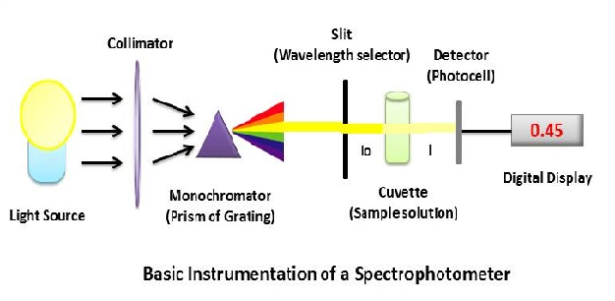 Figure 6.1 Basic instrumentation of spectrophotometer

Sources of UV radiation
It is important that the power of the radiation source does not change abruptly over it's wavelength range. Both deuterium and hydrogen lamps emit radiation in the range 160 - 375 nm. Quartz windows must be used in these lamps, and quartz cuvettes must be used, because glass absorbs radiation of wavelengths less than 350 nm.

Sources of visible radiation

The tungsten filament lamp is commonly employed as a source of visible light. This type of lamp is used in the wavelength range of 350 - 2500 nm. Tungsten/halogen lamps contain a small amount of iodine in a quartz "envelope" which also contains the tungsten filament. The iodine reacts with gaseous tungsten, formed by sublimation, producing the volatile compound WI₂. When molecules of WI₂ hit the filament they decompose, redepositing tungsten back on the filament. The lifetime of a tungsten/halogen lamp is approximately double that of an ordinary tungsten filament lamp. Tungsten/halogen lamps are very efficient, and their output extends well into the ultra-violet. They are used in many modern spectrophotometers.

Wavelength selector (monochromator)
All monochromators contain the following component parts;
- An entrance slit
- A collimating lens
- A dispersing device (usually a prism or a grating)
- A focusing lens
- An exit slit
Polychromatic radiation (radiation of more than one wavelength) enters the monochromator through the entrance slit. The beam is collimated, and then strikes the dispersing element at an angle. The beam is split into its component wavelengths by the grating or prism. By moving the dispersing element or the exit slit, radiation of only a particular wavelength leaves the monochromator through the exit slit.

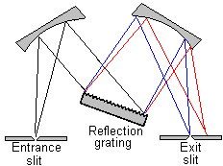
Figure 6.2 Czerney-Turner grating monochromator

Cuvettes

The sample containers, cells or cuvettes, must be fabricated from material that is transparent to radiation in the spectral region of interest. The commonly used materials
for different wave length regions are:
- Quartz or fused silica: UV to 2 mm in I R
- Silicate glass: Above 350 nm to 2 mm in I R
- Plastic: visible region
- Polished NaCI or AgCI: Wave lengths longer than 2mm

Cuvettes or cells are provided in pairs that have been carefully matched to make possible the transmission through the solvent and the sample. Accurate spectrophotometric analysis requires the use of good quality, matched cells. These should be regularly checked against one another to detect differences that can arise from scratches, etching and wear. The most common cell path for UV-visible region is 1 cm. For reasons of economy, cylindrical cells are frequently used. Care must be taken to duplicate the position of such cells with respect to the light path; otherwise, variations in path length and in reflection losses will introduce errors.
Detectors
The three common types of detectors are:
a) Barrier layer cell or photovoltaic cell
b) Phototube or photocell or photo-emissive tubes
c) Photomultiplier tubes (PMT)

- Photovoltaic cell :
Photovoltaic cell is also known as barrier layer cell. It consists of a metallic base plate like iron or aluminium which acts as one electrode. On its surface, a thin layer of a semiconductor metal like selenium is deposited. Then the surface of selenium is covered by a very thin layer of silver or gold which acts as a second collector tube.
When the radiation is incident upon the surface of selenium, electrons are generated at the selenium- silver surface and the electrons are collected by the silver. This accumulation at the silver surface creates an electric voltage difference between the silver surface and the basis of the cell.
- Phototubes :
Phototubes are also known as photo emissive cells. A phototube consists of an evacuated glass bulb. There is light sensitive cathode inside it. The inner surface of cathode is coated with light sensitive layer such as potassium oxide and silver oxide. When radiation is incident upon a cathode, photoelectrons are emitted. These are collected by an anode. Then these are returned via external circuit. And by this process current is amplified and recorded.
- photomultiplier tube :
The photomultiplier tube is a commonly used detector in UV spectroscopy. It consists of a photoemissive cathode (a cathode which emits electrons when struck by photons of radiation), several dynodes (which emit several electrons for each electron striking them)
and an anode.
A photon of radiation entering the tube strikes the cathode, causing the emission of several electrons. These electrons are accelerated towards the first dynode (which is 90V more positive than the cathode). The electrons strike the first dynode, causing the emission of several electrons for each incident electron. These electrons are then accelerated towards the second dynode, to produce more electrons which are accelerated towards dynode three and so on. Eventually, the electrons are collected at the anode. By this time, each original photon has produced 106 - 107 electrons.
The resulting current is amplified and measured. Photomultipliers are very sensitive to UV and visible radiation. They have fast response times. Intense light damages photomultipliers. They are limited to measuring low power radiation.

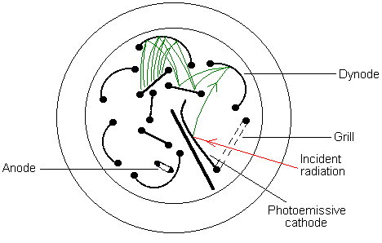

Figure 6.3 Photo multiplier tubes

TYPES OF SPECTROPHOTOMETERS

There are two types of spectrophotometers. It is important to understand the optical layout of both single beam and double beam systems before you begin to appreciate the advantages of one over the other.

Single Beam Systems
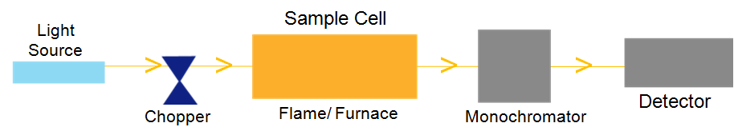
Figure 6.4 Single Beam Spectrophotometer

The light source comprising of a hollow cathode lamp emits sharp atomic line of the element whose determination is required. The light is modulated (switched on and off) rapidly by means of a rotating chopper located between the light source and the flame. Modulation can also be achieved by pulsing the power (switched on and off rapidly) to the light source. Modulation serves to differentiate the light coming from the source lamp to the flame. The modulated light is led to the flame where ground state atoms of the element of interest are present and after absorption is led to the monochromator which isolates the wavelength of interest which is then led to the detector.

Advantages of Single Beam Systems
- Single beam instruments are less expensive
- High energy throughput due to non-splitting of source beam results in high sensitivity of detection
Disadvantages
Instability due to lack of compensation for disturbances like electronic circuit fluctuations, voltage fluctuations, mechanical component’s instability or drift in energy of light sources. Such drifts result in abnormal fluctuations in the results.

Double Beam Systems
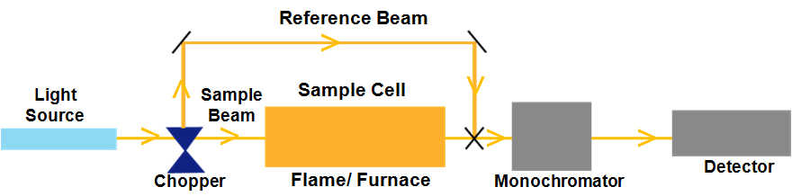
Figure 6.5 Double Beam Spectrophotometer
The light beam from the source is split into sample beam and reference beam by the mechanical chopper. The reference beam monitors the lamp energy whereas the sample beam reflects sample absorption. The observed absorbance measurement is the ratio of the sample and reference beams which are recombined before moving to the monochromator. This arrangement compensates the effects due to drift in lamp intensity, electronic and mechanical fluctuations which affect both the sample and reference beams equally.

Advantages of Double Beam Systems
- Modern improvements in optics permit high level of automation and offer the same or even better level of detection as compared to earlier single beam systems. Instability factors due to lamp drift, stray light, voltage fluctuations do not affect the measurement in real-time.
- Little or no lamp warm up time is required. This not only improves throughput of results but also conserves lamp life

General Measurement Procedures
As explained above, the Beer-Lambert Law forms the basis of the measurement procedure. The amount of light radiation absorbed by a compound is directly related to the concentration of the compound.
The general measurement procedure consists of 5 steps:
- Prepare samples to make colored compound
- Make series of standard solutions of known concentrations and treat them in the same manner as the sample for making colored compounds
- Set spectrophotometer to l of maximum light absorption
- Measure light absorbance of standards
- Plot standard curve: Absorbance vs. Concentration,

